Joseph Gregg (1937-1987)

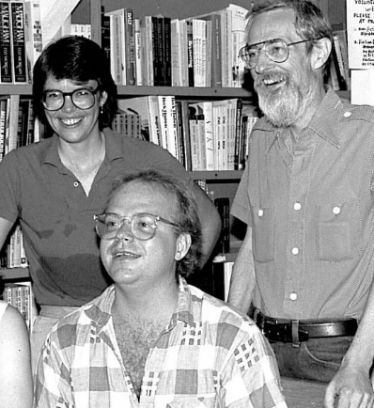
1987 photo of Joe Gregg, right

Joseph Gregg (also known as Joe Gregg) was an American librarian, archivist, and activist in gay and lesbian library services and LGBTQ+ history preservation.
In the early 1960s, Gregg began his professional career as a librarian in the art history department at the University of Chicago, where he rose to the rank of assistant professor. He later worked as a librarian at Northeastern Illinois University.
Gregg was deeply involved in Chicago’s gay community and activism. He participated in every gay parade and rally and was recognized for his leadership in the field. In 1978, he founded the Chicago History Project, a key precursor to the Gerber/Hart Library and Archives, one of the Midwest’s earliest and most significant LGBTQ+ community archives and libraries (established in the early 1980s).
Gregg served as the male co-librarian (sometimes described as librarian or co-director) from 1982 until shortly before his death.
He was instrumental in building collections, developing professional standards, and promoting visibility for gay and lesbian materials and librarians.
As founding chair of the American Library Association (ALA) Gay and Lesbian Task Force Thesaurus Committee, he contributed significantly to The International Thesaurus of Gay and Lesbian Index Terms, which helped establish best practices for describing LGBTQ+ materials in library and archival collections.
He also participated in international efforts, including the formation of the International Lesbian and Gay Archives and Libraries (IALGAL) in 1985. His work emphasized collaboration among LGBTQ+ archives and libraries worldwide.
Following his death, his personal collection of ephemera—handbills, advertisements, and newspaper clippings documenting gay and lesbian life in Chicago from the late 1950s through the late 1980s—was donated to the Gerber/Hart Library. His professional papers, preserved there, document efforts to build LGBTQ+ collections and professional networks.
In early 1988, the ALA Gay and Lesbian Task Force (at its Midwinter meeting) passed a memorial resolution honoring Gregg. It recognized him as “a respected librarian” who served as founding chair of the Thesaurus Committee and the Gerber/Hart Library, noting his efforts to improve visibility for gay and lesbian librarians within the ALA and his willingness to assist others. The resolution expressed “admiration and appreciation for Joseph Gregg’s leadership, insight and many accomplishments in gay and lesbian librarianship” and directed that a copy be sent to the Gerber/Hart Library.
Gregg’s legacy endures through the Gerber/Hart Library and Archives (which holds his papers and collection), his contributions to professional standards in LGBTQ+ librarianship and archiving, and his role in early community history preservation efforts.

Sources
Damski, Jon-Henri. “AIDS: Joe Gregg’s Private Affair.” Windy City Times, December 3, 1987. https://windycitytimes.com/2011/04/27/aids-joe-greggs-private-affair/
(reprint of original article).
“Jeannette Howard Foster.” Chicago LGBT Hall of Fame. Accessed June 16, 2026. https://chicagolgbthalloffame.org/howard-foster-jeannette/.
“Preserving the AIDS Legacy.” Chicago Tribune, August 9, 1992. https://www.chicagotribune.com/1992/08/09/preserving-the-aids-legacy/.
Gay and Lesbian Task Force, American Library Association. GLTF Newsletter 1, no. 1 (Spring 1988). https://www.ala.org/sites/default/files/rt/content/newsletter/newsletters/1988Spring.pdf.
“Uncovering the History of LGBTQ Archives and Libraries.” One Institute. Accessed June 16, 2026. https://www.oneinstitute.org/uncovering-history-lgbtq-archives-libraries/.

Additional supporting details drawn from Gerber/Hart Library & Archives collection descriptions and related historical references (e.g., Joe Gregg’s service as librarian/co-librarian 1982–1987 and founding of the Chicago History Project in 1978).

