Ferol Ann Accola Foos - 1941– 2014

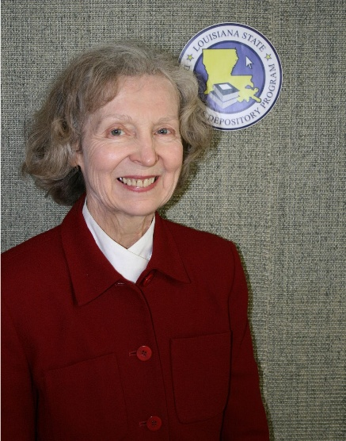

Ferol Ann Accola Foos (1941–July 2014) was an American librarian whose career spanned special libraries in the private sector and key roles in government documents and information services in Louisiana’s public sector. She was recognized for her leadership in documents librarianship, professional service, and ability to inspire colleagues in preserving and providing access to government publications.
Foos began her professional career in the private sector as Director of Special Libraries for the Ethyl and Albemarle chemical corporations. She later moved into public-sector librarianship at the State Library of Louisiana. There, she first served as Coordinator of the Louisiana Government Information Network (LaGIN).
She subsequently became Louisiana Recorder of Documents, a position she held from 2001 until her retirement in 2012. In this role, headquartered at the State Library, she administered the state’s document depository program, overseeing the receipt, classification, distribution, and preservation of Louisiana government publications (both print and, increasingly, digital).
Foos chaired the Government Documents Round Table (GODORT) of the Louisiana Library Association (LLA) and held leadership positions on the Louisiana Advisory Council for the State Documents Depository Program (later renamed the Louisiana Public Document Depository Program Advisory Council) and the Louisiana Federal Depository Library Council.
Her contributions earned several awards: the LLA GODORT Margaret T. Lane Award (2010), the LLA Lucy B. Foote Subject Specialist Award (1998), and the Special Libraries Association (SLA) LaSoMi Chapter’s Becky Skau Award for Excellence (1999).
Ferol often spent weekends volunteering for projects and causes she believed to be important to the community, including the Louisiana Book Festival, Louisiana Library Association, Special Library Association and the Unitarian Church of Baton Rouge.
Foos’s work strengthened Louisiana’s government information infrastructure during a period of transition toward digital resources, supporting depository libraries, state agencies, and public access to official publications. Her service exemplifies the vital role of specialized librarians in organizing and preserving public records.
Ferol Foos died in July, 2014 and donation were suggested for the Community Fund for the Arts through the Arts Council of Greater Baton Rouge or Patrons of the Public Library in care of the East Baton Rouge Public Library, Main Branch.

Sources

American Library Association. “A Memorial Resolution Honoring Ferol Ann Accola Foos.” 2014-2015 ALA Memorial #6. Adopted by the ALA Council, February 3, 2015, Chicago, Illinois..
Ferol Ann Accola Foos, obituary, The Advocate (Baton Rouge, LA), July 2014.
Louisiana Library Association. "Awards & Scholarships." LLA Online. Accessed July 10, 2026.

