Eleanor Estes -1906–1988

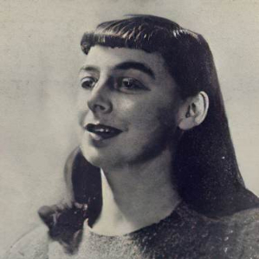

Eleanor Estes (1906–1988) was an American children’s author and former children’s librarian whose semi-autobiographical stories captured the everyday adventures of childhood in small-town New England. Her book, Ginger Pye, won the Newberry Medal in 1951.
Best known for the Moffats series and the Newbery Medal-winning Ginger Pye (1951), she drew heavily on her own experiences growing up in West Haven, Connecticut. Although she left full-time librarianship in 1941 to focus on writing, her early career as a children’s librarian profoundly shaped her understanding of young readers and storytelling.
Eleanor Ruth Rosenfeld was born on May 9, 1906, in West Haven, Connecticut.
After high school, she trained at the New Haven Free Public Library and quickly rose through the ranks, becoming head of the children’s department by 1928–1929. In 1931 she received the Caroline M. Hewins Scholarship for children’s librarians, which funded her studies at the Pratt Institute Library School in New York. There she met fellow student Rice Estes, whom she married in 1932.
Estes worked as a children’s librarian at the New Haven Free Public Library and later at multiple branches of the New York Public Library system (including Seward Park, Chatham Square, West New Brighton, and George Bruce). She remained in these roles until 1941. Her husband also pursued a career in librarianship, eventually becoming head librarian and acting dean at Pratt Institute and later serving at other institutions. Their daughter, Helena, also became a librarian.

Transition to Writing and Literary Career

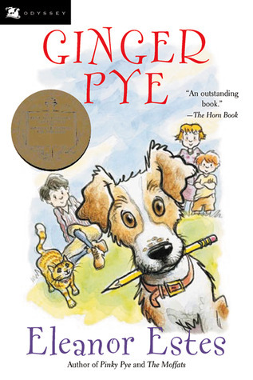
While confined to bed with tuberculosis, Estes began writing. Her first book, The Moffats (1941), introduced the four Moffat children living in the fictional town of Cranbury (closely modeled on West Haven). The series (The Middle Moffat, 1942; Rufus M., 1943; and later The Moffat Museum, 1983) became immediate classics for their warm, humorous portrayal of family life, resourcefulness, and small-town adventures. She illustrated some of her own books and went on to publish more than twenty works for children, plus one adult novel, The Echoing Green (1947).
Her books often blended realism with gentle fantasy and were praised for their sensitive characterizations and authentic child perspectives. She also taught at writers’ conferences, including the University of New Hampshire.
Following her husband’s career moves, the family lived in various locations, including New York and Washington, D.C., before returning to Connecticut. Estes received numerous honors, including the Pratt Institute Alumni Medal (1968) and recognition for her contributions to children’s literature.
Her papers are held at the University of Southern Mississippi, the University of Minnesota, and the University of Connecticut.
Eleanor Estes died on July 15, 1988.

Publications
Estes, Eleanor. The Moffats. New York: Harcourt, Brace, 1941. (Lewis Carroll Shelf Award)
Estes, Eleanor. The Middle Moffat. New York: Harcourt, Brace, 1942. (Newbery Honor)
Estes, Eleanor. The Sun and the Wind and Mr. Todd. New York: Harcourt, Brace, 1943.
Estes, Eleanor. Rufus M. New York: Harcourt, Brace, 1943. (Newbery Honor)
Estes, Eleanor. The Hundred Dresses. New York: Harcourt, Brace, 1944. (Newbery Honor)
Estes, Eleanor. The Echoing Green. New York: Macmillan, 1947. (adult novel)
Estes, Eleanor. The Sleeping Giant and Other Stories. New York: Harcourt, Brace, 1948.
Estes, Eleanor. Ginger Pye. New York: Harcourt, Brace, 1951. (Newbery Medal)
Estes, Eleanor. A Little Oven. New York: Harcourt, Brace, 1955.
Estes, Eleanor. Pinky Pye. New York: Harcourt, Brace, 1958.
Estes, Eleanor. The Witch Family. New York: Harcourt, Brace, 1960.
Estes, Eleanor. Small but Wiry. New York: Harcourt, Brace & World, 1963.
Estes, Eleanor. The Alley. New York: Harcourt, Brace & World, 1964.
Estes, Eleanor. The Lollipop Princess. New York: Harcourt, Brace & World, 1967.
Estes, Eleanor. Miranda the Great. New York: Harcourt, Brace & World, 1967.
Estes, Eleanor. The Tunnel of Hugsy Goode. New York: Harcourt Brace Jovanovich, 1972.
Estes, Eleanor. The Coat-Hanger Christmas Tree. New York: Atheneum, 1973.
Estes, Eleanor. The Lost Umbrella of Kim Chu. New York: Atheneum, 1978.
Estes, Eleanor. The Moffat Museum. New York: Harcourt Brace Jovanovich, 1983.
Estes, Eleanor. The Curious Adventures of Jimmy McGee. New York: Harcourt Brace Jovanovich, 1987.

Sources

“Eleanor Estes, 82, Children’s Book Author.” New York Times, July 19, 1988, Section B, p. 8.
“Eleanor Estes, Author of The Moffats & Ginger Pye.” LiteraryLadiesGuide. Updated May 9, 2024.
. “Eleanor Estes.” Wikipedia.

University of Connecticut. Estes, Eleanor. Eleanor Estes Papers. 1997-0049. Archives and Special Collections, University of Connecticut Library, Storrs.
University of Minnesota. Estes, Eleanor. Eleanor Estes Papers. CLRC-25. Children’s Literature Research Collections, University of Minnesota Libraries, Minneapolis.
University of Southern Mississippi. Estes, Eleanor. Eleanor Estes Papers. De Grummond Children’s Literature Collection, University of Southern Mississippi Libraries, Hattiesburg.
(Part of the de Grummond Collection; includes manuscript material dated 1951.)

Submitted by ALA Member

