Ernest R. DeProspo – 1937-1984

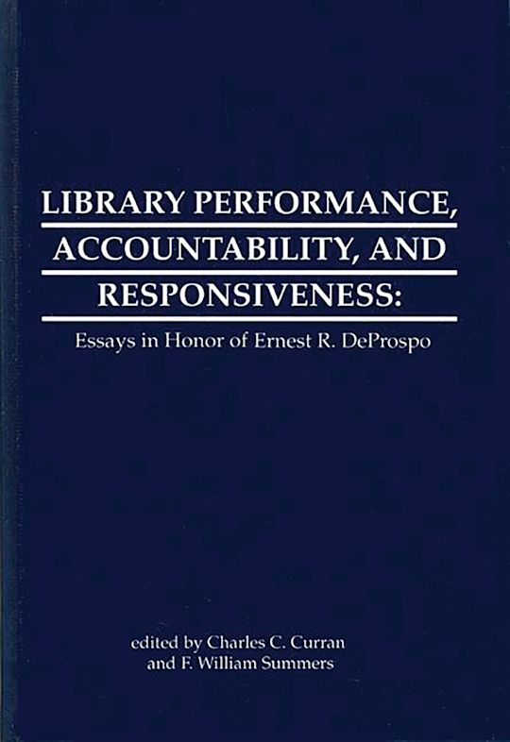

Ernest R. DeProspo, Jr. (also known as Ernest Rocco DeProspo Jr. or Ernest Orest DeProspo Jr.; 1937–1983) was an American librarian, educator, and researcher specializing in library administration, performance measurement, evaluation, planning, and accountability.
He was born January 10, 1937, in Worcester, Massachusetts.
Dr. Ernest R. Deprospo Jr., was director of graduate programs at Rutgers University's School of Communication, Information and Library Studies Rutgers University’s Graduate School of Library Service (now part of the School of Communication and Information), where he contributed to teaching, research, and professional development in library science.
DeProspo’s work focused on practical tools for improving library services, particularly in public libraries. He emphasized measurable outcomes, planning processes, and the role of libraries in broader accountability frameworks. His publications and seminars helped shape discussions on library evaluation during the 1960s and 1970s, a period when the field was moving toward more data-driven management practices.
Key contributions include editing The Library Building Consultant: Role and Responsibility (Rutgers University Press, 1969), a report from a seminar on the topic held at Rutgers. He also wrote or works such as Performance Measures for Public Libraries (1973) and contributed papers on library research, policy influence, and related topics (e.g., observations on the relationship between library researchers and policymakers).
Colleagues and former students regarded him as a mentor whose ideas influenced library planning and assessment. This is reflected in the 1990 volume Library Performance, Accountability, and Responsiveness: Essays in Honor of Ernest R. Deprospo, edited by Charles C. Curran with the assistance of F. William Summers (Ablex Publishing). The book features essays by prominent library researchers and practitioners on themes central to DeProspo’s career, along with a biographical sketch by Philip M. Clark.
DeProspo’s career left a lasting mark on library evaluation methodologies. His emphasis on performance measures, planning integration, and responsiveness continues to inform library administration scholarship and practice.

Selected Publications
DeProspo, Ernest R., ed. The Library Building Consultant: Role and Responsibility. New Brunswick, N.J.: Rutgers University Press, 1969. (Report of a seminar held at the Graduate School of Library Service, Rutgers University.)
DeProspo, Ernest R., Kenneth E. Beasley, Ellen Altman, and Ellen Clark. Measurement of Effectiveness of Public Library Service Study: A Report on Phases I and II. ERIC ED075052. Chicago: Public Library Association, 1971.
DeProspo, Ernest R., and Henry Voos. “The Library Researcher and Policymaker: An Observation Here, A Speculation There; and, Comments on Research in the Information Sciences.” ERIC ED081452. Chicago: American Library Association, Library Research Round Table, 1972. Paper presented at the American Library Association Annual Conference.
DeProspo, Ernest R. Performance Measures for Public Libraries. Chicago: Public Library Association, American Library Association, 1973.
DeProspo, Ernest R., and Ellen Altman. “Library Measurement: A Management Tool.” Library Journal 98, no. 22 (December 15, 1973): 3605–3607.
DeProspo, Ernest R. A Program Planning and Evaluation Training Manual. 1973.DeProspo, Ernest R. Statistical Data for New Jersey Public Libraries: Statewide Reporting. 1976.
MAVOR, ANNE S., JOSE ORLANDO TORO, and ERNEST R. DePROSPO. “An Overview of the National Adult Independent Learning Project.” RQ 15, no. 4 (1976): 293–308.
DeProspo, Ernest R. “Library Administration’s Responsibilities Outside the Library: The Consortium for Public Library Innovation.” Library Trends 28, no. 2 (Fall 1979.

Sources
Cohn, William L. Performance Measures for Public Libraries, by Ernest R. DeProspo, Ellen Altman, and Kenneth E. Beasley. RQ 14, no. 1 (1974): 75.
Clark, Philip M. “A Biographical Sketch of Ernest R. DeProspo, Jr.” In Library Performance, Accountability, and Responsiveness: Essays in Honor of Ernest R. Deprospo, edited by Charles C. Curran with the assistance of F. William Summers, [pages if known]. Norwood, N.J.: Ablex, 1990.
Curran, Charles C., and F. William Summers, eds. Library Performance, Accountability, and Responsiveness: Essays in Honor of Ernest R. Deprospo. Norwood, N.J.: Ablex, 1990.
Dragon, Andrea. “Ernest R. DeProspo 1937–1983.” Journal of Library Administration 5, no. 1 (1984): 3–4.
“Dr. Ernest R. DeProspo.” New York Times, September 19, 1983.

Submitted by ALA Member

