Donald Dale Foos- 1929 –2002

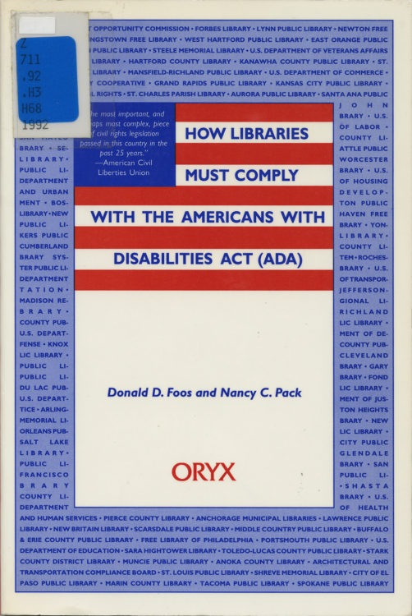

Donald Dale Foos (March 11, 1929 – March 31, 2002) was an American librarian, library educator, administrator, and advocate for library services to people with disabilities and older adults.
Foos served in the United States Air Force with the 9th Aeromedical Evacuation Group, 315th Air Division, from 1958 to 1961.
He began his library career with the Alabama Public Library Service His duties included bookmobile routes; Tuscaloosa County’s was among the first.
He earned a PhD. at Florida State University in 1971.
He later held senior academic and administrative roles in library and information science education. From 1971 to 1979 he served as Dean and Professor of the Graduate School of Library Science at Louisiana State University.
From 1981 to 1994 he was Director of the Center for Library and Information Sciences Program at the University of Arkansas. He also served as Dean of the West Virginia Library Skills Institute at Marshall University in Huntington, West Virginia.
Foos’s scholarly work included The Role of the State Library in Adult Education: A Critical Analysis of Nine Southeastern State Library Agencies (Libraries Unlimited, 1973), issued as Research Studies in Library Science no. 9. His later publications and advocacy focused on library services for people with disabilities and the aging population.
He represented libraries at the White House Conference on Aging.
With Nancy C. Pack (his wife), he co-compiled and edited How Libraries Must Comply with the Americans with Disabilities Act (ADA) (Oryx Press, 1992). He also worked as a contractor on Americans with Disabilities Act matters and as Executive Director of the Tri-State Resource and Advocacy Corporation in Chattanooga, Tennessee.
Foos died on March 31, 2002. A continuing education fund for Tuscaloosa library employees was later established in his memory.

Selected Publications
Foos, Donald Dale. The Role of the State Library in Adult Education: A Critical Analysis of Nine Southeastern State Library Agencies. Research Studies in Library Science, no. 9. Littleton, CO: Libraries Unlimited, 1973.
Foos, D.. (1982). Public libraries and electronic technology. Arkansas Libraries, 39, 23–25.
Foos, D.. (1983). ‘Museum dream’ spurs new public library task force. American Libraries, 14, 421.
Pack, Nancy C., and Donald D. Foos. “Library Compliance with the Americans with Disabilities Act.” RQ 32, no. 2 (Winter 1992): [page range not confirmed in available sources].
Foos, Donald D., and Nancy C. Pack, comps. and eds. How Libraries Must Comply with the Americans with Disabilities Act (ADA). Phoenix: Oryx Press, 1992.

Sources
American Library Association Memorial. Annual Conference 2002.
“Donald D. Foos,” Tuscaloosa News, April 2, 2002.
Donald, D. (1973). Foos, director of LSU’s School of library science, has been made dean of the school. Wilson Library Bulletin, 48, 226.
Donald Foos, director and professor, Center for Library and Information Science, University of Arkansas, Little Rock since 1981, retired. (1987). Library Journal, 112(8), 24.
Obituary. (2002, June 1). Arkansas Libraries, 59(3), 27.
O’Donnell, R., & Gunde, M. (1994). A core collection of ADA information. RQ, 33(3), 238.
Foos, Donald Dale. The Role of the State Library in Adult Education: A Critical Analysis of Nine Southeastern State Library Agencies. Research Studies in Library Science no. 9. Littleton, CO: Libraries Unlimited, 1973.
Foos, Donald D., and Nancy C. Pack, comps. and eds. How Libraries Must Comply with the Americans with Disabilities Act (ADA). Phoenix: Oryx Press, 1992.

Submitted by ALA Member

