Daniel W. Casey - 1921 –1995

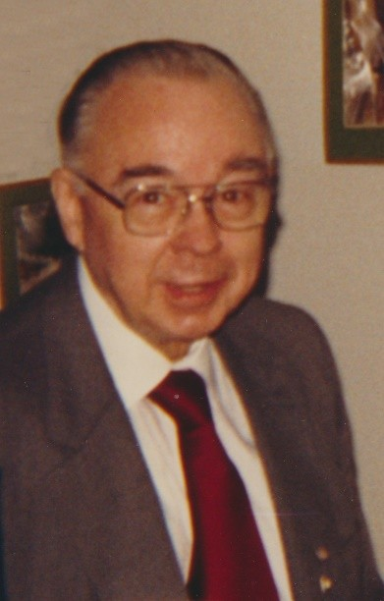

Daniel W. Casey (January 13, 1921 – March 1995), often called “Mr. Library,” was an attorney and prominent library trustee, advocate, and leader who devoted more than 40 years to advancing library services at local, state, national, and international levels.

Born in Malone, New York, Casey began his lifelong commitment to libraries in 1954 when he was appointed to the Board of Trustees of the Solvay Public Library (near Syracuse). He later served as president of that board.

His involvement quickly expanded: he became active in the New York State Association of Library Boards, served on the Onondaga County Public Library board, the Central New York Library Resources Council, and the Syracuse University Library Associates.

He was the first trustee appointed by the New York State Board of Regents to its Advisory Council on Libraries and served on statewide library committees under Governors Hugh Carey and Mario Cuomo.

At the national level, Casey was elected to the councils of both the American Library Association (ALA) and the American Library Trustee Association (ALTA), serving as president of ALTA.

The New York Library Association (NYLA) named him Councilor Emeritus and an honorary lifetime member; in 1981 it awarded him its Outstanding Services to Libraries Award.

His influence extended to the federal government. In 1973 President Richard Nixon appointed him to the U.S. National Commission on Libraries and Information Science (NCLIS). He was reappointed by Presidents Ronald Reagan and George H. W. Bush and served until his death in 1995. He served on the advisory committee for the 1991 White House Conference on Library and Information Services.

Internationally, Casey represented libraries as a member of the International Federation of Library Associations and Institutions (IFLA). Below is a photograph of Robert Wedgeworth, Daniel Casey, and Subhas C. Biswas at the 1991 IFLA Conference in Moscow, Russia.

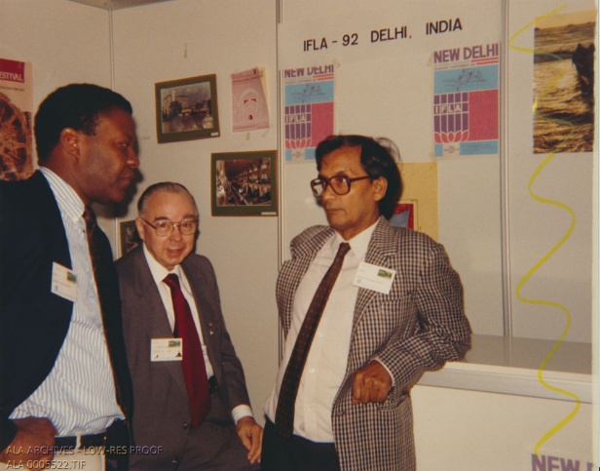

Casey was widely recognized for his tireless legislative and governmental advocacy on behalf of libraries and improved library services.

Daniel W. Casey died March 1995. In October 1995 the Empire Friends Roundtable posthumously presented him its Friends Lifetime Achievement Award and renamed it the Daniel W. Casey Library Advocacy Award in his honor; the award continues today under the Friends of Libraries Section of NYLA to recognize outstanding library volunteers and advocacy efforts.

Sources

American Library Association. American Library Trustee Association. “Newsletters, 1958-2011.” Finding aid. American Library Association Archives, University of Illinois at Urbana-Champaign Library, Urbana, Illinois.

American Library Association Archives. “Photograph of Robert Wedgeworth, Daniel Casey, and Subhas C. Biswas at the 1991 IFLA Conference in Moscow, Russia.” Digital content. University of Illinois at Urbana-Champaign Library, Urbana, Illinois.

Biswas, Subhas C. “Indian Legal Deposit Legislation and its Impact on the National Library.” Alexandria: The Journal of National and International Library and Information Issues 22, no. 2–3 (2011): 49–59.

New York Library Association. “FLS Daniel W. Casey Library Advocacy Award.” PDF document

Nostalgic Syracuse (Facebook group post summarizing Casey’s career, drawing on library association records). “Who was Daniel W. Casey.” June 27, 2022.

Syracuse University Library Associates. “News of the Library and of Library Associates, from Courier, Vol. XXX, 1995.” The Courier 326 (1995.

U.S. President (Ronald Reagan). “Nomination of Two Members of the National Commission on Libraries and Information Science.” October 4, 1984. The American Presidency Project.

Wedgeworth, Robert. Breaking Barriers: A Librarian’s Story of Changing Times. New York: Bloomsbury Libraries Unlimited, 2026.

Submitted by ALA Member

