Blanche M. Cretini -1929- 2010

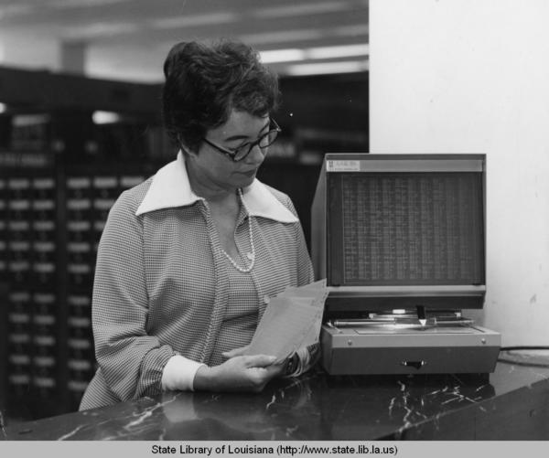

Blanche Meyers Cretini (May 16, 1929 – March 14, 2010) graduated from Newcomb College in New Orleans, Louisiana and earned a master’s degree in library science from Louisiana State University.



Her library career was at the State Library of Louisiana where she was Head of Reference and retired as Head of User Services.
During Blanche Cretini’s years of service at the State Library of Louisiana she compiled the Louisiana Numerical Register for interlibrary loan and then oversaw its development as LaserNet (the first CD-ROM based interlibrary loan catalog in the United States).
She worked with the department of the blind and physically handicapped to prepare lists of materials.
She also collaborated with other Louisiana state agencies on information sharing projects such as environmental quality.
Blanche Cretini oversaw the public services of the State Library as it moved from card catalog to OPAC.
“Blanche Cretini was a creative forward-thinking library administrator who listened to her people to help them develop innovative solutions to state-wide resource sharing. She was a good friend and a supportive supervisor.”- Sara M. Taffae, Automation Consultant and Head of Computer Services (retired), State Library of Louisiana.

Sources:
“Blanche Myers Cretini (1929–2010).” Find a Grave Memorial no. 230084345.
“Blanche Cretini Obituary.” The Advocate, March 18–20, 2010.
Hoffman, Wilbur C. The Second Twenty-Five Years of the Louisiana State Library, 1950–1975. Photograph of Mrs. Blanche Cretini (head reference librarian) holding microfiche sheets of the Louisiana Numerical Register, with a microfiche reader beside her in (Baton Rouge, LA: Louisiana State Library, 1976), 19.
Taffae, S. M. (1993). LAsernet: CD-ROM Technology for Louisiana Interlibrary Loan. Journal of Interlibrary Loan & Information Supply, 3(4), 19–24. https://doi.org/10.1300/J472v03n04_05

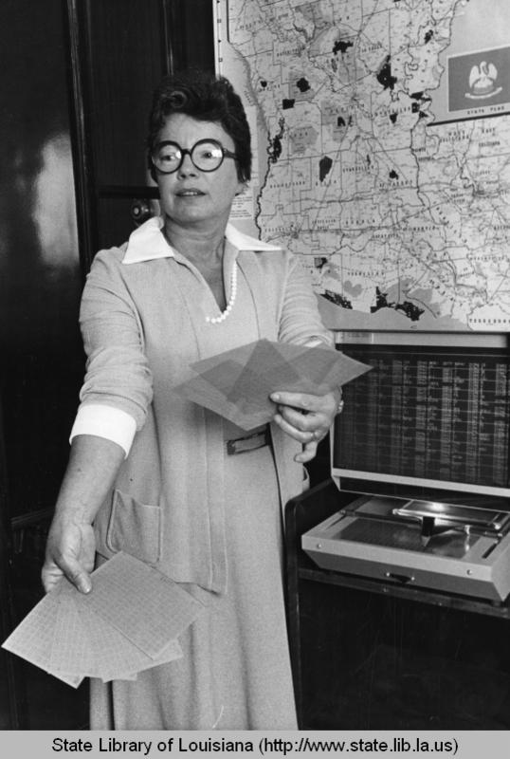

Submitted by Sara M. Taffae, Automation Consultant and Head of Computer Services (retired), State Library of Louisiana.

