Casper Leroy Jordan – 1924- 2000

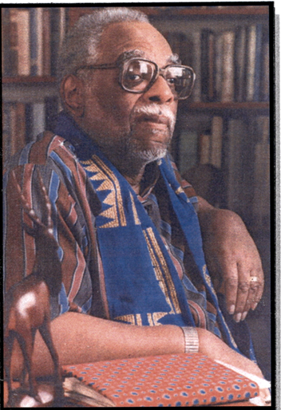

Casper LeRoy Jordan (March 5, 1924 – November 22, 2000) was an American librarian, educator, scholar of Black studies, and bibliographer known for his pioneering work in African American librarianship, archival collections, and documenting Black achievements.

Casper LeRoy Jordan was born in Cleveland, Ohio and graduated from Glenville High School.

He briefly attended Howard University before earning an A.B. degree in history from Adelbert College (now part of Case Western Reserve University) in 1947.

In 1951, he received the Master of Science in Library Science (M.S.L.S.) from Atlanta University (now Clark Atlanta University), specializing in academic librarianship, African-American bibliography, archival management, cataloging and classification, library management, and public library administration.

Casper Jordan built a distinguished career spanning university libraries, public library systems, and library education:

- 1951–1960: Chief Librarian at Wilberforce University in Ohio.
- 1961–1968: Supervisor of Technical Processes (1961–1967) and Assistant Director (1967–1968) at the Nioga Library System in New York.
- 1968–1974: Faculty member at Atlanta University’s School of Library Service (later School of Library and Information Studies), where he served as Associate Professor.
- 1974–1978: University Librarian at Atlanta University.
- 1978–1987: Central Librarian (1978–1982), Deputy Director (1982–1986), and Acting Director (1986–1987) of the Atlanta-Fulton County Public Library (now Atlanta-Fulton Public Library System). He retired in 1987.

After retirement, Casper Jordan worked as a consultant for institutions including Alabama State University, the University of Kentucky College of Library Science, the Dayton, Ohio Model Cities Educational Component, and the U.S. Department of Defense Race Institute.

Jordan was a leading figure in Black librarianship and the documentation of African American history and culture. His publications and editorial work focused on Black librarianship, the Black experience in America, and achievements in the arts and beyond.He served as book review editor for the African Methodist Episcopal Church Review (the oldest Black religious journal) and was the founding editor of Free Lance, a magazine of poetry and prose.

Casper Jordan held life memberships in the NAACP and the Association for the Study of African American Life and History (ASALH). He was also active in the African American Family History Association and the American Library Association.

In 1980, while at the Atlanta-Fulton Public Library, he established one of the earliest programs granting homeless individuals access to library services by allowing shelters to provide permanent addresses for borrower's cards.

Casper Leroy Jordan passed away November 22, 2000.

Jordan’s legacy lives on through his foundational contributions to preserving African American history, advancing Black librarianship, and inspiring future generations of scholars and information professionals. His work continues to be referenced in studies of Black bibliography and library history.

In 2024 the Auburn Avenue Research Library on African American Culture and History established The Casper LeRoy Jordan Lecture Series to honor the legacy of Casper LeRoy Jordan, a pioneering Black librarian, educator, scholar of Black studies, and longtime leader at the Atlanta-Fulton Public Library system. The series focuses on topics related to African American history, civil rights, culture, librarianship, and scholarship—areas central to Jordan’s career and contributions.

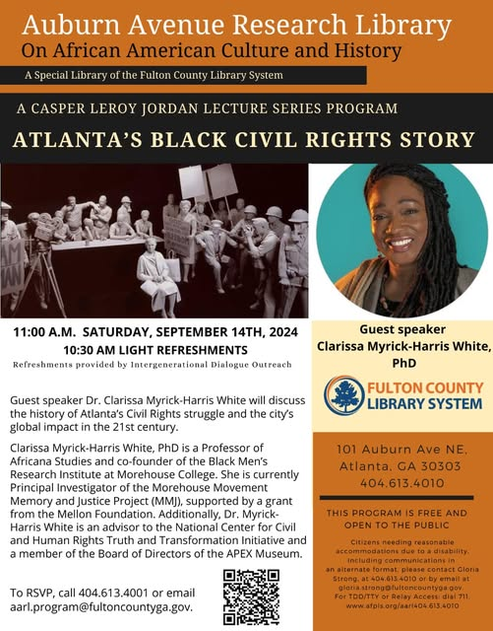

Selected Publications and Editorial Work

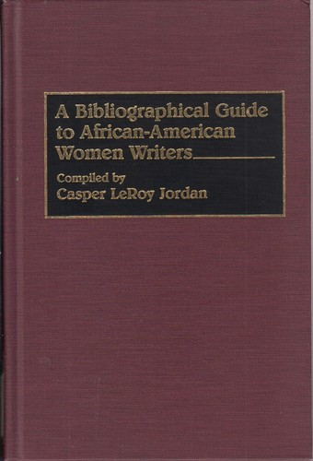

Jordan, Casper LeRoy, compiler. The Levi Jenkins Coppin Collection. Wilberforce, OH: Wilberforce University, Carnegie Library, 1957.

Hamlin, A. T., & Jordan, C. L. (1976). COMMENTARY. American Libraries, 7(6), 320.

Jordan, Casper LeRoy, and E.J. Josey. “A Chronology of Events in Black Librarianship.” In The Handbook of Black Librarianship, edited by E.J. Josey and Ann Allen Shockley, 15–24. Littleton, CO: Libraries Unlimited, 1977.

Jordan, Casper LeRoy, compiler. A Bibliographical Guide to African-American Women Writers. Bibliographies and Indexes in Afro-American and African Studies 31. Westport, CT: Greenwood Press, 1993.

Smith, Jessie Carney, editor, with Casper L. Jordan and Robert L. Johns. Black Firsts: 2,000 Years of Extraordinary Achievement. Detroit: Visible Ink Press, 1994.

Jordan, Casper LeRoy. Founding editor. Free Lance: A Magazine of Poetry and Prose, 1950–

Jordan, Casper LeRoy. Book review editor. African Methodist Episcopal Church Review.

Jordan contributed entries or sections to the following works (specific entry titles are generally not credited individually in available sources):
- Smith, Jessie Carney, editor. Ethnic Genealogy: A Research Guide. Westport, CT: Greenwood Press, 1983.
- Smith, Jessie Carney, editor. Notable Black American Women. Detroit: Gale Research, various volumes (1992– ).
- Famous Black Firsts. Detroit: Gale Research (various editions).
- The African Methodist and African American Experience in the United States: A Chronology of African Americans and the African Methodist Episcopal Church, 1703–1987. (Chronological contribution.)
He also contributed to:
- The Encyclopedia of Library and Information Science
- Dictionary of American Librarians

Sources

6 Atlanta Institutions to Explore Black History and Culture.” Atlanta Journal-Constitution, January 28, 2020.

American Library Association. Memorial. Annual Conference. 2001.

Auburn Avenue Research Library on African American Culture and History. “Casper LeRoy Jordan, undated.” General Photograph Collection.

Bloomsbury Publishing. “Casper L. Jordan.” Accessed July 19, 2026.

Digital Library of Georgia. “Memorial Services, A Celebration of Life for Casper LeRoy Jordan, Saturday, December 2, 2000, 11:00 A.M., Flipper Temple A.M.E. Church, 580 Fair Street, S.W., Atlanta, Georgia 30314.” Accessed July 19, 2026.

Myrick-Harris White, Clarissa. “Atlanta’s Black Civil Rights Story.” Inaugural Casper LeRoy Jordan Lecture Series, Auburn Avenue Research Library on African American Culture and History, Fulton County Library System, Atlanta, GA, September 14, 2024.

Submitted by ALA Member.

