William Irving Bunnell- 1940- 1999

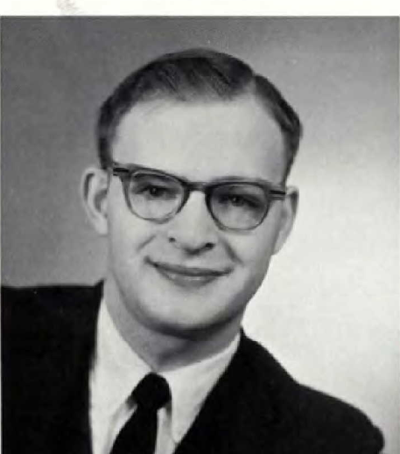
Image from "U.S., School Yearbooks, 1880-2012"; School Name: Trinity College; Year: 1962, p. 56.
William Irving Bunnell (October 25, 1940 – May 3, 1999) was an American librarian who advanced through academic library leadership roles and held prominent administrative positions in major library associations, particularly in technical services, community college libraries, and nonbook media cataloging.
Bunnell was born in Fairfield, Iowa and graduated in 1958 from Mercersburg Academy Mercersburg, Pennsylvania. He received his bachelor’s degree from Trinity College in Hartford, Conn., and his master's degree in library science from Columbia University, New York City.
He served as Director of Library Services at County College of Morris in Dover, New Jersey. In this role, he was active in state library affairs. He was president of the New Jersey Library Association in 1976-77.
He participated in national library policy discussions, including providing input at hearings of the National Commission on Libraries and Information Science.
He also contributed to the Association of College and Research Libraries (ACRL), serving as Secretary of its Community and Junior College Libraries Section (CJCLS) for the 1977–1978 term.
Bunnell relocated to Chicago to become Executive Director of the Resources and Technical Services Division (RTSD, later renamed the Association for Library Collections & Technical Services or ALCTS) of the American Library Association (ALA). He managed the division’s operations, supported professional committees and publications, and facilitated work on bibliographic control, cataloging standards, acquisitions, preservation, and nonbook media. He contributed a foreword to the volume Policy and Practice in Bibliographic Control of Nonbook Media and handled administrative correspondence and event coordination for RTSD activities throughout much of the 1980s.
Later in his career, Bunnell was Director of Library Services at Mercersburg Academy. He retired from this position and was honored with the establishment of the William I. Bunnell Library Fund at the academy.
Bunnell died on May 3, 1999.
Throughout his approximately three-decade career, Bunnell exemplified the transition many librarians made from hands-on academic library directorships to influential national association leadership. His work supported the professionalization of technical services, improved handling of non-print materials, and strengthened library services in community and junior colleges.
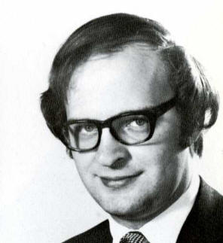
Image from CCM 40th Anniversary Archive Exhibit, PHOTO SOURCE:CCM yearbook, MUSE 1971, CCM Archives

Sources
“ACRL Officers for 1977/78.” College & Research Libraries News 38, no. 8 (1977).
American Library Association. Memorial. Annual Conference. 1999.
Barber, Peggy. “William I. Bunnell Appointed RTSD Executive Secretary.” American Library Association, July 1978.
Bunnell, William I. Foreword to Policy and Practice in Bibliographic Control of Nonbook Media, edited by Sheila S. Intner and others. Chicago: American Library Association, Resources and Technical Services Division, [ca. 1980s].
“CC-DA Roster Chairs-Members-Liaisons 1979-1989.” American Library Association Institutional Repository (ALAIR.
“IR 002 416: National Commission on Libraries and Information Science Hearing, May 21, 1975.” ERIC, ED111362.
“Maryland Obituary and Death Notice Collection – 1312: William I. Bunnell.” GenealogyBuff.com. March 25, 2019.

