William S. Budington – 1919- 2016

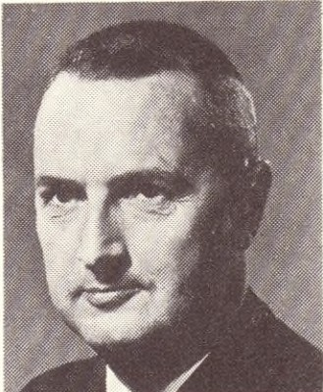

William Stone Budington (1919–2016) was an American librarian, administrator, and leader in special and research libraries, best known for his long tenure at the John Crerar Library in Chicago and his presidencies of major professional organizations. He received the 1982 Academic/Research Librarian of the Year Award from the Association of College and Research Libraries for his contributions to library service, resource sharing, and professional leadership.
Budington was born July 3, 1919, in Oberlin, Ohio
He earned a B.A. in American literature from Williams College in 1940, Phi Beta Kappa. He then obtained a B.S. in library science from Columbia University in 1941.
During World War II, Budington served in the U.S. Army (1942–1946) as an electrical technician at Oak Ridge, Tennessee, contributing to the Manhattan Project. This experience led him to pursue further technical education; he earned a B.S. in electrical engineering from Virginia Polytechnic Institute in 1946.
He later returned to Columbia University, completing an M.S. in library science in 1951. In 1975, Williams College awarded him an honorary L.H.D. (Doctor of Humane Letters).
Budington spent most of his professional career at the John Crerar Library (affiliated with the University of Chicago), joining in 1952 as associate librarian. He advanced to librarian in 1965 and served as executive director and librarian from 1969 until his retirement in 1984. During his tenure, he played a key role in modernizing the library, expanding its research information services, developing its Translations Center, and facilitating resource sharing through regional and state networks. He helped navigate significant institutional changes, including the library’s eventual merger with the University of Chicago (formalized in 1981, with integration completed in 1984).
His expertise extended beyond Crerar. He served as director of Region VIII of the Midwest Regional Medical Library (1968–1979) and participated in early American diplomatic missions to the USSR.

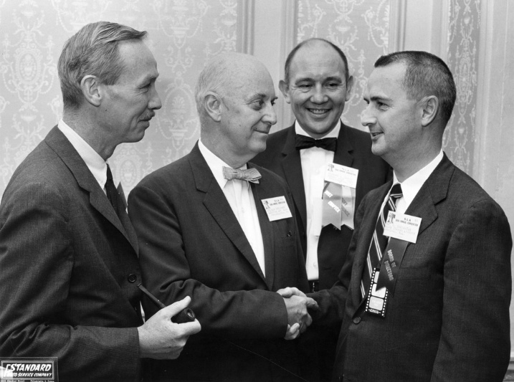

Budington (on the right) alongside other librarians at the 56th annual convention of the Special Libraries Association (SLA), where he served as president (1964–1965). The others pictured from left to right are Gordon R. Williams, Emerson Greenaway, and Richard A. Davis.

Budington was also active in professional organizations, holding leadership roles that shaped the fields of special and research librarianship.
President of the Special Libraries Association (SLA), 1964–1965 (he also led the Illinois chapter).
- President of the Association of Research Libraries (ARL), 1973.
- He served multiple terms on the American Library Association (ALA) Council and held positions in sections focused on engineering, reference services, and copying methods.

He wrote on library topics, including engineering library instruction and the role of independent research libraries, and was honored as a Fellow of the American Association for the Advancement of Science (AAAS). His work emphasized resource sharing, automation, and adapting libraries to technological and institutional changes.
Awards and Honors
- 1982: Association of College and Research Libraries- Academic/Research Librarian of the Year Award, recognizing his leadership at Crerar and service to SLA and ARL.
- 1984: Inducted into the Special Libraries Hall of Fame.

After retiring in 1984, Bill married Irma Y. Johnson, also a retired librarian, and they moved to Colorado Springs, where they were instrumental in founding the C G Jung Society of Colorado Springs in 1987. They donated many Jungian books, and a library was begun and dedicated to them as the Johnson-Budington Library of the C G Jung Institute of Colorado, located in Denver.
He died April 19, 2016 in Colorado Springs, Colorado. Keeping with John Crerar Library's motto, “Non est mortuus qui scientiam vivificavit,” ( "He has not died who has given life to knowledge)," donations were requested to local libraries in his memory because "Great is the gift that bringeth knowledge."
Budington’s career exemplified the evolution of research and special libraries in the mid-to-late 20th century, bridging traditional librarianship with emerging information technologies and cooperative networks.

Selected Publications
Budington, William S. “Teaching the Use of Engineering Libraries.” College & Research Libraries 12, no. 3 (July 1951): 268–74.
Budington, William S. “Cost of Information Service.” In The Library as a Community Information Center, edited by Rose B. Phelps and Janet Phillips, 40–55. Allerton Park Institute Proceedings, no. 4. Urbana: Graduate School of Library Science, University of Illinois, 1957.
Budington, William S. “Problems of Selection in Science.” In Collecting Science Literature for General Reading, 136–52. Allerton Park Institute Proceedings, no. 7. Urbana: Graduate School of Library Science, University of Illinois, 1960.
Budington, William S. “Service to Industry by Independent Research Libraries.” Library Trends 14, no. 3 (Winter 1966): 322–34.
Budington, William S. “Interrelations among Special Libraries.” The Library Quarterly 39, no. 1 (January 1969): 58–66. (Part of proceedings from the Thirty-Third Annual Conference of the University of Chicago Graduate Library School.)
Budington, William S. “Network Alternatives and Solutions for Storage.” Library Trends 19, no. 3 (January 1971): 329–40.
Budington, William S. “Venn Diagramming the Information Community.” Special Libraries 63, no. 9 (September 1972): 367–72.
Budington, William S. “‘To Enlarge the Sphere of Human Knowledge’: The Role of the Independent Research Library.” College & Research Libraries 37, no. 4 (July 1976): 299–306.
This list draws from indexed library science journals and conference proceedings. For a more complete inventory, consulting the finding aid for his personal and professional papers in the John Crerar Library Records at the University of Chicago Library is recommended.

Sources

Association of College and Research Libraries. (n.d.). ACRL Academic/Research Librarian of the Year Award. American Library Association.
Budington, William S. Photograph. Undated. Archival Photographic Files. University of Chicago Library, Special Collections Research Center. apf1-02311.
The Professional Library of the C.G. Jung Institute of Colorado. PDF. Denver: C.G. Jung Institute of Colorado, n.d. http://www.junginstituteofcolorado.org/pdfs/budington_library_exhibit-3.pdf.
“William S. Budington.” The Gazette (Colorado Springs, CO), April 24, 2016.
“William S. Budington -Personnel.” College & Research Libraries News 30, no. 3 (1969): 234–35.
“William S. Budington.” In Guide to the John Crerar Library Records, 1856–1984. University of Chicago Library. Accessed via finding aid descriptions.
“William Stone Budington.” College & Research Libraries News, July 1982.
University of Chicago Library. n.d. “William S. Budington.” In Guide to the John Crerar Library Records, 1856–1984. Accessed via finding aid descriptions.

Submitted by Kathleen de la Peña McCook

