Karen Avenick -1946 – 2016

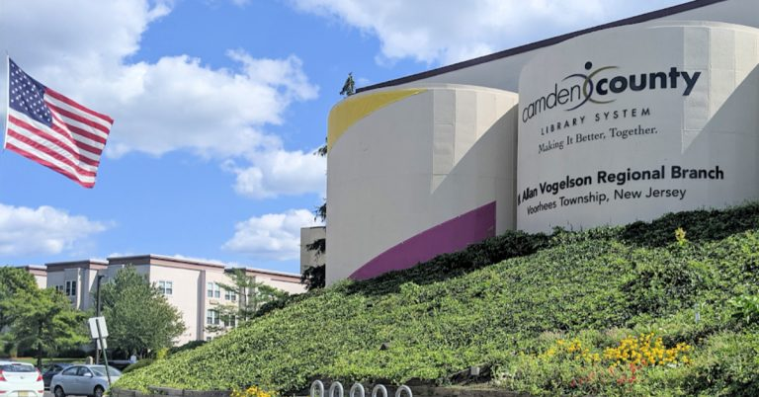

Karen Avenick (c. 1946 – December 25, 2016) was an American librarian, library administrator, and advocate in New Jersey. She worked for 29 years career with the Camden County Library System. )n 2002-2003 she was President of the New Jersey Library Association.
Avenick devoted nearly three decades to the Camden County (NJ) Library System. She started as Head of Reference Services and later served for most of her tenure as Assistant Library Director, where she was an active member of the library’s Management Team.

In her role as Assistant Director, she played a key part in guiding the design and construction of branch libraries in Bellmawr, South County, and Haddon Township.

She retired as Assistant Director of the Camden County Library System.
Avenick was an advocate for libraries at multiple levels:
She served as the original and long-time Chair of the South Jersey Regional Library Cooperative (SJRLC) Advocacy Team. In this role, she trained many librarians to become effective advocates and worked closely on training and advocacy initiatives for all types of libraries.
She was instrumental in developing the NJ Train the Trainers and Super Library Supervisor programs.
She served on the PALINET Board of Trustees (including terms as President) during a challenging leadership transition period.
She held the position of President of the New Jersey Library Association (NJLA) from 2002 to 2003, where she applied her advocacy skills statewide with enthusiasm, grace, and humor.

In 1997, her peers recognized her achievements across local, county, regional, statewide, and multistate levels by naming her New Jersey Librarian of the Year.
She was credited as a consultant/source in the American Library Association-Allied Professional Association (ALA-APA) toolkit Advocating for Better Salaries and Pay Equity.

She also contributed as a library consultant and facilitated strategic planning efforts, such as a VALE (Virtual Academic Library Environment) retreat. Post-retirement, she served as Friends/Trustees Liaison at the New Jersey Library Association.

Karen Avenick passed away on December 25, 2016.

Her career exemplified dedication to public service, leadership in advocacy, and a genuine commitment to supporting fellow librarians—leaving a lasting positive mark on libraries in New Jersey and the broader profession.

Sources

American Library Association. “A Memorial Resolution Honoring Karen Avenick.” 2017 ALA Midwinter Meeting, January 24, 2017. PDF file.
“Karen Avenick.” American Libraries Magazine, March/April 2017.
“In Memoriam: Robert White & Karen Avenick.” LibraryLinkNJ.
“ NJLA Librarian of the Year.” New Jersey Library Association.

Submitted by ALA Member

