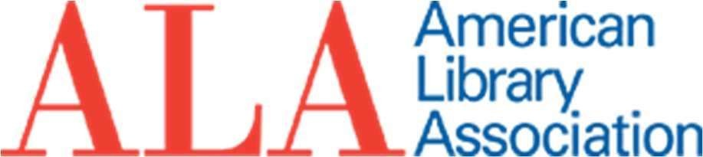

Memorial Resolution Honoring Patricia A. Wand
Whereas the American Library Association (ALA) and the library community lost a valued member, colleague, and friend on April 27, 2023, with the death of Patricia A. Wand;
Whereas Patricia A. Wand served her communities as an academic librarian for 22 years at Wittenberg University, College of Staten Island, City University of New York, Columbia University, and University of Oregon;
Whereas Patricia A. Wand served as the University Librarian and Professor at American University for 17 years;
Whereas Patricia A. Wand, as Dean of Library and Learning, contributed to the development of the information infrastructure for Zayed University, United Arab Emirates;
Whereas Patricia A. Wand started the first consortium of academic libraries in the
United Arab Emirates, thereby facilitating collaboration among academic institutions;
Whereas Patrica A. Wand promoted international librarianship and was instrumental in creating the partnership with the Sharjah Book Authority (United Arab Emirates) and
ALA, and the Sharjah International Library Conference at the Sharjah International Book
Fair (SIBF);
Whereas Patricia A. Wand was a prolific scholar publishing more than 35 articles and delivering numerous papers at professional conferences;
Whereas Patricia A. Wand was honored with the 1992 Distinguished Alumnus Award by the School of Information, University of Michigan;
Whereas Patricia A. Wand was a dedicated advocate for libraries testifying before the
U. S. House Appropriation Subcommittee in support of budgets for the Library of
Congress and before the Superintendent of Documents on behalf of the American Library Association and other national library associations;
Whereas Patricia A. Wand contributed in numerous ways to the American Library Association as Chair of its Committee on Legislation (1997-1998) and its Budget, Analysis, and Review Committee (2011-2015); as a Board member to the Association of College and Research Libraries (1986-1988, 2001-2004); as an ALA Councilor (3 terms); and six years as an ALA Endowment Trustee (2015-2021), including serving as the first female Senior Trustee;
Whereas in her capacity as its Senior Endowment Trustee, Patricia A. Wand led the work to expand ALA’s investments in environmental, social, and corporate governance (ESG) funds and to otherwise diversify the ALA Endowment portfolio;

Whereas Patricia A. Wand was a founding member of the ALA International Relations Round Table (IRRT) International Sustainable Library Development (ISLD) Interest Group that was organized in 2002;

Whereas Patricia A. Wand served as President of the District of Columbia Library
Association (1996–1997) and was honored with its 2003 Distinguished Service Award;
Whereas Patricia A. Wand was a passionate global citizen, serving in the Peace Corps in Colombia from 1963 to 1965 and later working as Peace Corps staff;
Whereas Patricia A. Wand encouraged returned Peace Corps librarians to make significant contributions to global library projects;
Whereas Patricia A. Wand advanced global understanding through her leadership on the National Peace Corps Association Board as a member (2005-2013) and Vice-Chair (2011-2013) as well as through her tireless volunteer work on behalf of the Museum of the Peace Corps Experience that resulted in increased archival deposits, private funding, and visibility;
Whereas Patricia A. Wand developed and presented her research on Middle Eastern and North African library collaboration including promotion of the Sharjah International Book Fair as an unique opportunity for multicultural engagement;
Whereas Patricia A. Wand received the Fulbright Senior Lecturer Award to Ecuador in 1989;
Whereas Patricia A. Wand joyfully promoted international librarianship and encouraged individuals to support and be involved in international conferences and activities;
Whereas Patricia A. Wand served as a welcoming and wise mentor to many throughout the American Library Association and other professional organizations;
Whereas Patricia A. Wand’s true legacy lies in the profound effect she had on students, faculty, librarians, and library workers around the world, now, therefore, be it
Resolved, that the American Library Association (ALA), on behalf of its members:
- recognizes the significant contributions of Patricia A. Wand over the course of her career;
- mourns her passing; and
2. extends its sincerest condolences to her friends and family, especially her son Kirk Dean Silvernail, daughter-in-law, Julia Silvernail, and grandsons Tristan and Logan.

Adopted by the Council of the American Library Association
Monday, June 26, 2023, ALA Annual Conference, Chicago, IL
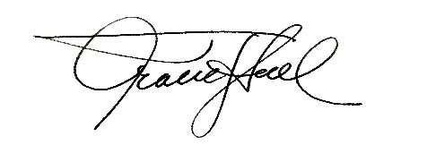
Tracie D. Hall, Executive Director, and
Secretary of the ALA Council

