Bruni Verges (- d. 1992)

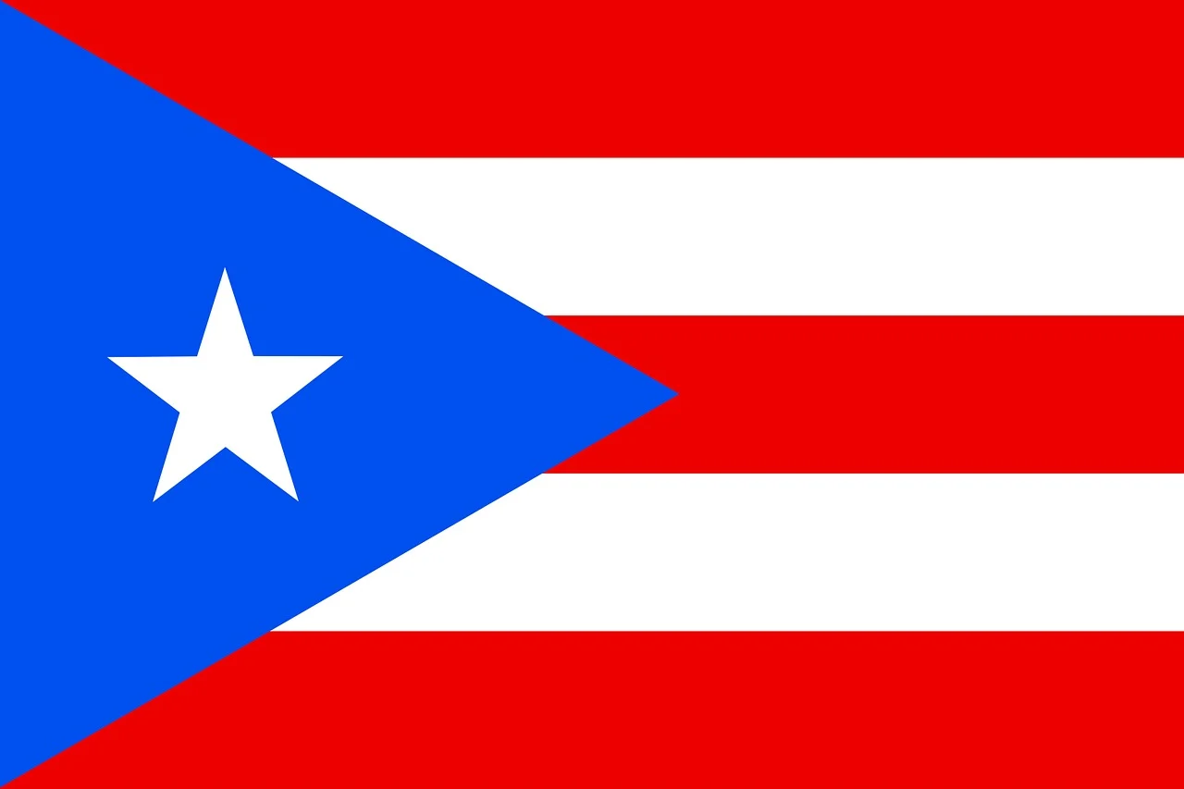

Bruni Verges (also known as Iris Bruni Verges or later Bruni Verges Klugman) was an American librarian who specialized in Hispanic and Puerto Rican heritage collections. She played a significant role in promoting cultural diversity in library services, particularly for Spanish-speaking and Puerto Rican communities.
She worked as a Supervising Librarian at the Bronx Borough Office of the New York Public Library (NYPL), where she also served as a Spanish Specialist.
In 1982, she contributed to “Developing Collections on Puerto Rican Heritage.”
From 1988 until her death, she served as assistant director of the Westchester Library System in New York, where she strongly supported Hispanic-focused programs and collections.
She married Werner Klugman in 1978 (following the death of his first wife in 1977) and lived in the Pleasantville, New York area.
She died in 1992.
In June 1993, the ALA membership adopted a memorial resolution/tribute in her honor (listed as M-14 among other memorials for library professionals).

A Bruni Verges Memorial Children’s Program Fund was later established by the Westchester Library System. It supports programs celebrating cultural diversity in children’s literature and events.

She was a dedicated librarian and advocate for multicultural library collections whose contributions were formally recognized by the library community in 1993 through an ALA memorial.

Publication
Verges, Bruni. “Developing Collections on Puerto Rican Heritage.” Collection Building 4, no. 2 (1982): 31.

Sources
American Library Association (ALA) Annual Conference in New Orleans, the ALA membership adopted a memorial resolution/tribute in her honor (listed as M-14 among other memorials for library professionals).
“Working as a Team on Children’s Books.” New York Times, September 25, 1994.
Buckvar, Felice. “Shrub Oak Library Is Host to Fair.” New York Times, September 28, 1997.

Submitted by ALA Member

