Nicolette Warisse Sosulski – 1963- 2019

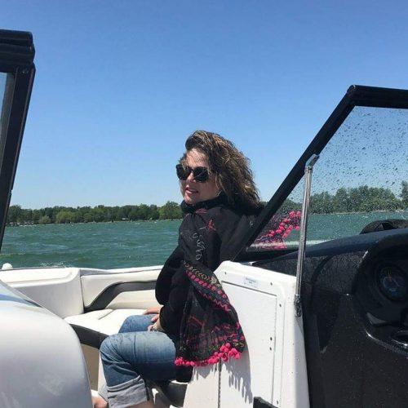

Nicolette Marie Warisse Sosulski (March 20, 1963 – May 15, 2019) was an innovative librarian whose career embodied the highest ideals of public service, reference expertise, and community connection.
A true “search ninja” and bibliophile, she left an enduring legacy in business librarianship, readers’ advisory, virtual reference, mentoring, and library education.
She was born in Louisville, Kentucky, and graduated from Sacred Heart Academy. She earned a Bachelor of Arts in English and Government from Georgetown University and a Master of Library and Information Science from the University of Washington.
Her path led her from early work as an OCLC staff librarian to her role as Business and Reference Librarian at the Portage District Library in Michigan, where she became a vital resource for local businesses, economic development, and everyday patrons seeking information on complex topics ranging from investments to medical and insurance questions.
Colleagues and community members knew her as “Nic”—magnetic, optimistic, enthusiastic, funny, and deeply kind. She had a remarkable gift for connecting people to information and to one another.
One memorable project paired her with the local farmers’ market: drawing on her extensive personal cookbook collection (including deselected library books), she researched and tested recipes using vendors’ produce, then created helpful recipe cards with citations so the farmers could better promote their goods and succeed. This initiative perfectly captured her love of cooking, her desire to help others thrive, and her belief in libraries as engines of practical community support.
Sosulski’s influence reached far beyond Portage. She served as a MeL (Michigan eLibrary) trainer, taught and lectured in library school programs, and gave generously of her time to the American Library Association, especially through the Reference and User Services Association (RUSA) and its sections, including BRASS.
She wrote columns such as “A Reference for That” for Reference and User Services Quarterly and “Real-Life Reference” for Booklist, along with articles and book chapters that combined insight, humor, and compassion.
Her sensitive and timely piece “Excuse Me, Is There a Loss Section?” on readers’ advisory for the grieving and bereaved earned widespread recognition.
Her excellence was formally honored with the 2011 BRASS Award for Excellence in Business Librarianship and the 2019 Margaret E. Monroe Library Adult Services Award for her innovative work across business services, reference, virtual librarianship, instructional services, and support for patrons facing life challenges.
She inspired countless librarians through mentoring and example, strengthened communities through creative service, and reminded us all that the best librarians are not just information professionals—they are connectors, teachers, and champions of human flourishing. Her light endures in every reference interaction guided by curiosity and kindness, every program that meets real community needs, and every librarian she helped shape.
Nicolette Marie Warisse Sosulski passed away May 15, 2019.

Selected Publications
Tyckoson, David A., and Nicolette Warisse Sosulski. “What are We Stopping?” And “What is Shifting?” Reference & User Services Quarterly 56, no. 2 (2016): 87–90.
Sosulski, Nicolette Warisse. “Excuse Me, Is There a Loss Section?” Readers’ Advisory to the Grieving and Bereaved. Public Libraries 56, no. 2 (March/April 2017): 24–26. Also published online at Public Libraries Online, December 8, 2017.
Tyckoson, David A., and Nicolette Warisse Sosulski. “Personal Service in an Impersonal World.” Reference & User Services Quarterly 56, no. 3 (2017): 177–179.
Tyckoson, David A., and Nicolette Warisse Sosulski. “A Reference for That: Building Better Communities, One Person at a Time.” Reference & User Services Quarterly 56, no. 4 (2017): 255–256.
Sosulski, Nicolette Warisse. “Reference Service: Every Time It’s Personal.” Reference & User Services Quarterly (January 2017).
Sosulski, Nicolette Warisse, and David A. Tyckoson. “Six Words.” Reference & User Services Quarterly 57, no. 1 (Fall 2017): 26–29.
Sosulski, Nicolette Warisse, and David A. Tyckoson. “Reference in the Age of Disinformation.” Reference & User Services Quarterly 57, no. 3 (2018): 178–182.
Sosulski, Nicolette Warisse. “Meet Scylla and Charybdis: Information Literacy in Current Times.” Reference & User Services Quarterly 57, no. 3 (2018): 178–179.
Additional Recurring Column
Sosulski, Nicolette Warisse. “Real-Life Reference” column. Booklist. ( column ran during her career and is noted for its insight, humor, and compassion.)

Sources
American Library Association. “New Orleans Annual, June 27, 2011: Nicolette Warisse Sosulski Interview.” YouTube video, 5:17. June 27, 2011. https://www.youtube.com/watch?v=ef2AgRj9Bhg.
American Library Association. “A Memorial Resolution Honoring Nicolette Warisse Sosulski.” Adopted by the ALA Council, June 25, 2019.
Davis, Ruth Frasur. “Nicolette Warisse Sosulski Day.” Medium.
“Nicolette Marie Warisse Sosulski Obituary.” The Courier-Journal, June 26, 2019.
RUSA. “Nicolette Warisse Sosulski Wins Margaret E. Monroe Award for Library Adult Services.” RUSA Update, April 2019.

Submitted by ALA Member

