Donna Wills Scheeder - 1947 – 2022

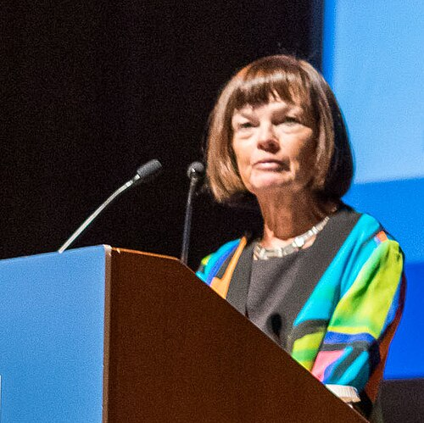

Donna Wills Scheeder (November 8, 1947 – March 7, 2022) was an American librarian, administrator, and community activist renowned for her leadership at the U.S. Library of Congress, her presidency of the International Federation of Library Associations and Institutions (IFLA) from 2015 to 2017, her presidency of the Special Libraries Association and her decades of service to Capitol Hill in Washington, D.C.

She was born in Buffalo, New York and attended Mount St. Joseph Academy, where she was a championship debater. She graduated from Georgetown University’s School of Foreign Service in 1969, one of only 25 women admitted in her undergraduate class.

Limited opportunities for women in the Foreign Service at the time led her to a career with Congress. She began in 1969 as a GS-5 library assistant at the Congressional Research Service (CRS) of the Library of Congress. Over more than four decades, she advanced through leadership roles, including Director of Law Library Services (for five years) and Deputy Chief Information Officer for CRS, retiring in March 2015. She was an early advocate for integrating computers into library work and introduced innovations such as the first collection of legal blogs and the Electronic Briefing Book product for members of Congress.

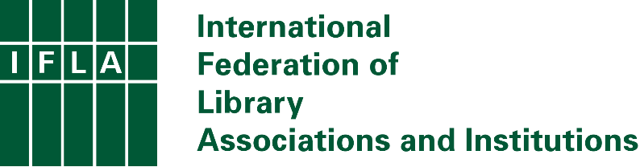

Donna Scheeder played a prominent role in the international library community. She served on the International Federation of Library Associations (IFLA) Standing Committees for Libraries and Research Services for Parliaments and for Law Libraries, and on the IFLA Governing Board from 2009 until her death (including as Treasurer, 2011–2013, and President-elect, 2013–2015).
As President (2015–2017) of the International Federation of Library Associations and Institutions (IFLA) her theme was “Libraries: A Call to Action.” She championed libraries’ contributions to the United Nations 2030 Agenda and Sustainable Development Goals, led the Global Vision process (a worldwide consultation of librarians), helped secure the Bill & Melinda Gates Foundation Legacy Grant for IFLA, and traveled extensively to represent the federation and train parliamentary librarians in many countries.
She was also a longtime member and past president of the Special Libraries Association (SLA), into whose Hall of Fame she was inducted.

In addition to her professional career, Scheeder was deeply engaged in Capitol Hill civic life for more than five decades. She chaired the Eastern Market Community Advisory Committee (EMCAC) for 18 years after her appointment in 2004. Following the devastating fire that destroyed much of the historic Eastern Market in April 2007, she played a central role in stakeholder coordination, merchant relocation during reconstruction, fundraising for relief, and advocacy that helped secure the building’s $22 million restoration and reopening in 2009.
She was a founding board member of the Hill Center at the Old Naval Hospital and served as its board president from 2020 until her death.

Scheeder received these honors:
- 1998: SLA Fellow (Special Libraries Association)
Recognized for outstanding contributions to the profession and the association.
- 2004: John Cotton Dana Award (Special Libraries Association)
Awarded for distinguished service and outstanding contributions to special librarianship.
Contemporary mention in LOC Annual Report context
- 2009: SLA Hall of Fame (Special Libraries Association)
- 2009: Federal Librarians Achievement Award (American Library Association – Federal and Armed Forces Libraries Round Table)
- 2009: Community Achievement Award (Capitol Hill Community Foundation)
Awarded in April 2009 for her leadership as chair of the Eastern Market Community Advisory Committee (EMCAC), especially her role in the post-fire restoration of Eastern Market.
- 2019: IFLA Honorary Fellow .Honored for her achievements as IFLA President (2015–2017), organizational transformation of IFLA, and advocacy for libraries in the UN Sustainable Development Goals.

Scheeder died peacefully at her Capitol Hill home on March 7, 2022.

Selected Publications and Presentations
Scheeder, Donna. “Change Is Our Tradition: A Message from SLA’s President.” Library Hi Tech News 17, no. 8 (August 2000).
Scheeder, Donna. “Innovation and Interconnectivity for Social Development.” Speech delivered at the United Nations Commission for Social Development, New York, January 30, 2018..
Scheeder, Donna, and Steve Witt. “Libraries: A Call to Build the Action Agenda.” IFLA Journal 42, no. 2 (June 2016): 83–84.
Presidential Addresses and Speeches (Published by IFLA)
Scheeder, Donna. Acceptance Speech. Delivered at the 81st IFLA World Library and Information Congress, Cape Town, South Africa, August 2015.
Scheeder, Donna. “Address by the President.” Delivered at the IFLA General Assembly, 2016..
Scheeder, Donna. Opening Address. Delivered at the IFLA World Library and Information Congress (WLIC), 2016.
Scheeder, Donna. Keynote Speech on “Libraries in Support of Sustainable Development.” Delivered at the opening of Bulgaria’s 12th National Library Week, May 9, 2017.

Sources

Donna Scheeder, “Change Is Our Tradition: A Message from SLA’s President,” Library Hi Tech News 17, no. 8 (August 2000).
"Donna Scheeder 1947-2022". The Washington Post. Archived from the original March 13, 2022.
IFLA Honorary Fellow .Honored for her achievements as IFLA President (2015–2017), organizational transformation of IFLA, and advocacy for libraries in the UN Sustainable Development Goals.
“Obituary for Donna Wills Scheeder.” John T. Rhines Funeral Home.
O’Gorek, Elizabeth. “Donna Scheeder: 1947 to 2022.” Hill Rag, April 7, 2022.
“Vale Donna Scheeder 1947-2022.” International Federation of Library Associations and Institutions, March 8, 2022.
Wikipedia. “Donna Scheeder.” Wikipedia.

Submitted by ALA Member

