Coleen Cole Salley - 1929 -2008

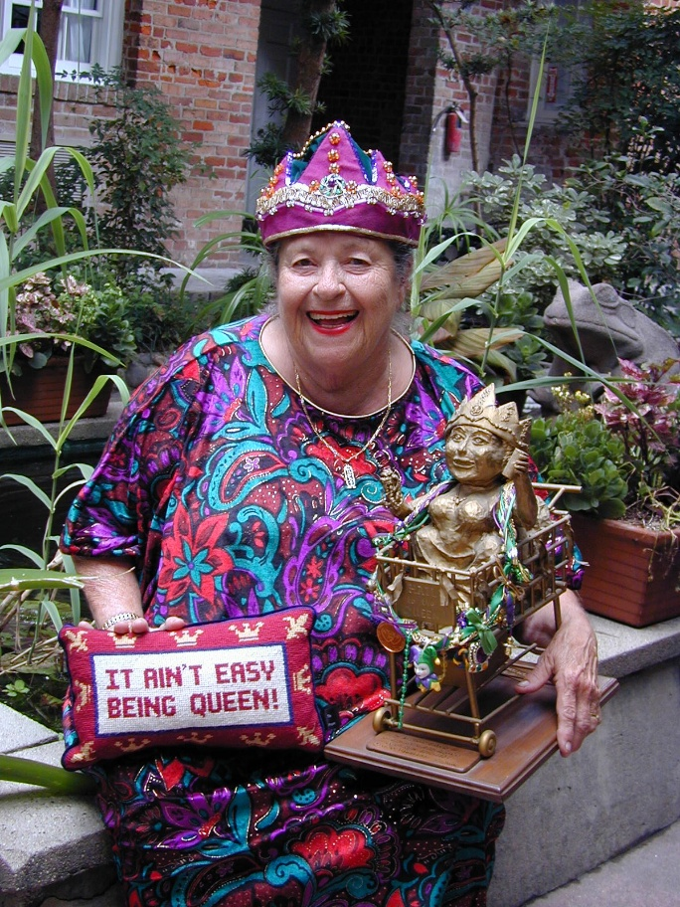

Coleen Cole Salley (c. 1929 – September 16, 2008) was a celebrated American storyteller, children’s literature expert, author, educator, and library advocate, best known for her vibrant performances and the popular Epossumondas picture book series.

She was born in Louisiana and began her career in the 1950s as an elementary school teacher. She later earned a Master of Library Science from Louisiana State University.

She joined the faculty at the University of New Orleans in 1964. She taught children’s literature and library science there for thirty years, retiring in 1994 as Distinguished Professor of Children’s Literature and Library Sciences (Professor Emerita).

Salley gained national and international renown as a master storyteller, captivating audiences of all ages for more than forty years with Louisiana folk tales, Southern stories, and original tales. She performed extensively across the United States and in other countries.

As an author, Salley wrote picture books, most notably the humorous Epossumondas series. These works drew on Southern folklore and appealed to young readers with their wit and charm. She also produced storytelling recordings.

Original children’s books by Coleen Salley.

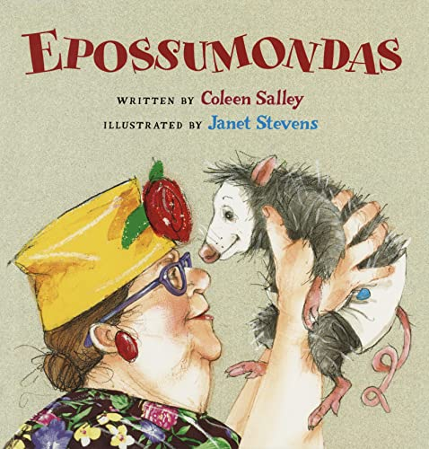

- Salley, Coleen. Who’s That Tripping Over My Bridge? Illustrated by Amy Jackson Dixon. Gretna, LA: Pelican Publishing, 2002.

- Salley, Coleen. Epossumondas. Illustrated by Janet Stevens. San Diego: Harcourt, 2002. Narrated here at You Tube: Epossumondas Book 1 by Coleen Salley · Audiobook preview

- Salley, Coleen. Why Epossumondas Has No Hair on His Tail. Illustrated by Janet Stevens. San Diego: Harcourt, 2004.

- Salley, Coleen. Epossumondas Saves the Day. Illustrated by Janet Stevens. San Diego: Harcourt, 2006.

- Salley, Coleen. Epossumondas Plays Possum. Illustrated by Janet Stevens. San Diego: Harcourt, 2009.

The Krewe of Coleen

Coleen Salley’s distinctive style made her a beloved figure in New Orleans, where she was affectionately known by many names, including “Queen Coleen.”

The Krewe of Coleen was a whimsical and beloved Mardi Gras tradition in New Orleans centered on Coleen Salley, who was affectionately known as Queen Coleen or the Grocery Cart Queen.

It was founded around 1974 by Salley along with her children and a close circle of friends. The krewe began informally but quickly gained a cult following for its eccentric and humorous approach to Carnival. Its signature element was Salley’s iconic grocery cart, which she began using as a makeshift throne after receiving one as a gift.

Parades often featured playful antics, such as the cart being dramatically “cart-napped,” lively chants of “Make way for the Queen,” music led by the Howell brothers, and participants wearing decorated colander hats.

Coleen Salley reigned as the sole monarch of the Krewe of Coleen since its founding in 1974 and served as Queen of the Krewe de Vieux in 2004. (more images at Coleen Salley.” Mardi Gras Traditions).

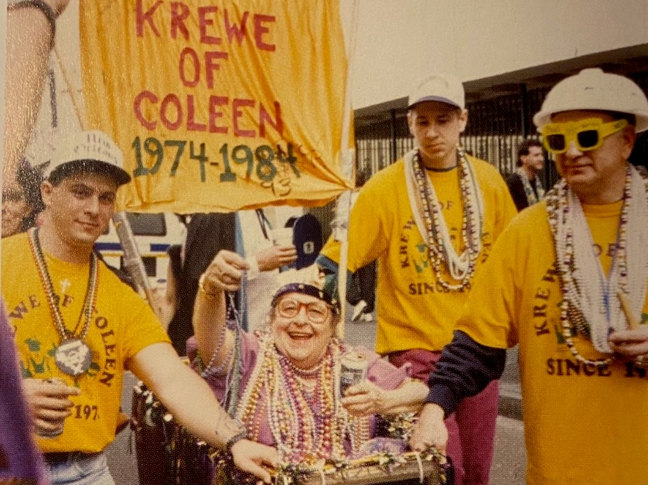

A passionate advocate for literacy and libraries, Salley served as president of the Louisiana Library Association and was a longtime active member of the American Library Association.

In 2004, she founded the Coleen Salley / Bill Morris Literacy Foundation to bring children’s book authors and illustrators to schools in underserved communities. She was a staunch supporter of libraries, librarianship, and access to books for children.

Coleen Cole Salley passed away on September 16, 2008 in New Orleans. A funeral Mass was held at Our Lady of Guadalupe Church in the French Quarter.

Her legacy continues through her books, storytelling recordings, the literacy foundation she established, the Coleen Salley Storytelling Endowment at the University of Southern Mississippi, and the countless children, educators, and librarians she inspired over decades.

Storytelling Narrations

Salley, Coleen, narrator. Cajun Night before Christmas / Gaston the Green Nose Alligator and Cajun Night before Christmas / Cajun Night after Christmas. Gretna, LA: Pelican Publishing Company.

Salley, Coleen, narrator. Louisiana Folk Tales, Texas Folk Tales, and Georgia Folk Tales. [Place of publication not specified]: Gateway Productions, [undated collection; produced during her active storytelling career].

Salley, Coleen, narrator. Tub People. New York: HarperCollins, [undated; part of her recorded storytelling repertoire].

Salley, Coleen, narrator. Read-aloud Riches, Eight Favorites and Big Mama Makes the World. Somerville, MA: Candlewick Press, [undated; part of her recorded storytelling repertoire].

Salley, Coleen, narrator. Cocodrie Cajun Classics. [Place of publication not specified]: More than a Card Press, [undated].

Salley, Coleen, narrator (with others). Three Classy Storytellers Read Three Classy Tales. [Place of publication not specified]: Sea Star Books, [undated].

Sources

American Library Association Council. “Memorial Resolution Honoring Coleen Cole Salley.” 2008-2009 ALA Memorial #12. Adopted July 15, 2009, Chicago, Illinois.

“Coleen Cole Salley.” The Times-Picayune, September 2008.

“Coleen Salley. ” Mardi Gras Traditions. Accessed June 19, 2026.

HarperCollins Publishers. “Coleen Salley.” Accessed June 19, 2026.

School Library Journal. “Obituary: Coleen Salley.” School Library Journal, September 17, 2008.

University of Southern Mississippi. “The Coleen Salley Storytelling Award.” Fay B. Kaigler Children’s Book Festival. Accessed June 19, 2026.

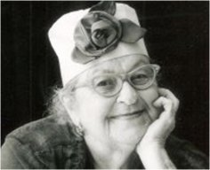

Submitted by Kathleen de la Peña McCook

