Stanley D. Stevens – 1933-2022

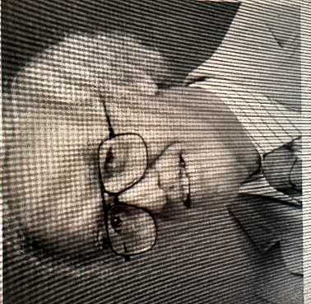

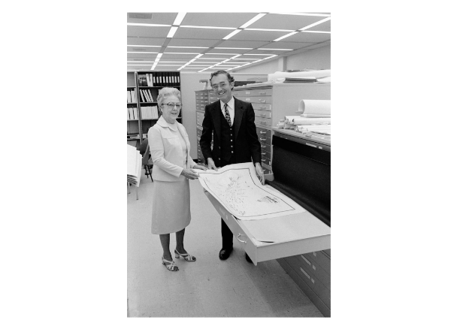

Stanley D. Stevens (1933–2022) was a map librarian at the University of California, Santa Cruz (UCSC), a founding leader in professional map librarianship organizations, and a dedicated local historian of Santa Cruz County.
Stevens was the first person to receive the highest honors from all three major U.S. map-librarianship organizations:
- Geography and Map Division of the Special Libraries Association (Honors Award, 1981)
- Western Association of Map Libraries (Honorary Lifetime Membership)
- ALA Map and Geography Round Table (now Map and Geospatial Information Round Table (MAGIRT). (Honors Award, 1992)

He attended San Jose State University, where he studied political science with an emphasis on international relations. After a brief stint working at the United Nations, he returned to San Jose and took a position in the San Jose State University library.

In 1965, shortly before UCSC welcomed its first students, Stevens joined the staff of the new campus library (McHenry Library). He served as its map librarian for nearly 30 years, until his retirement in 1993, and was later named Librarian Emeritus.
Starting with essentially no collection, he built an extensive and highly regarded map library that served students, faculty, researchers, and the local community. He deliberately focused the holdings on Santa Cruz and surrounding areas (including parts of Santa Clara County) while also acquiring significant historical materials, such as records from the F.A. Hihn Company—a major 19th-century Santa Cruz business empire. Colleagues praised the collection for its relevance to both academic and local needs.
He was WAML Representative to Cartographic Users Advisory Council, 1978-1986 and
Chairman of CUAC, 1982-1986.
In 1994 he established the Santa Cruz County History Journal and in 2000 he was named Historian of the Year by the History Forum at the Santa Cruz Museum of Art & History.

Professional Activity

Stevens was a charter member of the Western Association of Map Libraries (WAML), which he helped establish in 1967. He served as its first president (1967–1968), its first editor of the Information Bulletin, and treasurer for 20 years (1969–1989). He chaired the committee that drafted WAML’s constitution and by-laws and advocated for the inclusive name “Map Libraries” (rather than “Map Librarians”) so the organization would welcome all library workers regardless of formal credentials or rank.
Stevens was also an early member of the California Map Society.
He was active in the Map and Geospatial Information Round Table (MAGIRT) of the American Library Association. He received the inaugural Hammond Incorporated/MAGERT Award for the best English-language paper on map librarianship. The winning article, “Map Librarianship: Suggestions for Improvement,” appeared in Wilson Library Bulletin 60, no. 2 (October 1985): 33–36, 79. It addressed evolving relationships between map librarians and federal mapping agencies and was praised for advancing the field.
Stevens was awarded the MAGIRT Honors Award in 1992, the Round Table’s premier recognition for “outstanding achievement and major contributions to map and geospatial librarianship and to the Round Table”. The citation highlighted his scholarship, service, collection development, mentoring, and overall impact on the profession.

Community

Stevens was actively involved in Santa Cruz community life. He supported the ACLU, the Genealogical Society, the Santa Cruz Museum of Art & History, and other historical organizations. In 1966 he helped found The Catalyst (an early local publication) in the old St. George Hotel.
Stevens died on October 25, 2022). Memorial contributions were suggested to Santa Cruz County historical museums or societies.

Selected Publications

Stevens, Stanley D. “Planning a Map Library? Create a Master Plan!” Special Libraries (1972).
Stevens, Stanley D. “Map Librarianship—Today and Tomorrow.” Special Libraries (1973).
Stevens, Stanley D. “Map and Aerial Photo Collections in the United States: Survey of the Seventy Largest Collections” (1981; published/submitted for publication).
Stevens, Stanley D. “Map Librarianship: Suggestions for Improvement.” Wilson Library Bulletin 60, no. 2 (October 1985): 33–36, 79.
Stevens, Stanley D. “Personal Reflections and Perspectives” (first 20 years of WAML). WAML Information Bulletin 19, no. 3 (June 1988); republished in 49, no. 1 (November 2017).
Stevens, Stanley D., comp. Every Structure Tells a Story: How to Research the History of a Property in Santa Cruz County. Santa Cruz County Historical Trust, Occasional Research Papers, 1990.
Stevens, Stanley D. “Biographical References to Charley Parkhurst” (1993).
Stevens, Stanley D. Variants on the Santa Cruz Railroad Company and related subjects (1997).
Stevens, Stanley D. A Researcher’s Digest on F.A. Hihn and His Santa Cruz County Pioneers. Hihn-Younger Archive / University Library, UCSC, 1998.
Stevens, Stanley D., ed. The Society of California Pioneers of Santa Cruz County. Santa Cruz County History Journal No. 4 (1998).
Stevens, Stanley D. Index to the Watsonville Pajaronian for the Year 1890 (2008). Stevens, Stanley D. “German Immigrant Frederick A. Hihn” (article, 2011).
Stevens, Stanley D. Hihn-Younger Biographies (2014).
Stevens, Stanley D. “The Grand Old Man of Santa Cruz County”: F.A. Hihn. (compiled and annotated from 1928 text, 2014).
Stevens, Stanley D. African American Churches in the City of Santa Cruz, California: The Early Years (article, 2016).
Stevens, Stanley D. Cumulative Index to Santa Cruz County History Journal Nos. 1–8 (1994–2016) (originally September 2016).
Stevens, Stanley D. Cumulative Index to Santa Cruz County History Journal Nos. 1–8 (revised edition edited by Joan Gilbert Martin, 2017).
Stevens, Stanley D. “50 Years Young – WAML 1967-2017: Some Personal Observations.” WAML Information Bulletin 49, no. 2 (2017).
Stevens, Stanley D. Index to the Watsonville Pajaronian for the Year 1890 (revised/transcribed 2018).
Stevens, Stanley D. Letters of F.A. Hihn & F.A. Hihn Company (transcribed and indexed from letter books, 2018; companion volume of abbreviations/terms/subject headings also 2018).
Stevens, Stanley D. Names on the Map: History of the 1889 “Hatch” Map, the “First” Official Map of Santa Cruz County, California. Santa Cruz Museum of Art & History, 2020; also dated October 2019 in some editions.
Stevens, Stanley D. Attempted Impeachment of Judge Lucas Flattery Smith (transcribed/compiled sections, 2021).
Stevens, Stanley D. Index to California City, County & Regional Histories, 1867–1910 (33 rolls of microfilm at UCSC Library, 2021).
Stevens, Stanley D., co-compiler with Frank Perry, Barry Brown, and Rick Hyman. “Notes on the History of Santa Cruz Wharves.” Online History Journal of Santa Cruz County (2022).

Sources
Gelfand, Julia. “1992 MAGERT Honors Award.” Baseline 13, no. 4 (August 1992): 4.
Rankin, Katherine. “Memorial for Stanley D. Stevens (1933–2022).” WAML Information Bulletin 54, no. 2.
Stanley D. Stevens. Interview Capitola Memories Project. Capitola Historical Museum, February 24, 2018. Video, 1:22:00.
Stevens, Stanley D. “50 Years Young – WAML 1967-2017: Some Personal Observations.” WAML Information Bulletin 49, no. 2 (2017).
“Stanley Stevens.” Santa Cruz Sentinel .November 8, 2022.

Submitted by Kathleen de la Peña McCook

