Ann Laurie Pechacek- 1969-2021

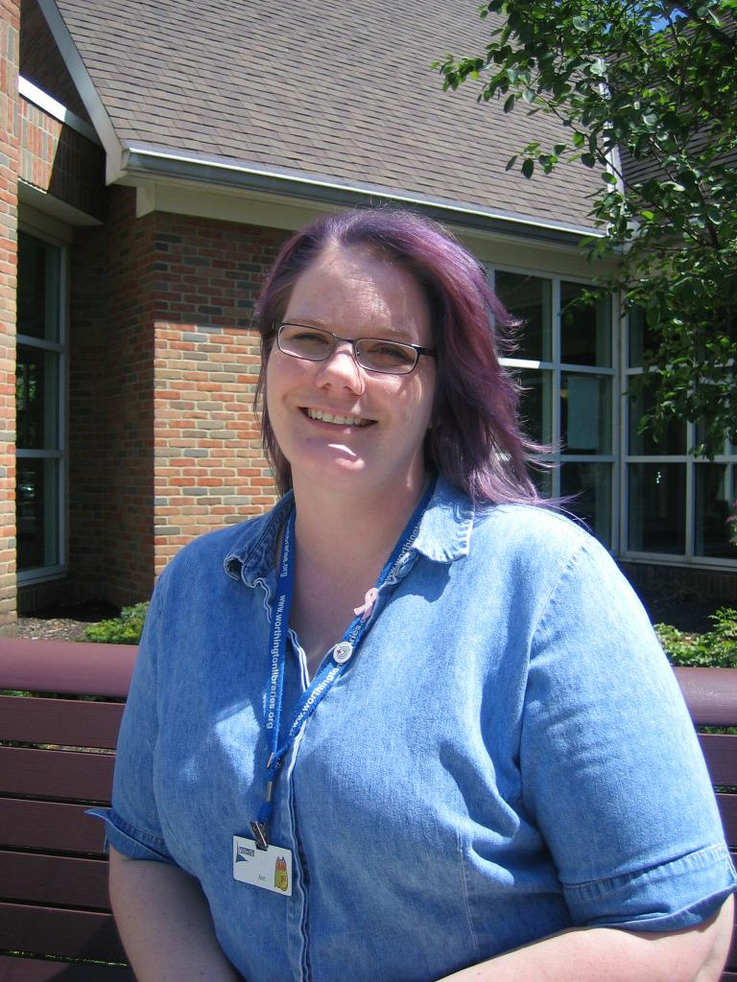

Ann Laurie Pechacek (December 16, 1969 – July 30, 2021) was an American public librarian specializing in teen and young adult services, best known for her two-decade career at Worthington Libraries in Worthington, Ohio, and her active involvement in the Young Adult Library Services Association (YALSA).
She was born
in Muskogee, Oklahoma, and attended the University of Oklahoma, graduated from the University of Alaska in Anchorage, and earned her Master’s degree in Library Science from the University of Southern Mississippi.
Ann Laurie
Pechacek joined Worthington Libraries in 2001 and spent 20 years there, beginning as a teen/young adult librarian at the Old Worthington branch (and also serving at the Northwest Library). She was appointed lead librarian at the Old Worthington branch in 2012, a role she held until her death.
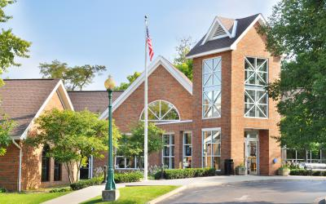
Colleagues and patrons remembered her as exceptionally dedicated to engaging reluctant readers—especially children and teens—through creative programs, heartfelt booktalks, and personal mentorship that turned many into lifelong readers and learners.
In 2006, she famously dyed her hair purple as a reward after teens voted on the color for high participation in the Summer Reading Club. She was described by colleagues as a “ray of sunshine,” positive, welcoming, funny, and deeply supportive; one coworker noted her off-the-cuff, passionate book talks came “from the heart.”
Professional organizations

Pechacek made significant contributions at the national level through YALSA (a division of the American Library Association). She served on multiple prestigious committees, including:

- Michael L. Printz Award for Excellence in Young Adult Literature,
- William C. Morris YA Debut Award,
- Quick Picks for Reluctant Readers,
- Best Books for Young Adults, and
- YALSA Teens’ Top Ten.

She wrote multiple articles for the Young Adult Library Services journal and received the 2020 Friends of YALSA Distinction.

Beyond librarianship, Pechacek loved travel (road trips and international journeys alike), exploration through books and cultures, the arts, and live music.
Ann Laurie Pechacek passed away peacefully July 30, 2021. Worthington Libraries closed in her honor for her Celebration of Life service on August 7, 2021.
Her legacy lives on in the readers she inspired and the librarians she mentored and supported.

Selected Publications

Pechacek, Ann L., and Sarah Cofer. “Teen Poets Sought for Contest.” This Week in Worthington, March 20, 2003.
Pechacek, Ann L. “Cool Teen Programs Are Planned.” This Week in Worthington, July 3, 2003.
Pechacek, Ann L., and Sarah Cofer. “Teens Have Time to Get ‘Authorized.’” This Week in Worthington, July 17, 2003
Pechacek, Ann L., and Sarah Cofer. “Hard-Working Volunteens Thanked.” This Week in Worthington, August 14, 2003.
Pechacek, Ann L., and Hillary Kline. “Library Lines: Feedback Rewards Staff for Job Well Done.” This Week Worthington , February 28, 2019.
Book Chapter:
Reuter, Kara, Sarah Cofer, Ann Pechacek, and Mandy R. Simon. “Following and Leading Teens Online: Using Digital Library Services to Reach Urban Teens.” In Urban Teens in the Library: Research and Practice, edited by Denise E. Agosto and Sandra Hughes-Hassell, Chapter 13. Chicago: American Library Association, 2010.

Sources

2020 Friends of YALSA.
American Library Association. “A Memorial Resolution Honoring Ann Pechacek.” Adopted June 27, 2022. PDF file.
“Ann Pechacek: Old Worthington lead librarian remembered for engaging younger readers.” The Columbus Dispatch, August 4, 2021.
“Ann Pechacek Obituary.” Dignity Memorial.
Worthington Libraries. “Librarian Ann Pechacek with Purple Hair.” Worthington Memory.

