Arthur “Art” Solomon Meyers – 1937-2023

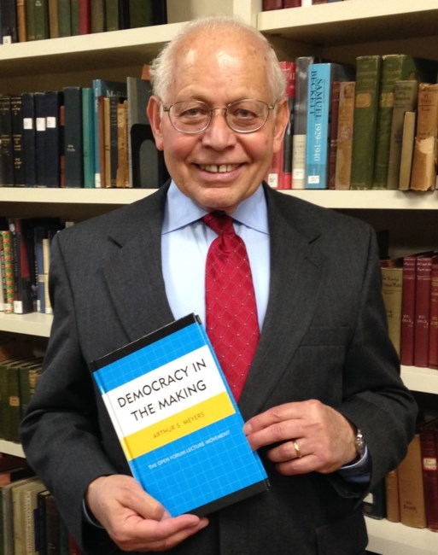

Arthur Solomon Meyers (December 14, 1937 – May 24, 2023) was a longtime librarian and library director known for his community-focused leadership, commitment to library services to labor, advocacy for public funding of libraries, and promotion of civil discourse through discussion groups. He was elected President of the Reference and Adult Services Division of the American Library Association for 1989–1990.

Art Meyers was born in New York City and grew up in the Bronx and Florida.
He served two years in the U.S. Army (peacetime deployment to Germany) before beginning a career in librarianship in the 1950s.
He earned a BA degree in History from the University of Miami and a master’s degree in library science from Columbia University.

Meyers served as a librarian and director at public libraries in New York City, Detroit, Baltimore, St. Louis, and Muncie (Indiana).
In Muncie the library won the first John Sessions Memorial Award in 1981. This ALA/RUSA award for service to labor was presented to Muncie Public Library (MPL) thanks to then Director Arthur Meyers (1980-1986). His presentation “Libraries and the Unemployed” discussed how libraries support the information needs of job seekers. The presentation led to MPL’s participation in Project MUNCIE (Muncie Unemployment Community Information Network). The program disseminated information to those seeking employment, and the library sponsored a community forum: “Coping with Unemployment in Muncie.”
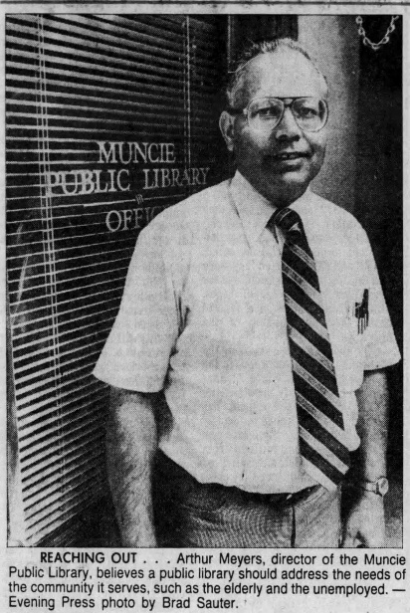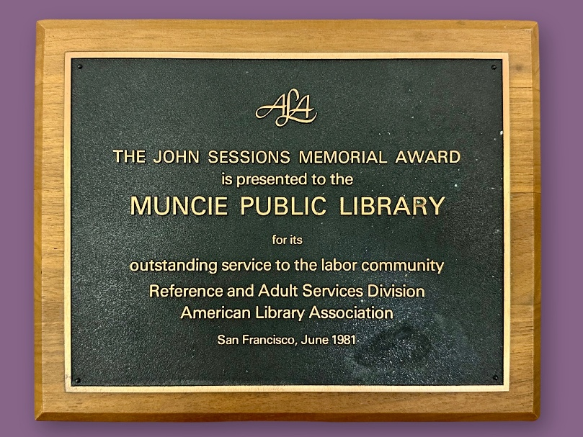
John Sessions was a former AFL-CIO (American Federation of Labor – Congress of Industrial Organizations) co-chair of the AFL-CIO/ALA Joint Committee on Library Service to Labor Groups. The “John Sessions Memorial Award recognizes a library or library system which has made significant effort to work with the labor community and by doing so has brought recognition to the history and contribution of the labor movement to the development of the United States” (RUSA, John Sessions Memorial Award).

While director of the Hammond Public Library, Meyers was Project Director for the National Endowment for the Humanities initiative titled “Books for Bicentennial Bookshelf” tied to the U.S. Constitution’s bicentennial celebrations. This grant aligned with Meyers’ emphasis on humanities programming, grant-writing, and community engagement during his Hammond tenure (1986/87–1996/97). It overlapped with his LSCA-funded literacy and workforce projects (e.g., Hammond Workforce 2000). From October 1993 to September 1994, the Hammond Workforce 2000 project provided equipment and materials to extend literacy efforts to older adults at the Hammond Public Library.

In May 1997, Meyers was appointed director of Russell Library in Middletown, Connecticut, serving for 19 years until his retirement in February 2016. During his tenure, he transformed the library into a vibrant community hub amid the rise of the internet era. He emphasized listening to patrons’ needs rather than imposing top-down programs—leading to strong job-and-career services (including interview coaching and office-skills classes), children’s programming, historical and cultural exhibits, and teen offerings.
He presided over the library’s annual naturalization ceremonies around the Fourth of July, drawing federal judges, U.S. senators, state officials, and local leaders to make the events especially meaningful for new citizens.

Professional Activity

Arthur Meyers held several leadership and committee roles in the American Library Association (ALA), primarily within its Reference and Adult Services Division (RASD, later renamed RUSA).
He was co-chair, Cooperative Reference Service Committee, RASD, ALA (circa 1983.
He was elected President, Reference and Adult Services Division (RASD), ALA (1989–1990). He served a full one-year term as the elected president of RASD following the 1972 merger of the Adult Services Division and Reference Services Division.
Meyers was acknowledged for providing input and assistance for the 1999 revision of the “Guidelines for Library Service to Older Adults Library Services to an Aging Population Committee “ (Management and User Services Section [MOUSS] of RUSA), ALA.

The Open Forum Movement and Public Learning
Meyers was particularly noted for fostering civil dialogue. A plaque installed at Russell Library in his honor reads in part:
“During his tenure as Director of Russell Library, Arthur Meyers engaged the entire community. His special warmth encouraged diverse populations to connect and discuss issues in the Open Forum style… Art established local groups for discussions on a variety of subjects; many lives have been enriched through his efforts.”

Meyers wrote Democracy in the Making: The Open Forum Lecture Movement. (Lanham, MD: University Press of America, 2012). His volume recounted the largely forgotten Open Forum lecture movement (1908–circa 1941), which began at Boston’s Ford Hall Forum and spread to hundreds of communities nationwide. The Open Forum lecture movement was a pioneering early 20th-century American initiative in adult education and democratic public discourse which emphasized free speech, open discussion, and community-based learning on controversial social, economic, and political issues. It was Meyers’ contention that the Open Forum’s emphasis on respectful, evidence-based dialogue remains relevant amid polarized public discourse.

Meyers passed away May 24, 2023.

Selected Publications

Meyers, Arthur S. “The Public Library and Ethnic Heritage.” Indiana Libraries 2, no. 4 (1982).
Meyers, Arthur S., and Deborah J. Somerville. Hammond Workforce 2000: A Three-Year Project. October 1989 to September 1992. ERIC Document ED361007. Hammond, IN: Hammond Public Library, 1992. (Co-authored final report on a Library Services and Construction Act–funded adult literacy and job-skills project at Hammond Public Library; includes a related third-year summary titled: Workforce 2000: Bringing Literacy Home.)
Meyers, Arthur S. “Building a Partnership: Library Service to Labor.” American Libraries 30, no. 7 (August 1999): 52–55.
Arthur S. Meyers, “W. E. B. Du Bois and the Open Forum: Human Relations in a ‘Difficult Industrial District,’” Journal of Negro History 84, no. 2 (Spring 1999): 192–205. (Examines Du Bois’s lectures within the movement.)
Meyers, Arthur S. “A Fifty-Five Year Partnership: ALA and the AFL-CIO.” Library Trends 51, no. 1 (Summer 2002): 36–49.
Arthur S. Meyers, “‘A Sturdy Core of Thinking, Fact Seeking Citizens’: The Open Forum Movement and Public Learning in Terre Haute and Hammond, Indiana, in the 1920s,” Indiana Magazine of History 99, no. 4 (December 2003): 353–369.
Meyers, Arthur S. Democracy in the Making: The Open Forum Lecture Movement. Lanham, MD: University Press of America, 2012. (based on extensive research into the early 20th-century Open Forum movement; Meyers’ research files are preserved in the Meyers Open Forum Collection at Suffolk University.)
Gray, Alan Kirk, and Arthur Meyers. “A Strategic Plan for Russell Library, Middletown, 2013–2017.” Public Library Quarterly 32, no. 4 (2013): 322–332.

Sources
American Library Association. “Library Services to Older Adults Guidelines.” American Library Association.
“The Art of Civil Discourse: the late, great Arthur Meyers.” Open Studio Radio. July 9, 2023.
“Arthur Meyers Obituary - Centerbrook, CT.” Dignity Memorial. May 24, 2023.
Arthur Meyers Obituary (1937 - 2023) - Middletown, CT.” Legacy.com. May 26, 2023.
Eberhard, Neysa, Judy Quinlan, Douglas Ferguson, Arthur S. Meyers, Judith Tuttle, George M. Bailey, Helen B. Josephine, and Sandra Leach. “RASD Committees.” RASD Update 4, no. 1/2 (January/June 1983): 2–4.
Hansen, Andrew M. “RASD: Serving Those Who Serve the Public.” RQ 34, no. 3 (Spring 1995): 314–38.

Meyers Open Forum Collection (MS 114), 1885–2011, is the research collection Arthur S. Meyers donated to Suffolk University (housed in the Moakley Archive and Institute).
Direct link to the official finding aid . The collection contains 9 boxes of Arthur S. Meyers' research files related to his book, Democracy in the Making: The Open Forum Movement. The book, published in 2012, chronicles the history of the nationwide open forum movement, including the role of the Ford Hall Forum. The collection contains photocopies of letters, articles, and programs related to open forums and the movement’s proponents such as George W. Coleman and Mary Caroline Crawford.

Submitted by Kathleen de la Peña McCook

