Philip J. McNiff 1912–1994

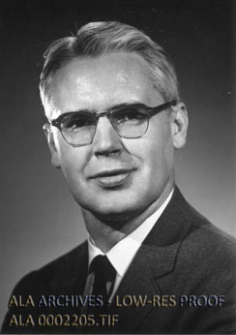

Philip J. McNiff was an American librarian whose long career advanced undergraduate library services at Harvard and modern public library administration at the Boston Public Library (BPL).
He played a key role in developing specialized undergraduate collections, professional library organizations, and urban library services during the mid-20th century.
McNiff began his library career in 1926 as a student assistant at the Brookline (Massachusetts) Public Library. He earned his bachelor’s degree from Boston College in 1933 and worked at the Newton Free Library, serving as an assistant and then as librarian of the West Newton branch (1935–1940). In 1940 he received his B.S. in Library Science from Columbia University and became head of the cataloging department at Newton Free Library.

In 1942 he joined the Harvard College Library as a reference assistant. He advanced rapidly, serving as superintendent of the reading room (1943–1948), librarian of the Lamont Library (1948–1956)—the first U.S. library designed specifically for undergraduates—and assistant librarian of Harvard College (1949–1956).
In 1954 McNiff joined the Harvard Faculty of Arts and Sciences. He was appointed associate librarian of Harvard College in 1956 and Archibald Cary Coolidge Bibliographer in 1962. [note: the Archibald Cary Coolidge Bibliographer was tied to building and managing Harvard’s major international and Slavic collections, reflecting the legacy of Archibald Cary Coolidge as a pioneering Harvard librarian and scholar who greatly expanded foreign-language holdings in the early 20th century].
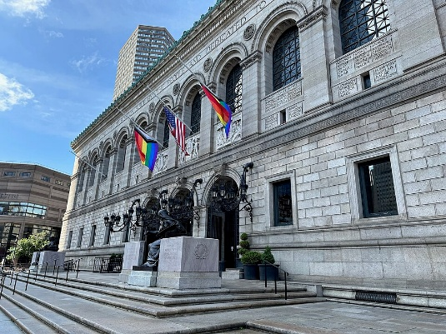
McNiff succeeded Milton E. Lord as Director and Librarian of the Boston Public Library in 1965. He led the institution during a transformative era that included planning and construction of the modern Johnson Building the addition to the historic McKim building.
His tenure emphasized service to diverse urban populations, collection development, and adaptation to contemporary needs. He later held the title of Director Emeritus.

Professional Activity
Philip J. McNiff began his involvement in Massachusetts library organizations in the early 1940s, serving as secretary of the Massachusetts Library Association (1943–44). He was later elected president of the same association (1952–54).
During the 1950s and 1960s, he served on the advisory boards of the New England Library Association (NELA), Cambridge Center for Adult Education, Newton College of the Sacred Heart, and Newton Junior College, while also acting as a member and later chairman of the Boston College Visiting Library Committee.
In the same period, he held several state-level positions, including membership on the Massachusetts Library Commission to Study State Aid to Public Libraries, the Massachusetts Board of Higher Education Advisory Committee on Library Needs in Public Institutions of Higher Education, and the Massachusetts Board of Library Commissioners Advisory Committee on the Library Services and Construction Act.
He also chaired the Massachusetts Library Development Committee and the Special Library Committee for Drafting Personnel Standards for Regional Public Library Systems, and served as a member of the Special Advisory Committee on Certification of Librarians.
Philip J. McNiff was elected to the American Library Association Council for 1954–1961 and
elected president of the Association of College and Research Libraries (ACRL) for 1969–1970.

McNiff was married to Yen-Tsai Feng, a librarian who served at institutions including Harvard and Wellesley College.
He died in November 1994.

Selected Publications
McNiff, Philip J. “The Charging System of the Lamont Library.” Harvard Library Bulletin 3, no. 3 (Autumn 1949): 438–40.
McNiff, Philip J., and Edwin E. Williams. “Lamont Library: The First Year.” Harvard Library Bulletin 4 (Spring 1950): 203–12.
McNiff, Philip J., and members of the library staff, comps. Catalogue of the Lamont Library, Harvard College. Cambridge, MA: Harvard University Press, 1953.
McNiff, Philip J. “Foreign Area Studies and Their Effect on Library Development.” College & Research Libraries 24, no. 4 (1963): 283–89.
McNiff, Philip J., comp. A List of Book Dealers in Underdeveloped Countries. Chicago: American Library Association, Acquisitions Section, Policy and Research Committee, 1963.
McNiff, Philip J. Freedom and Responsibility. 1966.
McNiff, Philip J. “Book Selection and Provision in the Urban Library.” The Library Quarterly 38, no. 1 (January 1968): 58–69.
McNiff, Philip J., comp. Twelve Mayors of Boston: 1900–1970. Boston, 1970.
McNiff, Philip J., ed. Switzerland, a View from Boston: Essays in Tribute to Dr. Freddy Homburger. Boston: Boston Public Library, 1984.
McNiff, Philip J. “The Role of the National Library at Home and Abroad.” Journal of the National Central Library 13, no. 1 (April 1987): 29–42. {note: 國立中央圖書館館刊, Guó lì Zhōng yāng Tú shū guǎn Guǎn kān is a scholarly journal published by Taiwan’s National Central Library.

Sources

American Library Association Archives. “Philip J. McNiff.” Photograph, ca. 1970. Library Photographic Vertical File. Accessed June 14, 2026.
American Library Association. “McNiff Is ACRL President-Elect.” College & Research Libraries News, 29, no. 4 (July/August 1968).
American Library Association. “Philip J. McNiff, former director and librarian emeritus of the Boston Public Library (BPL), died in November.” College & Research Libraries News. v 56,no 5, 1995.
“Philip McNiff replaced Milton Lord as the Director of the Library in 1965” in ” Boston Public Library Central Branch, architectural/historical report. (November 16, 2000).

Submitted by Kathleen de la Peña McCook

