Mabel Williams (1887 – 1985)

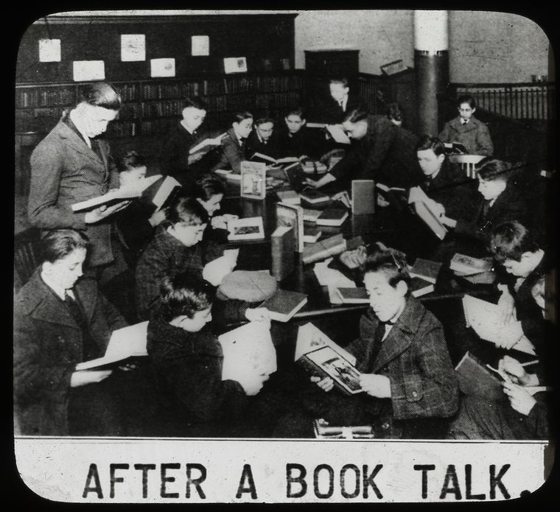
School visit to a branch ca. 1920s from blog post by Rouyer “How Did YA Becomes YA?

Mabel Williams (May 31, 1887 – November 17, 1985) was an American librarian who played a foundational role in developing public library services for young adults at the New York Public Library (NYPL).
Her work helped bridge the gap between children’s and adult library collections, established dedicated teen spaces and reading lists, and contributed significantly to the emergence of young adult literature as a recognized category.

Mabel Williams was born in Newton Centre, Massachusetts. She joined the NYPL staff in 1916. In 1919 Anne Carroll Moore—the influential Director of Work with Children at NYPL—promoted her to the newly created position of Supervisor of Work with Schools. Williams held this role (later expanded to encompass “Work with Schools and Young People”) until her retirement in 1952.

At the time, teenagers were frequently viewed as disruptive in children’s rooms or were expected to use school libraries exclusively. Williams advocated for and implemented specialized services tailored to their needs, interests, and reading levels. She created dedicated shelves and collections in NYPL branches by selecting books from both children’s and adult sections that suited adolescent readers. By 1940, she had helped establish teen-specific spaces in eight NYPL branches.

A landmark achievement came in 1929, when, under her direction, the NYPL published its first annual list of recommended books for teenagers (initially titled Books for Young People now known as Best Books for Teens ). This list formalized recreational reading guidance for teens and helped shape the young adult book category by identifying and promoting suitable titles .
Williams supported experimental initiatives, including granting her protégé Margaret Scoggin broad freedom in the early 1940s to develop the Nathan Straus Branch (an old milk laboratory converted into a dedicated young adult library space). This branch featured browsing rooms, social areas, and opportunities for teens to interact with books, authors, editors, and publishers, serving as a model for teen engagement and demonstrating that well-chosen books could act as “ice-breakers” for library visits.

Mabel Williams
was active in the American Library Association. She was
Chair of the subcommittee that produced the ALA publication: The Public Library–Plans for the Teen Age (1948). This was part of ALA’s “Planning for Libraries” series. The subcommittee operated under the Division of Libraries for Children and Young People.
She was honored in 1980 with the Grolier Award by the American Library Association which recognizes a librarian who has made outstanding contributions to the stimulation and guidance of reading by children and young people. It was a prestigious professional recognition in the field of youth services librarianship, often highlighting lifetime or long-term achievement.
Mabel Williams’s career spanned a transformative period in librarianship. Her emphasis on recreational reading, age-appropriate collections, social library spaces, and the transition from children’s to adult literature laid essential groundwork for modern young adult librarianship.

She retired in 1952 and died November 17, 1985.

Publications
Mabel Williams’ most significant “publications” were the curated and published book lists she developed at NYPL. These were not just internal tools—they were printed, distributed widely across the U.S., and helped standardize recommendations for teen reading at a national level.
The “Books for Young People” (NYPL list) was compiled by Mabel Williams (as Chairman of the Book Committee for Young People at the New York Public Library).
This was an influential annual or periodic book list that mixed titles from adult and children’s collections suitable for teenagers. It began as browsing shelf selections around 1929 and evolved into a published list sent nationally to schools and libraries.
American Library Association. The Public Library–Plans for the Teen Age. Chicago: American Library Association, 1948. Planning for Libraries, no. 7. Prepared by the Committee on Post-War Planning, Division of Libraries for Children and Young People and its Section, The Young People’s Reading Round Table; Mabel Williams, chairman.

Sources

Allen, A. K. “A Room (and Books) of Their Own: Young Adult Library Services and the Development of the Young Adult Category.” International Journal of Young Adult Literature, 2025.
Atkinson, Joan L. “Pioneers in Public Library Service to Young Adults.” Top of the News 43, no. 1 (Fall 1986): 27–44.
Campbell, Patty. Two Pioneers of Young Adult Library Services: A VOYA Occasional Paper. Lanham, Md.: Scarecrow Press, 1998. [profiles Mabel Williams and Margaret Edwards, with the Mabel Williams section drawing on a 1975 interview conducted by Mary K. Chelton].
Doherty, Alison. “How Librarians Helped Invent the YA Category of Books.” Book Riot, August 31, 2020.
“Grolier: Mabel Williams.” In “ALA Report,” American Libraries, 1980, 344.
Jenkins, Christine A. “The History of Youth Services Librarianship: A Review of the Research Literature.” Libraries & Culture, vol. 35, no. 1, Winter 2000, pp. 103-140.
Rouyer, Anne. “How Did YA Become YA?” New York Public Library (blog), April 20, 2015. Archived at Wayback Machine, March 12, 2022.
Rouyer, Anne. “Mabel Williams’s Legacy.” In “NYPL’s Mabel Williams: Giving Teens a Voice.” New York Public Library (blog), March 8, 2021.
“NYPL’s Mabel Williams: Giving Teens a Voice.” New York Public Library. March 8, 2021.

Submitted by ALA Member

