Adelaide B. Lockhart- 1917 – 1978

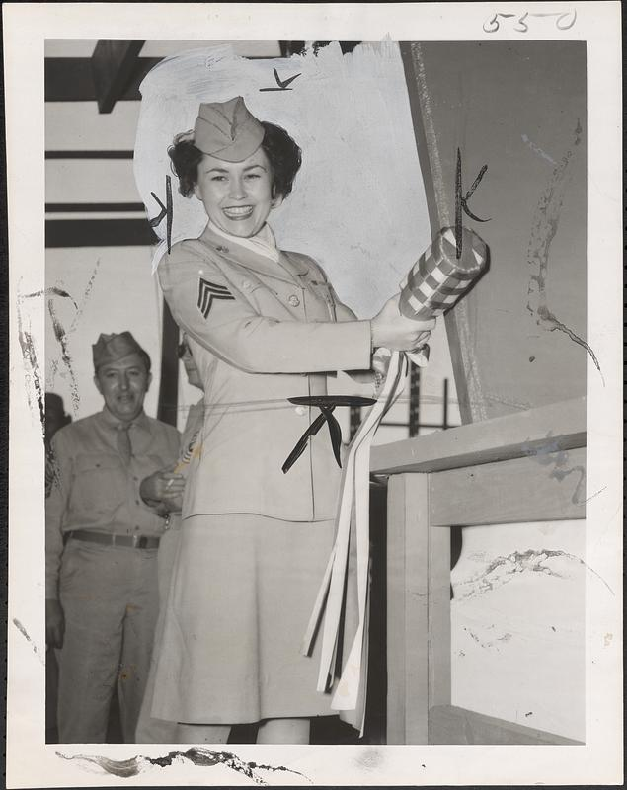

Sgt. Adelaide Lockhart, chosen as the Typical WAC at Drew Field, Tampa, Florida, poses just prior to swinging the champagne bottle and launching a Navy supply ship at the Tampa Shipbuilding Company's yards Sunday, October 29., 1944. Sgt. Lockhart was formerly a librarian in the Brockton Public Library.

Adelaide B. Lockhart (c. 1917 – January 15, 1978) was a prominent American academic librarian and library administrator, best known for her leadership at Dartmouth College in Hanover, New Hampshire. She rose from assistant librarian to Director of Library Services and was active in national and regional professional organizations.
Lockhart began her library career as an assistant at the Brockton (Massachusetts) Public Library.

Her early work was interrupted by service in the Women’s Army Corps (WAC) during World War II.

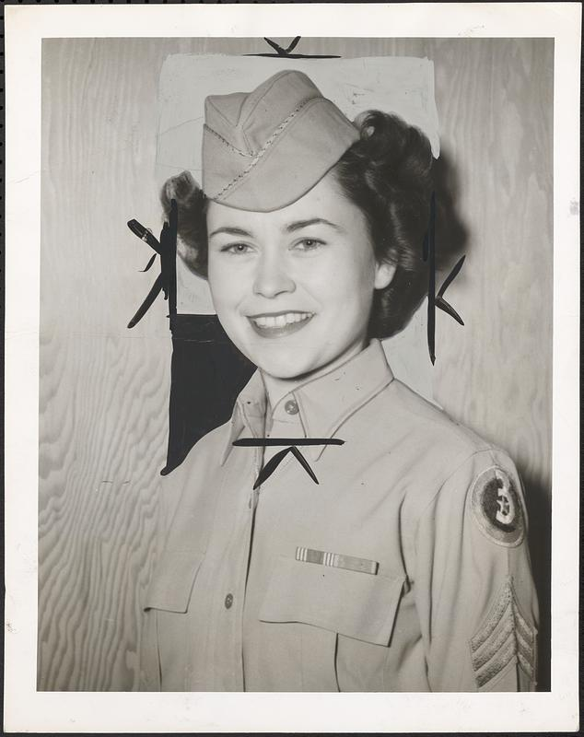
While in the Army she participated in the “Typical WAC” contest and was chosen to represent the army at dinners and on the radio.
After the war, Adelaide Lockhart joined the Boston Public Library staff, working in the young people’s room and the reference department.
She earned a bachelor’s degree in political science from Boston University in 1950. She then received a Master of Library Science (MLS) from Simmons College in 1951. She pursued additional graduate studies at the Sorbonne in Paris (1953) and at Western Reserve University (1954).

For seven and a half years, she served as a management research assistant at the Yale University Library before joining Dartmouth in 1960.
At Dartmouth, Lockhart started as assistant librarian and advanced to become the chief operational officer of the college’s library system as Director of Library Services. She was widely respected for her administrative expertise in academic librarianship.
She was active in professional circles throughout New England and nationally:
- President of the New England Library Association (1970–1971).
- Member of the Council of the American Library Association (ALA), where she served on the budget committee.
- Consultant to the ALA’s Micropublishing Projects Committee for many years.
In 1976, Simmons College presented her with its annual Alumni Achievement Award, citing her “distinguished career in academic librarianship and administration.”

She died on January 15, 1978.

Sources

"Deaths." Dartmouth Alumni Magazine, March 1978.
College & Research Libraries News. "People.” College & Research Libraries News 39 (1978).
College & Research Libraries News. "News from the Field." (1978)
Digital Commonwealth. “Sgt. Adelaide Lockhart.” Accessed June 12, 2026. From press release: “ Sgt. Adelaide Lockhart, former Brockton, mass., librarian, will act as sponsor at the launching of a navy supply ship at the Tampa shipbuilding company's yards here on Sunday afternoon, October 29. Sgt. Lockhart, chosen recently as the typical WAC at Drew Field, Tampa, Fla., will be the first WAC in this area to ever launch a ship. Since winning the typical WAC contest, the former Massachusetts girl has been the guest at a number of civic functions and has made several radio appearances.”
The Women’s Army Corps (WAC) was the women’s branch of the U.S. Army during World War II. It began as the Women’s Army Auxiliary Corps (WAAC), established by an act of Congress on May 15, 1942 (signed by President Franklin D. Roosevelt). The WAAC provided auxiliary support but lacked full military status. On July 1, 1943, it converted to the WAC, granting women official military rank, pay, and benefits equivalent to male soldiers (though they remained non-combat).

