Clement Chu-Sing Lau -1958-2020

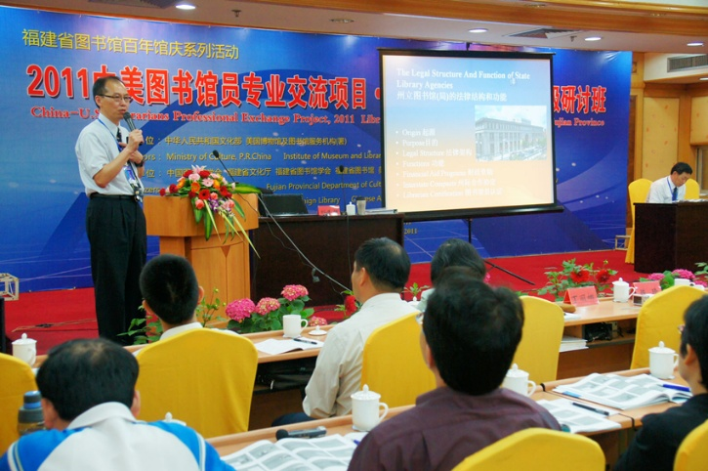

Clement Chu-Sing Lau (劉朱勝 / 刘朱胜) (c. 1958 – May 24, 2020) was a dedicated academic librarian, administrator, scholar, and active leader in international and Asian American librarianship.
Born in Hong he developed a strong appreciation for education, sports, and martial arts (including Kung Fu) from a young age. He earned a Bachelor of Arts in Library Science (with a minor in Chinese history) from National Taiwan University in Taipei.

After working as a language instructor and interpreter for the U.S. Department of State in Taiwan, Lau immigrated to the United States with his family in 1988.
Lau held multiple advanced degrees: a Master of Library Science from the University of Maryland, as well as an MBA, Master of Science in Management Information Systems, and a certificate in Nonprofit and Association Management from the University of Maryland Global Campus. He pursued doctoral studies in Education Policy and Administration.
He established a career in librarianship, holding positions including:
- Head of Technical Services at Trinity University (Washington, D.C.),
- Associate Director for Technical Services and Administration at the University of Baltimore Law,
- Associate Librarian for Technical and Collection Services at Hong Kong Baptist University Library,
- Associate Dean of Libraries and Director of the Zach S. Henderson Library at Georgia Southern University.

Clement Chu-Sing Lau published scholarly articles on topics including international librarianship, law librarianship, library assessment, and library architecture (in both English and Chinese). He co-authored A Handbook of Sinitic Languages, Dialects, and Non-standard Mandarin.
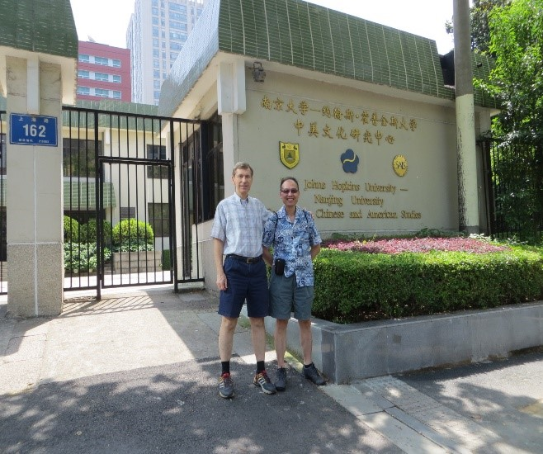

In 2013 Clement Chu-Sing Lau was honored by the Chinese American Librarians Association (CALA) Jing Liao Annual Award for the Best Research (also known as the Jing Liao Award).
This award recognizes excellence in library and information science research by CALA members across all media. Lau was honored for his two-part scholarly article series titled “American Public Library Law Research” (美国公共图书馆法研究), published in the Chinese journal Library (图书馆) in 2012. The work provided a thorough, well-organized introduction to the history, development, and legal framework of U.S. public libraries, serving as a valuable bridge for knowledge exchange between American and Chinese library communities.

Clement Chu-Sing Lau was involved with the Chinese American Librarians Association (CALA), serving on and co-chairing numerous committees and participating in ALA conferences.
He was also an active member of the American Library Association (ALA) and its International Relations Round Table (IRRT). His international engagement included presenting and organizing at conferences across regions, with a focus on building bridges between U.S. and Asian library communities. Colleagues remembered him as a mentor of high integrity who profoundly influenced those he worked with and guided.

Clement Chu-Sing Lau passed away on May 24, 2020.
The ALA and CALA honored him with a formal memorial resolution in June 2020. His legacy lives on through his family, scholarly contributions, and the many librarians he mentored.

Selected Publications

[Note: Lau published extensively in both English and Chinese, with a focus on international librarianship, U.S. library law, library assessment, subject librarian systems, and law librarianship].
Kubler, Cornelius C., and Clement Chu Sing Lau. A Handbook of Sinitic Languages, Dialects, and Non-standard Mandarin. Amherst, NY: Cambria Press, 2025.
Lau, Clement Chu Sing. “Assessing and Improving Library Services at Georgia Southern University.” Library Philosophy and Practice, 2018.

Lau, Clement. “Assess and Improve: A Case Study at Georgia Southern University Library.” In Proceedings of the International Conference on Embedded Education and Instruction of New Models of Library Service: The 4th International Conference of Beijing Academic Network Library, edited by C. Shi, L. Xiong, and M. B. Huang, 268–278. Beijing: Capital Normal University Press, 2017.

Lau, Clement Chu Sing, and M. E. Murtha. “Going Green and Repurposing Space: The University of Baltimore Debuts Its New Law Center, Slated to Receive LEED Platinum Certification.” AALL Spectrum 17 (2013): 23–24, 27.

Lau, Clement Chu Sing. “The Role of NGOs in China.” Quarterly Journal of Ideology 31, no. 3–4 (2009).
(Chinese, selected major works- from Google Scholar)
刘朱胜 [Lau, Clement Chu Sing]. “美国公共图书馆法研究” [American Public Library Law Research]. 图书馆 [Library] 2012, no. 3: 1–7. (Part 1) [Winner of the 2013 CALA Jing Liao Award]
刘朱胜 [Lau, Clement Chu Sing]. “美国公共图书馆法研究（续）” [American Public Library Law Research (Continued)]. 图书馆 [Library] 2012, no. 4: 1–7. (Part 2) [Winner of the 2013 CALA Jing Liao Award]
刘朱胜 [Lau, Clement Chu Sing]. “公共图书馆法--美国马里兰州介绍” [Public Library Law: An Introduction to Maryland, U.S.]. 图书馆 [Library] 2014, no. 5: 51–55, 71.

刘朱胜 [Lau, Clement Chu Sing]. “香港浸会大学图书馆学科馆员制度探究” [An Exploration of the Subject Librarian System at Hong Kong Baptist University Library]. 图书馆 [Library] 2016, no. 4: 13–18.

Sources

American Library Association. “A Memorial Resolution Honoring Clement Chu-Sing Lau.” 2019-2020 ALA Memorial #11. Adopted June 27, 2020.
Chinese American Librarians Association.
Chinese American Librarians Association (CALA), “The CALA Jing Liao Annual Award for the Best Research,” accessed June 22, 2026.
Georgia Southern University. “Clement Lau.” Scholars@GeorgiaSouthern. Accessed June 22, 2026.
Obituary / Community Notice. “Clement Chu-Sing Lau.” Greenbelt News Review, May 28, 2020.

Submitted by Kathleen de la Peña McCook

