Mary Larsgaard- 1946-2017

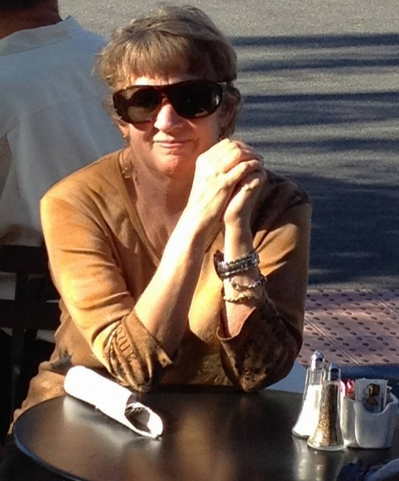

Mary Lynette Larsgaard (August 4, 1946–July 18, 2017) was a leading figure in map and geospatial librarianship, widely recognized as the author of the field’s foundational textbook and a pioneer in map cataloging, collection development, and digital geospatial initiatives. She served on Ad Hoc Organizing Committee that established the Map and Geography Round Table (MAGERT, now MAGIRT) in the early 1980s.
Mary Lynette Larsgaard dedicated nearly forty years to building and professionalizing map libraries, with a particular focus on topographic and geologic maps, metadata standards, and advancing the role of spatial data in academic libraries.

Mary Larsgaard earned the BA in geology from Macalester College in St. Paul, Minnesota in 1968, and an M.A. in Library Science at the University of Minnesota in 1969, and an M.A. in Geography from the University of Oregon.
Her professional career began in the 1970s at Central Washington State College (now Central Washington University) in Ellensburg, where she served as map librarian and contributed early writings on map collections.
In 1978 she published the first edition of Map Librarianship: An Introduction, which quickly became the standard text in the field.

From 1979 to 1988 she was the first Map Librarian at the Colorado School of Mines, where she single-handedly cataloged the entire collection, and expanded its size and scope.
In 1988 she moved to the University of California, Santa Barbara (UCSB), serving as Assistant Head (and later Head, 2008–2009) of the Map and Imagery Laboratory in the Davidson Library. She retired as Librarian Emerita and continued consulting and writing.

Professional Activity
Mary Larsgaard held leadership roles in three important American map library organizations: Western Association of Map Libraries (and she was also editor of its journal), the American Library Association’s Map and Geography Round Table (now Map and Geospatial Information Round Table MAGIRT), and the Special Libraries Association’s Geography and Map Division.
She was Chair of the Special Libraries Association’s Geography and Map Division (SLA G&M or GMD) in 1980. Her SLA involvement is most prominently tied to her 1980 chairmanship and the broader leadership that helped catalyze the creation of ALA’s Map and Geography Round Table (MAGERT/MAGIRT).
Mary Larsgaard was a founding member and early leader of the Map and Geography Round Table of the American Library Association (MAGERT, renamed MAGIRT—Map and Geospatial Information Round Table—in 2011). She served on the Ad Hoc Organizing Committee that established the round table in the early 1980s. On the first board of directors, she held the position of treasurer also acted as membership promotion chair.
She served as editor of base line, MAGERT’s official newsletter and wrote the regular “On the Cataloging/Cataloguing Front” column in base line for several years.
She helped form its Cataloging and Classification Committee (later serving on it, including as chair), participated in the Map Cataloging Discussion Group,
As MAGERT’s official representative, she contributed to the first edition of Cartographic Materials: A Manual of Interpretation for AACR2 and served (jointly with WAML) as representative to the Anglo-American Cataloguing Committee for Cartographic Materials second edition. Her work focused on advancing map cataloging rules and standards through ALA channels.
She was deeply involved in the Western Association of Map Libraries (WAML). She edited the WAML Information Bulletin.

Honors
1983- MAGIRT (then MAGERT) Honors Award in 1983 which recognizes outstanding achievement and major contributions to map and geospatial librarianship and to the Round Table.
1995. Special Libraries Association Geography and Map Division Honors Award.
2007. Nancy B. Olson Award (formerly the OLAC Award) is OLAC’s highest honor. It recognizes outstanding contributions to the advancement of audiovisual cataloging. Nancy B. Olson was the founder of OLAC, and the award was renamed in her honor).

Colleagues remembered her as a generous mentor, a witty and engaging personality, and a “workhorse” driven by a lifelong passion for maps—she famously declared at age eight that she wanted to become a map librarian and later described herself as a “topoholic.”

Mary Lynette Larsgaard died on July 18, 2017.
Selected Publications
Larsgaard, Mary Lynette. Map Librarianship: An Introduction. Littleton, CO: Libraries Unlimited, 1978.
Larsgaard, Mary Lynette. Topographic Mapping of the Americas, Australia, and New Zealand. Western Association of Map Libraries Occasional Paper, 1984.
Larsgaard, Mary Lynette. Map Librarianship: An Introduction. 2nd ed. Littleton, CO: Libraries Unlimited, 1987.
Larsgaard, Mary Lynette, Suzanne M. Clark, and Cynthia M. Teague. Cartographic Citations: A Style Guide. 1st ed. 1992.
Larsgaard, Mary Lynette. Topographic Mapping of Africa, Antarctica, and Eurasia. Western Association of Map Libraries Occasional Paper No. 14, 1992.
Larsgaard, Mary Lynette. Map Librarianship: An Introduction. 3rd ed. Englewood, CO: Libraries Unlimited, 1998.
Andrew, Paige G., and Mary Lynette Larsgaard, eds. Maps and Related Cartographic Materials: Cataloging, Classification, and Bibliographic Control. Binghamton, NY: Haworth Information Press, 1999.
Intner, Sheila S., Sally C. Tseng, and Mary Lynette Larsgaard, eds. Electronic Cataloging: AACR2 and Metadata for Serials and Monographs. New York: Haworth Press, 2003.
Andrew, Paige G., Susan M. Moore, and Mary Lynette Larsgaard. RDA and Cartographic Resources. Chicago: ALA Editions, 2015.

Sources

American Library Association. “2017-2018 ALA Memorial #10: A Memorial Resolution Honoring Mary Lynette Larsgaard.” Adopted by the Council of the American Library Association, June 26, 2018. Reprinted in base line 39, no. 4 (June 2018): [full text: https://www.ala.org/sites/default/files/rt/content/publicationsab/baseline/BL-39-4.pdf ] (This is the publicly available PDF version of the official ALA Council memorial, as reprinted in full in the MAGIRT base line newsletter immediately following the June 2018 ALA Annual Conference.
Andrew, Paige G., and Katherine H. Weimer. “A Memorial to Mary Lynette Larsgaard (August 4, 1946–July 18, 2017).” Journal of Map & Geography Libraries 13, no. 3 (2017): 346–348.
Anglo-American Cataloguing Committee for Cartographic Materials. Cartographic Materials: A Manual of Interpretation for AACR2. Chicago: American Library Association, 1982.

Anglo-American Cataloguing Committee for Cartographic Materials. Cartographic Materials: A Manual of Interpretation for AACR2, 2002 Revision. 2nd ed. Edited by Elizabeth U. Mangan. Chicago: American Library Association, 2003.
“Mary Lynette Larsgaard,” ALA Store author biography, accessed June 7, 2026.
“Nancy B. Olson Award.” OLAC Inc. Accessed June 7, 2026. OLAC or the On-line Audiovisual Catalogers, Inc., is a non-profit membership organization that provides networking and resources to those involved or interested in the creation, maintenance, and discovery of metadata for all types of non-print materials, including a wide range of digital resources, video and sound recordings, websites, maps, multimedia, graphic materials, and realia. OLAC was founded in 1980 and is an ALA Affiliate library organization.
Stevens, Stanley D. “Mary Lynette Larsgaard (August 4, 1946—July 18, 2017).” WAML Information Bulletin 49, no. 1 (2018).
Thiry, Christopher J. J . “Mary Larsgaard Tribute,” WAML Information Bulletin 49, no. 1 (2018).
Weimer, Katherine H. The Founding of ALA’s Map and Geography Round Table (MAGERT). MAGIRT Electronic Publications Series no. 11. College Station, TX: Texas A&M University Libraries, 2011.

Submitted by Kathleen de la Peña McCook

