Donald William Krummel – 1929 - 2026



Donald William Krummel (July 12, 1929 – June 25, 2026) was a distinguished American music bibliographer, librarian, professor, and scholar whose work profoundly shaped the fields of music librarianship, bibliography, and the history of music printing and publishing.
Donald William Krummel was born in Sioux City, Iowa. He earned the Bachelor of Music (B.Mus., 1951) and Master of Music (M.Mus., 1953) from the University of Michigan in Ann Arbor. Recognizing the value of librarianship for a scholarly career in music, he continued at Michigan, obtaining a Master of Arts in Library Science (M.A.L.S., 1954) and a Ph.D. (1958). During his graduate years, he served as a Teaching Fellow (1952–1954) and Instructor in Music Literature (1954–1956).
Dr. Krummel was a reference librarian at the Library of Congress, from 1956 to 1961 in the Music Division. This period was an important early stage in his career. It gave him direct experience with one of the world’s major music research collections and helped shape his later expertise in music bibliography and librarianship.

In 1962 he was appointed Head of the Reference Department (1962–1964) at the Newberry Library in Chicago, and was promoted to Associate Librarian (1964–1969). The Newberry Library is an independent humanities research library founded in 1887. It is renowned for its rare books, manuscripts, maps, and special collections focused on history, literature, and culture.

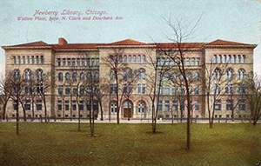

Dr. Krummel later described these years at the Newberry as among the most important and rewarding of his career, where he gained significant experience managing library operations and deepened his expertise in rare books and bibliography.
In 1970, Dr. Krummel joined the faculty of the Graduate School of Library and Information Science (GSLIS, now the School of Information Sciences or iSchool) at the University of Illinois at Urbana-Champaign. He was awarded project grants from the National Endowment for the Humanities in 1976, 1979, and 1983. These grants supported his research in music bibliography and American music history resources, most notably contributing to the landmark reference work Resources of American Music History: A Directory of Source Materials from Colonial Times to World War II (University of Illinois Press, 1981).
Dr. Krummel remained on the faculty at Illinois until his retirement in 1997, after which he continued teaching bibliography courses until 2015.
He also held honors at Illinois at the Center for Advanced Study, and as University Scholar, and Centennial Scholar.
Dr. Krummel
- also served on the faculty of the Rare Book School, first at Columbia University and later at the University of Virginia, from 1990 to 2008 where he taught:
- ” How to Research a Rare Book” (1990–2002);
- “Music as Bibliographical Artifact” (1994); and
- “The History of American Music Printing & Publishing (2002–2008).
These courses drew on his expertise in music bibliography, using the Rare Book School collections of music printing surfaces, original sheet music, and bibliographical tools.

Professional Service and Leadership

Dr. Krummel was elected President of the Music Library Association (MLA) from 1981 to 1983 and as a Counselor for the American Library Association (1964–1968).
He was also active in these societies:
- Bibliographical Society of America (named Honorary Member in 2017),
- Bibliographical Society (London),
- American Antiquarian Society,
- Society for American Music,
- American Printing History Association,
- Caxton Club (Chicago),
- Grolier Club (New York).

Selected Honors and Awards
Dr. Krummel’s scholarship was foundational to music bibliography and the history of music printing and publishing.
In respect and honor for his career the festschrift, Music Publishing & Collecting: Essays in Honor of Donald W. Krummel, edited by David Hunter, was published in 1994 with essays by scholars in music bibliography, librarianship, historical music trade practices, British music publishing/collecting, subscription lists (e.g., Handel-related), violin culture and commerce in Britain, and collector archives or specific music collections.[ See Sources for reviews by Henry and Jones].

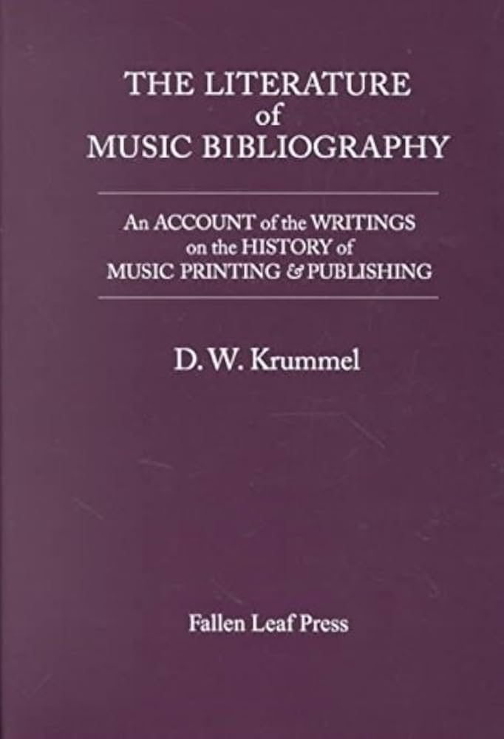

- Aspen Institute for Humanistic Studies Scholar in Residence (1969)
- Henry E. Huntington Library Grant-in-Aid (1965)
- Newberry Library Traveling Research Fellow (1969–1970)
- University College London Honorary Research Fellow (1974–1975)
- Guggenheim Fellowship (1976–1977)
- Vincent H. Duckles Award from the Music Library Association for Resources of American Music History: A Directory of Source Materials from Colonial Times to World War II. [The Award is for the best book-length bibliography or reference work in music]. 1983.

- American Library Association. G.K. Hall Award (1987).

- The Society for American Music. Irving Lowens Award (1989)
- University of Illinois University Scholar (1991)
- In 1994 (around his 65th birthday), colleagues published Music Publishing & Collecting: Essays in Honor of Donald W. Krummel, a festschrift celebrating his contributions.
- Beta Phi Mu Award (1999), for distinguished service to education for librarianship
- The Society for American Music. Lifetime Achievement Award (2012)
- American Printing History Association. Laureate Award (2004).
- Bibliographical Society of America Honorary Member. 2017.

Donald W. Krummel’s meticulous scholarship, teaching, and leadership helped establish rigorous standards in music bibliography and preserved and made accessible vast resources for the study of music history, particularly American music. His work continues to influence librarians, bibliographers, musicologists, and printing historians.

Selected Major Publications of Donald William Krummel

Krummel, Donald William. “Philadelphia Music Engraving and Publishing, 1800–1820: A Study in Bibliography and Cultural History.” PhD diss., University of Michigan, 1958.
Krummel, Donald W., and James B. Coover. “Current National Bibliographies: Their Music Coverage.” Notes 17, no. 3 (1960): 375–88.
Krummel, Donald W. “Observations on Library Acquisitions of Music.” Notes 23, no. 1 (1966): 5–16.
Krummel, Donald W. “[The Music Collections at] The Newberry Library, Chicago,” Fontes Artis Musicae 16.3 (1969): 119–134.
Krummel, Donald William, and the Bibliographical Society (Great Britain). Oblong Format in Early Music Books. London: Bibliographical Society, 1971.
Krummel, Donald William. “Guide for Dating Early Music: A Synopsis.” Fontes Artis Musicae 18, no. 1/2 (1971): 40–59.
Krummel, Donald William, and the International Association of Music Libraries, Commission for Bibliographical Research. Guide for Dating Early Published Music: A Manual of Bibliographical Practices. Hackensack, NJ: J. Boonin, 1974.
Krummel, Donald William, and the Lessing J. Rosenwald Reference Collection (Library of Congress). English Music Printing, 1553–1700. London: Bibliographical Society, 1975.
Krummel, Donald William. Musical Functions and Bibliographical Forms. Oxford: Oxford University Press, 1976.
Krummel, Donald William Krummel and Newberry Library. Bibliographical Inventory to the Early Music in the Newberry Library, Chicago, Illinois. Boston: G.K. Hall, 1977.
Krummel, Donald William. Resources of American Music History: A Directory of Source Materials from Colonial Times to World War II. Urbana: University of Illinois Press, 1981.
Krummel, Donald William. Bibliographies: Their Aims and Methods. London: Mansell Publishing Limited, 1984.
Krummel, Donald W. “Publishing and Printing of Music.” In The New Grove Dictionary of American Music, edited by H. Wiley Hitchcock and Stanley Sadie. 4 vols. London: Macmillan Press, 1986.
Krummel, Donald William. Bibliographical Handbook of American Music. Urbana: University of Illinois Press, 1987.
Krummel, Donald William. Citing the Score: Descriptive Bibliography and Printed Music. London: Oxford University Press, 1987.
Krummel, D. W. The Memory of Sound: Observations on the History of Music on Paper. Center for the Book Viewpoint Series, no. 20. Washington, DC: Library of Congress, 1988. [Engelhard Lecture delivered at the Library of Congress Center for the Book. Published as No. 20 in the Center for the Book Viewpoint Series.]
Krummel, Donald William, and Stanley Sadie. Music Printing and Publishing. 1st American ed. New York: W.W. Norton, 1990.
Krummel, Donald William. The Literature of Music Bibliography: An Account of the Writings on the History of Music Printing & Publishing. Berkeley, CA: Fallen Leaf Press, 1992.
Krummel, Donald William. Fiat lux, fiat latebra: A Celebration of Historical Library Functions. Occasional Paper 209. Champaign: Graduate School of Library and Information Science, University of Illinois at Urbana-Champaign, 1999.
Krummel, Donald William, Stinehour Press, and Grolier Club. The Petrucci Centenary. New Series. New York: Grolier Club, 2000.
Krummel, D. W. “Notes: A Sixtieth Birthday Retrospective.” Notes 61, no. 1 (2004): 9–23.
Krummel, Donald W. “Early American Imprint Bibliography and Its Stories: An Introductory Course in Bibliographical Civics.” Libraries & Culture 40, no. 3 (2005): 239–50.
Note:
Dr. Krummel also wrote reviews, chapters, and dictionary entries (including sections on music printing and publishing) in the New Grove Dictionary of Music and Musicians. These include:
- Krummel, Donald W. “Publishing and Printing of Music.” In The New Grove Dictionary of American Music, edited by H. Wiley Hitchcock and Stanley Sadie. 4 vols. London: Macmillan Press, 1986.

- Boorman, Stanley, Eleanor Selfridge-Field, and Donald W. Krummel. “Printing and publishing of music.” In Grove Music Online. Oxford Music Online. Oxford: Oxford University Press. 2001. Accessed June 28, 2026.

His research emphasized the intersection of music, printing technology, publishing history, and library resources, providing essential tools for scholars studying American music and early printed music.

Sources

American Printing History Association. “Awards.” Accessed June 28, 2026.
Campbell, Peter. Review of Music Publishing & Collecting: Essays in Honor of Donald W. Krummel, edited by David Hunter. Musicology Australia 19, no. 1 (1996): 74–75.
“Donald Krummel Presented with GK Hall Award at ALA.” Newsletter (Graduate School of Library and Information Science, University of Illinois at Urbana-Champaign), 1987–1992.
Hamm, Charles. Review of Resources of American Music History: A Directory of Source Materials from Colonial Times to World War II*, by D. W. Krummel, Jean Geil, Doris J. Dyen, and Deane L. Root. American Music 3, no. 2 (Summer 1985): 232–235.
Henry, Barbara. Review of Music Publishing & Collecting: Essays in Honor of Donald W. Krummel, edited by David Hunter. Library & Information Science Research 17, no. 4 (1995): 415-416.
Hunter, David, ed. Music Publishing & Collecting: Essays in Honor of Donald W. Krummel. Urbana, Ill.: Graduate School of Library and Information Science, University of Illinois at Urbana-Champaign, 1994. 252 pp. ISBN 0-87845-095-5.
Jones, Peter Ward. Review of Music Publishing & Collecting: Essays in Honor of Donald W. Krummel, edited by David Hunter. Notes 52, no. 3 (March 1996): 794+.
Kroeger, Karl. Review of The Literature of Music Bibliography: An Account of the Writings on the History of Music Printing & Publishing, by D. W. Krummel. Fontes Artis Musicae.

“Krummel, Donald W. (1929-).” University of Illinois Archives, University of Illinois at Urbana-Champaign. Accessed 28 June 2026.
"Krummel Honored for Lifetime Achievement in American Music." University of Illinois School of Information Sciences. May 2, 2012.
Lerner, Neil (Spring 2012). "Reports from the 2012 Annual Meeting in Charlotte". Bulletin of the Society for American Music. XXXVIII (2).
Marco, Guy. ―” Beginnings of the Newberry Library Music Collections: Background and Personal Influences.” in Approaches to Library History, Proceedings of the Second Library History seminar, Florida State University Library School, Tallahassee, March 4, 5, and 6, 1965. Tallahassee: Journal of Library History, 1966: 165-181.
Music Library Association. “ALA Presents the 1999 Beta Phi Mu Award to D. W. Krummel.”. p.12.
Music Library Association. "Vincent H. Duckles Award."
Newberry Library. “Music – Publications about the Newberry Library Collections
Rare Book School, “We remember RBS emeritus faculty member Donald W. Krummel, who passed away on 25 June 2026, at the age of 97. From 1990 through 2008...,” Instagram, June 2026.
Society for American Music. “Irving Lowens Book Award.”
Wagstaff, John. Review of The Literature of Music Bibliography: An Account of the Writings on the History of Music Printing & Publishing*, by D. W. Krummel. Music & Letters 75, no. 2 (May 1994): 255–256.

Submitted by Kathleen de la Peña McCook

