Zubaidah Isa – 1922-1978

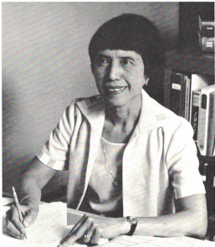

Dr. Zubaidah Isa (also spelled Zubaida Isa; 1922–1978) was an Indonesian-born scholar and faculty member in library science whose work focused on the history of printing and publishing. She is remembered for her academic contributions and her tragic death in one of Kansas’s worst boating disasters.

Born in 1922 in Indonesia, Isa pursued advanced studies in the United States. Some recent Indonesian library-science histories (e.g., the 2024 BRIN volume Tren dan Dinamika Kajian Ilmu Perpustakaan dan Informasi) recognize her as the first Indonesian to earn an advanced degree in library/information science.
In 1972 she earned her Ph.D. from Indiana University with a dissertation titled “Printing and Publishing in Indonesia, 1602–1970,” a detailed historical study spanning nearly four centuries of the printing industry in the archipelago (from early Dutch colonial efforts through the mid-20th century). The work, advised by Cecil K. Byrd, remains a cited reference in Southeast Asian bibliographic and media history.

Shortly after completing her doctorate, Dr. Isa joined the faculty of the School of Library Science (now the School of Library and Information Management, or SLIM) at Emporia State University (then Emporia Kansas State College) in Kansas. She served as an assistant professor or faculty member specializing in areas aligned with her expertise in library history and bibliography.

On June 17, 1978, Dr. Isa was one of three Emporia State University faculty members aboard the tourist showboat Whippoorwill on Lake Pomona, Kansas, when a freak tornado (part of the 1978 Pomona Lake tornado event) struck the vessel. The boat capsized in high winds, resulting in 16 deaths—the worst boating disaster in Kansas history at the time.
Dr. Isa perished alongside SLIM Dean Dr. Sarah Reed and summer faculty member Dr. Muriel Fuller. She was identified in contemporary accounts as “Zubaidah Isa, Indonesia (Emporia), staff member ESU.”

The university community rallied after the tragedy to cover classes and support the school. While scholarships were later established in memory of Reed and Fuller, no immediate on-campus memorial existed specifically for Isa.
On October 1, 2018—marking the 40th anniversary—SLIM faculty, staff, and alumni planted a memorial tree and plaque in front of the William Allen White Library on the Emporia State campus to honor her life and service.
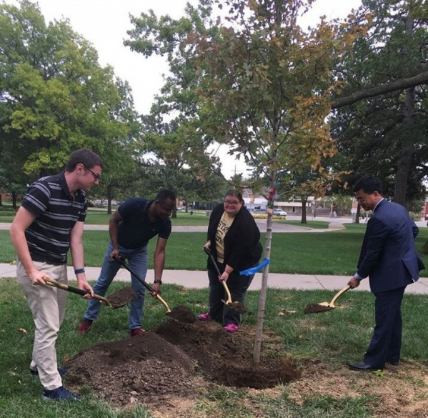

Publications
Isa, Zubaidah. “The Entry-Word in Indonesian Names and Titles.” Library Resources & Technical Services 15, no. 3 (1971): 393–398.
ISA Z. Printing And Publishing In Indonesia: 1602-1970. [Order No. 7302666]. Indiana University; 1972.

Sources
1978 Pomona Lake tornado, also known as the Whippoorwill Disaster, was a deadly tornado that struck Osage County, Kansas on June 17, 1978.
“ESU SLIM Department Plants Tree in Memory of Zubaida Isa after Whippoorwill Boating Tragedy.” KVOE, October 3, 2018.
Isa, Zubaidah. Printing and Publishing in Indonesia: 1602–1970. PhD diss., Indiana University, 1972.
Citations in Sematic Scholar on June 10, 2026 include:
- Guerrilla Resistance: Sitti Nurbaya and Balai Pustaka’s Censorship
Censorship, a tool of cultural hegemony often employed by colonizers, was practiced by the Dutch colonials in the Dutch East Indies through the people's reading commission or Balai Pustaka.
- Print Culture in the Sultanate of Riau-Lingga during the Late Nineteenth and Early Twentieth Centuries
- Malay Schools and School Libraries in the Straits Settlements Under British Colonial Rule Before the Second World War, 1876-1941
- European and Asian papers in Malay manuscripts; A provisional assessment

Laksmi, Ike et. Al. Tren dan Dinamika Kajian Ilmu Perpustakaan dan Informasi. Jakarta: Penerbit BRIN, 2024. DOI: https://doi.org/10.55981/brin.1079
“Pomona Lake’s 50th: Memorial Service to Remember Whippoorwill Tragedy.” Osage County Online, June 12, 2014.
“SLIM History.” Emporia State University School of Library and Information Management. n.d. Accessed June 10, 2026.

Submitted by Kathleen de la Peña McCook

