Peter Hiatt – 1930-2014

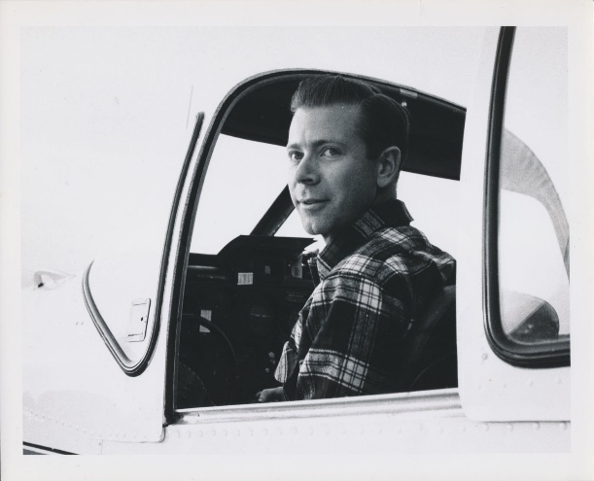

Peter Hiatt (October 19, 1930–December 11, 2014) was a librarian, library educator, administrator, consultant, and advocate who emphasized libraries—particularly publicly supported ones—as agencies of social change and democratization through free services.
Peter Hiatt earned a B.A. in history from Colgate University (1952).
He served in the U.S. Army as a corporal and company clerk during the Korean War era.
He earned an M.L.S. (1957) and Ph.D. (1963) from Rutgers University. His Rutgers dissertation focused on public library branch services for adults of low education, reflecting an early interest in outreach to underserved populations.
Dr.
Hiatt began his professional practice as a branch head librarian in the Elizabeth, New Jersey Public Library system (1957–1959) while also serving as an instructor at Rutgers during his doctoral studies.
In 1963, he assumed a joint appointment in Indiana as the first cooperative hire between Indiana University’s Graduate Library School (Bloomington) and the Indiana State Library: as a consultant for the state library (running continuing education and workshops) and as assistant/associate professor at IU (teaching on campus and at regional sites like Gary and Fort Wayne). Shortly after beginning this itinerant career, Peter became a flying professor, eventually earning his instrument rating, by purchasing a Ryan Navion, a single-engine, low-wing, retractable-gear aircraft.
He conducted planning studies, including The Monroe County Public Library: Planning for the Future (1966), and directed major initiatives such as the federally funded Indiana Library Studies Project (chief investigator, late 1960s–early 1970s), which produced 19 volumes of reports on improving statewide library services.
He also co-directed institutes on library services for inner-city disadvantaged populations (e.g., 1969–1971 Title IIB Institute).

The Flying Professor

Hiatt was known as a “flying professor.” In 1970 he moved to the Western Interstate Commission for Higher Education (WICHE) in Boulder, Colorado, as Library Program Director, coordinating continuing education for library personnel across 13 western states. This large territory ensured that his flying and traveling career continued.

In 1974, Hiatt was appointed director of the University of Washington Graduate Library School (now the Information School/iSchool) in Seattle—serving in that role until 1981 before continuing as a faculty member until his retirement in 1998 as professor emeritus.
Key achievements there included leading a major 1979 curriculum overhaul of the two-year Master of Librarianship program), which incorporated emerging technologies, expanded specialties, and shifted focus from the library as an institution to user-centered information services and delivery. He championed libraries’ societal role against privatization or fee-based models.

Professional activities

Peter Hiatt held leadership positions in the American Library Association (ALA), including president of the Library Education Division (LED) and the Adult Services Division (ASD).
He chaired the Public Library Association’s “Goals, Guidelines, and Standards Committee,” producing a 1977 “mission statement” for public libraries
He served as chief investigator on two W.K. Kellogg Foundation grants for the Career Development and Assessment Center for Librarians (focusing on professional leadership development).
Dr. Hiatt was the official liaison/representative from the American Library Association’s Library Education Division (LED) to the Association of American Library Schools (AALS now ALISE). In 1979 he was honored with the AALS Outstanding Service Award for his sustained contributions to library education.
Hiatt functioned as a key connector between ALA divisions, library schools, and AALS/ALISE priorities, helping coordinate efforts on education standards, state library personnel training (via his chairmanship of the related ALA-LED report), and the broader advancement of LIS programs.
He served two terms -1990–1997, including as president, on the King County Library System Board of Trustees.
In retirement in Port Townsend/Cape George, Washington, he remained active with local library projects, the Port Townsend Library Foundation, and his lifelong passions for classical music .as a performer, collector, and discography expert.
Dr. Peter Hiatt died Dec. 11, 2014.

Selected Publications

Hiatt, Peter. 1963. Public Library Branch Services for Adults of Low Education. PhD diss., Rutgers University.
Hiatt, Peter. 1965. “Urban Public Library Services for Adults of Low Education.” The Library Quarterly 35, no. 2: 81–96.
Hiatt, Peter, and Donald Thompson. 1966. The Monroe County Public Library: Planning for the Future. [Bloomington, IN]: Monroe County Public Library.
Davis, Charles H., and Peter Hiatt. 1970. “An Automated Current-Awareness Service for Public Libraries.” Journal of the American Society for Information Science 21, no. 1: 29–33.
Hiatt, Peter. 1970. “Editorial.” College & Research Libraries 31, no. 3: 145.
Hiatt, Peter, ed./director. 1970–1972. Indiana Library Studies. 19 vols. Bloomington: Indiana University Graduate Library School and Indiana State Library. (Major federally funded series of statewide library planning and needs-assessment reports for which Hiatt served as chief investigator and general editor.)
Hiatt, Peter. 1971. Improving Library Services for the Inner City Disadvantaged: A Title IIB Institute in Four Parts, October 1969–March 1971. Bloomington: Indiana University Graduate Library School (ERIC ED047770).
Hiatt, Peter. 1973. “Continuing Education.” College & Research Libraries 34, no. 2: 101–102.
ALA’s Public Library Assn. Goals, Guidelines, and Standards Committee. “A Mission Statement for Public Libraries: Guidelines for Public Library Service: Part I.” American Libraries 8, no. 11 (1977): 615–20. http://www.jstor.org/stable/25621250. (Hiatt was chair).
Hiatt, Peter. 1983. “Should Professionals Be Managers?” Journal of Library Administration 4, no. 1: 21–39.
Hiatt, Peter. 1992. “Identifying and Encouraging Leadership Potential: Assessment Technology and the Library Profession.” Library Trends 40, no. 3: 489–507. (Part of a special issue on training for library leadership.)
Hiatt, Peter, Ruth H. Hamilton, and Charlotte L. Wood. 1993. Assessment Centers for Professional Library Leadership: A Report to the Profession from the Career Development and Assessment Center for Librarians. Chicago: American Library Association, Office for Library Personnel Resources.
Hiatt, Peter. 1996. “Reclaiming the American Library Past: Writing the Women In.” Library & Information Science Research 18, no. 3: 281–283. (Commentary/review contribution.)
Attributed or chaired works include the ALA Library Education Division report, Education of State Library Personnel (Hiatt, chair; undated but ca. late 1960s–early 1970s) and contributions to Public Library Association standards/guidelines (e.g., 1977 mission statement as committee chair).

Sources

“Association Activities.” Journal of Education for Librarianship (various issues referencing Hiatt as LED representative to AALS and in directories; e.g., listings of Peter Hiatt [Washington]). JSTOR.
Michael, Mary Ellen, comp. IR 001 104: Library Planning; Library Science; Professional Development. ERIC Document ED095919, 1973.

“Obituaries: Peter Hiatt.” Port Townsend & Jefferson County Leader, January 20, 2015.
University of Washington Information School. “In Remembrance: Peter Hiatt, 1930-2014.” Last modified December 2016 (originally posted 2015).
University of Washington. “University of Washington Graduate School of Library and Information Science Records, 1965-1992 and 1913-2003.” Archives West (Orbis Cascade Alliance). Accessed May 30, 2026.

Submitted by Kathleen de la Peña McCook

