2012-2013 ALA Memorial #9
2013 ALA Midwinter Meeting

A Memorial Resolution Honoring Dr. Genevieve “Kay” Bishop
Whereas Dr. Genevieve “Kay” Bishop dedicated her life’s work to the advancement of library services and the sharing of children’s literature, through research and the education of librarians and library and information studies faculty, and
Whereas Dr. Genevieve “Kay” Bishop earned her A.A. from Manatee Junior College, her B.A. in
English Education and her Ph.D. in Library and Information Studies from Florida State
University, her M.A. from the University of South Florida in Library Science and her M.Ed. in Guidance and Counseling from Washington State University, and
Whereas Dr. Genevieve “Kay” Bishop served as a member of the Peace Corps in Nepal, served as a teacher and school librarian in the school district of Manatee County, Florida, served as reference librarian at the New College Library at the University of South Florida, served as school librarian at international schools in Montagnola-Lugano, Switzerland and Hanau,
Germany and began her years in library education in 1994 as a member of the faculty at
Murray State University and continued with positions at the University of Southern Mississippi, the University of South Florida, and the University at Buffalo, where she taught and served as the Director of the School Library Media Program and Director of the Online MLS Programuntil her retirement in 2012, and
Whereas Dr. Genevieve “Kay” Bishop made many contributions to library education particularly by teaching courses in children’s and young adult literature, school library administration, collection development and overseeing school librarian internships, by mentoring numerous master’s students and faculty colleagues, and by the publication and use of her book, The Collection Program in Schools, and numerous scholarly research publications and practical articles, and
Whereas Dr. Genevieve “Kay” Bishop served the library profession most notably as a member of the Library Media Connection Advisory Board, the NCATE Board of Examiners, as an evaluator for the national Library Power program, and numerous committee appointments within the Association for Library Service to Children and the American Association of School Librarians, and
Whereas Dr. Genevieve “Kay” Bishop was a true scholar elected to Beta Phi Mu, the International
Library and Information Science Honor Society, Phi Beta Kappa, and Phi Kappa Phi, and
Whereas Dr. Genevieve “Kay” Bishop was much loved and respected by her many students as a kind and thoughtful woman, her academic colleagues and co-workers, and her friends as a woman of great integrity and compassion, therefore, be it

A Memorial Resolution Honoring Dr. Genevieve “Kay” Bishop/2
Resolved, that the American Library Association (ALA) on behalf of its members;
- honors Dr. Genevieve “Kay” Bishop for her lifetime of work in the library and information science profession and her significant work as a library educator.
- sends copies of this resolution to Dr. Bishop’s children Lara Bishop Oerter, Jennifer Bishop Cahall and James Bishop.

Adopted by the Council of the American Library Association
Tuesday, January 29, 2013 In Seattle, Washington
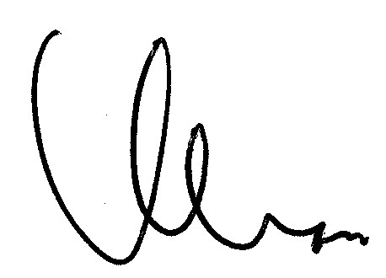
Keith Michael Fiels
ALA Executive Director and Secretary of the ALA Council

