Kenya S. Flash (1980-2021)

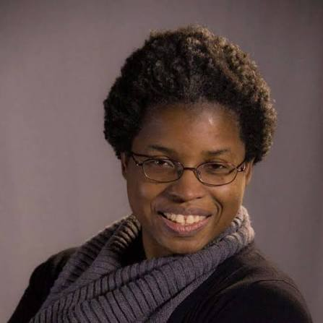

Introduction
Kenya Siana Flash was the librarian for political science, global information, and government information at the Marx Science and Social Science Library at Yale University. Born in Jamaica on July 14, 1980, she moved to Buffalo, New York with her mother and siblings at a young age. After high school, Kenya attended Lafayette College in Easton, PA, where she majored in government and law. She continued her studies at East Stroudsburg University where she earned a master’s degree in political science and at Drexel University where she earned her master’s in library science.

Kenya’s academic librarianship career began as an adjunct reference librarian at Wilkes University. In 2015 she began a three year residency at the University of Tennessee Knoxville as a Diversity Resident Librarian and Research Assistant Professor working in the instruction, collections, and assessment departments and serving as the Social Sciences liaison. After her residency at the University of Tennessee, she was hired by Yale University in 2017 where she worked until her passing in 2021.

Contributions to librarianship
Kenya’s professional associations included membership and very active involvement in ALA’s Government Documents Round Table (GODORT) and ACRL’s Politics, Policy, and International Relations Section (PPIRS). She was also a member of the 2018 class of the Emerging Leaders program, ALA’s leadership development program for new library workers. Beyond her work and professional interest in social science librarianship and government documents, Kenya was also a dedicated advocate for equity, diversity, inclusion and justice in the field of librarianship. Kenya’s life and career inspired many. In 2022 GODORT and PPIRS, established the Kenya S. Flash Virtual Lecture Series in Librarianship to honor their colleague and her career. In 2023, Yale Library created a three year long residency program in honor of Kenya to continue her work in DEIA advocacy in libraries.

Publications

Flash, Kenya, et al. “STEM Bridges: Evolution of an Academic Library STEM Outreach Program.” Journal of Library Administration, vol. 57, no. 8, 22 Sept. 2017, pp. 879–890.

Flash, Kenya, and Dominique Hallett. “Tales from the Trenches—Part 1.” DttP: Documents to the People, vol. 48, no. 1, 16 Apr. 2020, pp. 8–9, https://doi.org/10.5860/dttp.v48i1.7334. Accessed 19 Sept. 2021.

Flash, Kenya, and Dominique Hallett. “Tales from the Trenches—Part 2.” DttP: Documents to the People, vol. 48, no. 2, 2020, pp. 4–5,journals.ala.org/index.php/dttp/article/view/7355/10112.

Flash, Kenya, and Dominique Hallett. “Tales from the Trenches—Part 3.” DttP: Documents to the People, vol. 48, no. 3, 10 Sept. 2020, pp. 8–9, https://doi.org/10.5860/dttp.v48i3.7418.
Flash, Kenya, and Dominique Hallett. “Tales from the Trenches—Part 4.” DttP: Documents to the People, vol. 48, no. 4, 4 Dec. 2020, pp. 7–8, https://doi.org/10.5860/dttp.v48i4.7475.
Flash, Kenya and Dominique Hallett, " Who Are' We the People'?": Pilot Survey Investigating Government Information Professionals: A Conversation.” DttP: Documents to the People, vol 48, no. 25, 2020.
Flash, Kenya and Dominique Hallett. “Documents De-emphasized? The Shifting Roles of Government Information Professionals” in The Academic Librarian in the Digital Age, pp108-119, McFarland, 2020.
Hodge, Twanna, Bartley, Kelsa, Flash, Kenya, “Assumed Identity: Realities of Afro-Caribbean Librarians” in The Black Librarian in America: Reflections, Resistance, and Reawakening, pp. 73-89, Bloomsbury Publishing, 2022.
Flash, Kenya. “The Data Librarian’s Handbook.” DttP: Documents to the People, vol. 45, no. 4, 26 Jan. 2018, p. 32, https://doi.org/10.5860/dttp.v45i4.6571.

Pun, Raymond, et al. Ethnic Studies in Academic and Research Libraries. Chicago, Illinois, Association Of College And Research Libraries, A Division Of The American Library Association, 2021.

Pun, Raymond, et al. “Libraries and Gender Neutral / Inclusive Bathrooms: Case Studies on Promoting Information, Inclusivity and Access in Open Spaces.” Ifla.org, 2017, repository.ifla.org/items/6935a465-da7b-4620-baea-9cb2b1845f4c/full.

Pun, Raymond, et al. "Prioritizing Ethnic Studies.” American Libraries, vol. 53, issue 3 / 4, 1 March 2022, p. 46.

Sources:

“Kenya S. Flash Virtual Lecture Series in Librarianship.” Ala.org, 2017, www.ala.org/godort/publications-resources/kenya-s-flash-virtual-lecture-series.

“Kenya S. Flash Librarian Residency Celebrates a First Year Filled with Firsts.” Yale.edu, 2022, library.yale.edu/news/kenya-s-flash-librarian-residency-celebrates-first-year-filled-firsts
Editor.

“In Memoriam: Kenya Siana Flash, 1980-2021.” The Journal of Blacks in Higher Education, 25 Jan. 2022, jbhe.com/2022/01/in-memoriam-kenya-siana-flash-1980-2021/.
“Remembering Kenya Flash: “Brilliance, Generosity, and Vast Knowledge.” Yale.edu, 2022, library.yale.edu/news/remembering-kenya-flash-brilliance-generosity-and-vast-knowledge.

“Resident of the Month: Kenya Flash – Residency Interest Group.” Ala.org, 4 July 2017, acrl.ala.org/residency/resident-of-the-month-kenya-flash/.

“Memorial Resolution Honoring Kenya S. Flash.” American Library Association, 4 January 2022,
https://www.ala.org/sites/default/files/aboutala/content/Kenya%20S.%20Flash.pdf.

