

A Memorial Resolution Honoring Dr. Yen-Tsai Feng
Whereas the American Library Association (ALA), the Asian/Pacific American Librarians Association (APALA), and the academic library community lost a valued member and colleague on September 6, 2019, with the death of Dr. Yen-Tsai Feng;
Whereas Yen-Tsai received her bachelor’s degree from University of Shanghai, a
master’s degree from Colorado State University, a library science degree from
Columbia University, and a doctorate in international relations from the University of Denver;
Whereas Yen-Tsai Feng worked in many institutions such as Harvard Library, Boston Public Library, Wellesley College Library and became the first Roy E. Larsen Librarian in Harvard University Libraries in 1982;
Whereas Yen-Tsai Feng co-founded the Asian American Librarians Caucus (AALC) in 1975 and served as a trustee or board member at several academic and cultural institutions. A predecessor of APALA, AALC was organized in 1975 as a discussion group of the ALA Office of Library Outreach Services reflecting the interest in library services in minority communities and professional support of librarians of minority ancestry during the 1960s and 1970s; and
Whereas at the Asian American Librarians Caucus (AALC) and Asian/Pacific American Librarians Association (APALA), members recognize our founders and leaders who have brought us together to support one another and to advance diversity, equity, and inclusion in the profession; now, therefore, be it
Resolved, that the American Library Association (ALA), on behalf of its members:
- recognizes the significant contributions of Dr. Yen-Tsai Feng over the course of her career and mourns her death; and
- extends its sincerest condolences to her friends and family.

Adopted by the Council of the American Library Association Saturday, June 27, 2020, ALA Virtual Council Meeting
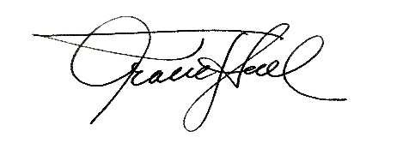
Tracie D. Hall, Executive Director and Secretary of the ALA Council

