Adelaide Del Frate - 1924–1991

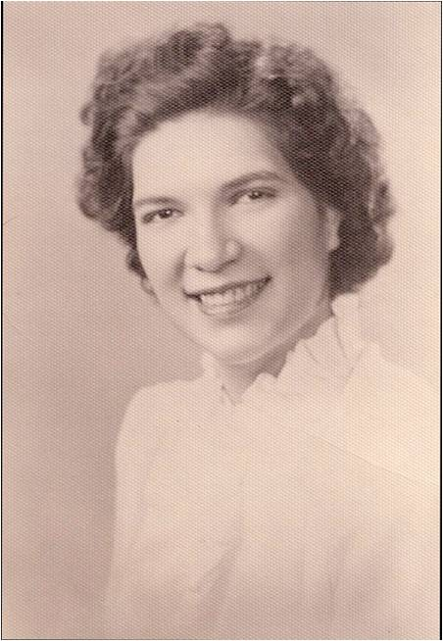

Adelaide Anna Del Frate (c. 1924–1991) was a federal librarian known for her leadership in scientific and aerospace information services, particularly at NASA. She played a key role in modernizing library systems within the agency during the late 20th century. She is honored on the Wall of Honor at the Smithsonian National Air and Space Museum

A native of Somerville, Massachusetts, Del Frate earned a B.S. from Simmons College in 1947. Her early career included two years at the Massachusetts Institute of Technology (MIT), followed by four years in the patent department of the Dewey and Almy Chemical Company in Cambridge. She later worked as a chemical library scientist at the Jackson Moreland Company before joining the federal government.

In 1966, she began a 25-year career with NASA, starting at the Electronics Research Center in Cambridge. She moved to the NASA Goddard Space Flight Center in Maryland, where she became Head of the Library Branch around 1968. There, she led the ambitious project to automate all library systems and integrate its functions—an innovative effort for the era.

In 1986, she was promoted to NASA Headquarters in Washington, D.C., where she served as Coordinator of all NASA libraries. She was instrumental in developing and implementing the agency’s Aerospace Research Information Network (ARIN), an online catalog that linked NASA libraries nationwide.

Del Frate was active in professional organizations, including the Federal and Armed Forces Library Round Table (FAFLRT) of the American Library Association. She was ALA FLRT Director from 1984 to 1987 and chaired the ALA FLRT A-76 Task Force which was instrumental in informing federal librarians on the issues of contracting out and employee rights. She was the ALA liaison to the Library of Congress' Federal Library and Information Center Committee and
on the Local Organizing Committee for the first Library and Information Services in Astronomy (LISA I) conference in 1988.

In 1990, she received the John Cotton Dana Award (Special Libraries Association) in recognition of her contributions to the profession.

She retired in late 1991 and passed away on December 24, 1991.

Del Frate’s legacy endured through the annual Federal Librarians Adelaide Del Frate Conference Sponsorship Award which encouraged library school students and new federal librarians to attend professional conferences.

Sources

“Adelaide Anna Del Frate.” Smithsonian National Air and Space Museum Wall of Honor. Accessed June 16, 2026.

American Library Association. Federal Librarian, the Newsletter of the Federal and Armed Forces Libraries Round Table | ALA [December 1992 newsletter].”

American Library Association. Memorial Resolution Concerning Adelaide Del Frate January 29, 1992.

Callow, J.R. “at NASA-Goddard - Space Flight Center.” Special Libraries 61, no. 1 (1970): 15–18. (Mentions Del Frate’s role.).

Corbin, B.G. “Mentoring LISA.” In Library and Information Services in Astronomy VI: 21st Century Astronomy Librarianship, from New Ideas to Action, edited by E. Isaksson, J. Lagerstrom, A. Holl, and N. Bawdekar, 11–16. ASP Conference Series, vol. 433. San Francisco: Astronomical Society of the Pacific, 2010.

Federal and Armed Forces Libraries Round Table (FAFLRT). Various newsletters, including Federal Librarian (2009–2011 issues discussing the Adelaide Del Frate Award).

Additional context appears in NASA technical reports and conference proceedings from the 1970s–1980s referencing her work on library automation and the Aerospace Research Information Network.

