Terrilyn Lehua Chun -1966–2022

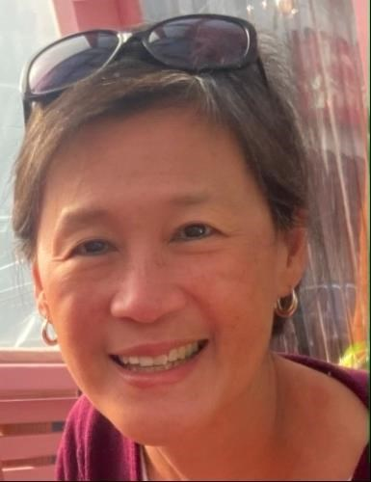

Terrilyn Lehua Chun (1966–2022) was a dedicated public librarian and leader at Multnomah County Library in Portland, Oregon, where she served for more than 32 years. She rose through the ranks to become Deputy Director, championing accessible public programming, community outreach, and equitable library services for diverse populations.
She was born on April 19, 1966, in Portland, Oregon and grew up in the Pacific Northwest. She earned a Bachelor of Arts degree in Communications from Mills College in Oakland, California, in 1988. Later in her career, she pursued library science, receiving her Master of Library Science (MLS) from Emporia State University in 2009 as an Emporia Diversity Initiative scholar. She remained connected to the program as a mentor for students.
Terrilyn Lehua Chun began her public service career in 1988 at Multnomah County Library, initially working in public relations as a public affairs specialist. Over the decades, she advanced into roles focused on programming and community outreach. As senior manager for Programming and Community Outreach, she was responsible for the development, resource allocation, and evaluation of public programs serving adults, youth, and families. She notably coordinated Everybody Reads, the library’s long-running One City/One Book community reading initiative, from 2003 to 2016, expanding programming to reach diverse audiences.

In 2017, she was appointed Deputy Director, where she oversaw public services across all 19 library locations as well as outreach programs serving childcare centers, schools, retirement facilities, shelters, and other community settings. She played a key role in library bond efforts aimed at modernizing and strengthening the library system for Multnomah County residents. She managed day-to-day operations with dedication until her retirement on June 30, 2022.

Professional Leadership and Advocacy
Chun was actively involved in national library organizations. She served as a member and later chair of the American Library Association’s (ALA) Public and Cultural Programs Advisory Committee.
She was also a member of the ALA Spectrum Advisory Committee. The ALA Spectrum Initiative has had a substantial positive impact as a sustained, national-scale effort to diversify librarianship. Its combination of financial support, leadership development, and community-building has helped hundreds of individuals enter and advance in the field while modeling inclusive practices. It has contributed to cultural change within ALA and libraries, even as broader demographic shifts in the profession continue to evolve.
She was active in the Public Library Association’s (PLA) Leadership Development Committee. She frequently presented, served as a panelist, and moderated programs at conferences and continuing education webinars.
At the 2012 ALA Annual Conference, ALA Public and Cultural Programs Advisory Committee Chair Terrilyn Chun interviews Reed College Professor Kambiz Ghanea Bassiri about the Bridging Cultures: Muslim Journeys bookshelf, how it can help to increase cultural awareness, and the need for discussion in libraries about religion and its role in public life. [Sources has a brief YouTube}.
She advised on national grants, including a National Endowment for the Humanities grant focused on citizenship in the 21st century and an Institute of Museum and Library Services grant assessing the impact of library public programs.

Colleagues remembered her as a tireless advocate for library access and the transformative power of public libraries in communities. She was known for her leadership in change initiatives, support for staff, and ability to remove obstacles while maintaining optimism and professionalism.
In 2017, shortly after beginning her role as Deputy Director, Chun was diagnosed with stage III ovarian cancer. She underwent surgery and chemotherapy while continuing to work, drawing strength from the support of her “work family” at the library. After a recurrence, she chose treatments that allowed her to maintain quality of life and work until retirement. She openly shared her journey, emphasizing resilience, prioritizing what matters most, and living without regrets. Her colleagues and the broader library community were inspired by her persistent optimism even in the face of adversity.
Terrilyn Chun’s career exemplified dedication to public service, inclusive programming, and community impact. Her contributions to expanding library outreach and fostering vibrant public programs left a lasting mark on Multnomah County Library and the broader library profession.
She passed away on July 27, 2022, in Vancouver, Washington.

Sources
American Library Association. “A Memorial Resolution Honoring Terrilyn Chun.” 2022-2023 ALA Memorial #1. Adopted at the 2023 ALA LLX Meeting.
Chun, Terrilyn. “The Bridging Cultures: Muslim Journeys Bookshelf.” YouTube video. Interview with Kambiz GhaneaBassiri at the 2012 ALA Annual Conference. Posted by American Library Association, June 24, 2012. https://www.youtube.com/watch?v=iJROyoXd3IA.
Chun, Terrilyn. “Terrilyn Chun.” Ovarian Cancer Alliance of Oregon and Southwest Washington. March 2020.
“Terrilyn Chun.” NILPPA (National Impact of Library Public Programs Assessment).
“Terrilyn Chun Obituary.” The Oregonian / OregonLive. Published 2022.

Submitted by ALA Member

