2008-2009 ALA Memorial#11
2009 ALA Annual Conference

Memorial Resolution Honoring Minnie-Lou Chittick Lynch

Whereas, | Minnie-Lou Chittick Lynch was a pioneer and true leader for the cause of libraries and librarianship. Minnie-Lou Chittick Lynch was a highly-regarded member of the Louisiana Library Association as well as the American Library Association for her countless efforts to promote our profession, her lasting and cherished smile, and her contagious love of all things literacy; and
Whereas, | Minnie-Lou Chittick Lynch will be forever remembered for her distinguished career, speaking on library affairs in 35 states and Canada. Her 52-year professional career was notable as a book reviewer for audiences, entertainment she dubbed “Book Theatre”; and
Whereas, | Minnie-Lou Chittick Lynch was the founder and organizer of the public library of Oakdale, Louisiana, she is credited for the political efforts she spearheaded to achieve library services for her entire community, leading to the creation of the Allen Parish Public Library System in 1957; and
Whereas, | Minnie-Lou Chittick Lynch served dutifully and with great distinction on the Allen Parish Public Library System Board of Control from 1957 until her death December 18, 2008—a total of 51 dedicated years; and
Whereas, | Minnie-Lou Chittick Lynch presided on the state level as the  Executive Director of Louisiana’s two Governor’s Conferences on Libraries; and
Whereas, | Minnie-Lou Chittick Lynch served on numerous committees of the Louisiana Library Association, of which she was a member in excellent standing for 52 years; and
Whereas, | Minnie-Lou Chittick Lynch served on the national level as president of the American Library Trustee Association, a division of the  American Library Association; and

Memorial Resolution Honoring Minnie-Lou Chittick Lynch/2

Whereas, | Minnie-Lou Chittick Lynch’s library honors included: the American  Library Association’s Trustee Citation and recognition by the  American Library Association as an “Extraordinary Library Advocate of the 20th Century,” Louisiana’s Outstanding Trustee Award, and the Southwestern Library Association’s Honorary Life Membership. In 2000, Minnie-Lou Chittck Lynch was declared a “Woman of Distinction” by the Town Talk; and
Whereas, | Minnie-Lou Chittck Lynch was a trusted colleague, a cherished friend, a library pioneer, a true leader and mentor to countless members of the library community and beyond who learned their principles and commitment from her example; therefore, be it
Resolved, | That American Library Association (ALA):  - Salutes the life and legacy of Louisiana’s leader, friend and mentor Minnie-Lous Chittick Lynch;  - Extends its deepest sympathy to the family of Minnie-Lou Chittick Lynch on the loss of their beloved mother, sister, and grandmother.  - Recognizes the lifetime dedication and commitment of MinnieLou Chittick Lynch to libraries, librarianship and the people of Louisiana and the citizens of the United States of America.

Adopted by the Council of the American Library Association
Wednesday, July 15, 2009
In Chicago, Illinois
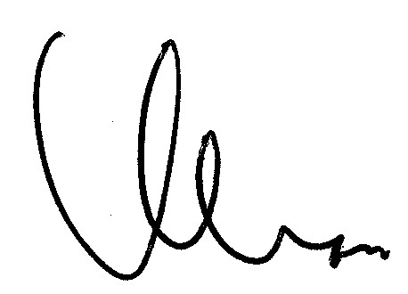
Keith Michael Fiels
ALA Executive Director and ALA Council Secretary

