Clara O. Jackson – 1915-1987

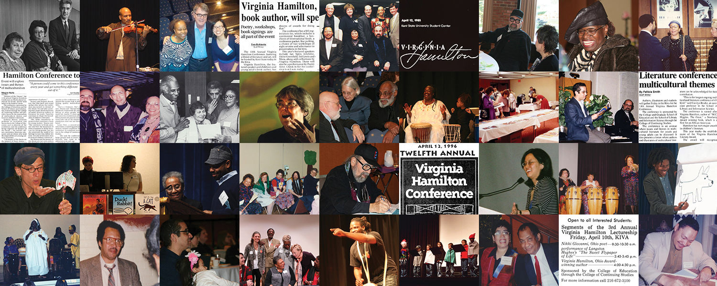

Clara O. Jackson (née Ostrowsky, 1915–1987) was an American librarian, library educator, author, and advocate for children’s library services and diverse library collections. She is best known for her work on minority representation in library resources, children’s literature collection development, and international contributions to children’s librarianship.
Claro Ostrowsky was born
in 1915 and married Sidney L. Jackson (1914–1979), a historian, author, and library educator in 1944. Clara O. Jackson joined him at Kent State University as associate professor.
Clara
Jackson’s scholarship emphasized practical and inclusive approaches to librarianship. She wrote and compiled A Bibliography of Afro-American and Other American Minorities Represented in Library and Library-Related Listings, a resource highlighting library material about minority groups.
She collaborated with Harriet B. Quimby on Building a Children’s Literature Collection: A Suggested Basic Reference Collection for Academic Libraries.
She contributed the chapter, “Service to Urban Children,” to the American Library Association centennial volume A Century of Service: Librarianship in the United States and Canada.

Virginia Hamilton Conferences
Clara O. Jackson played a foundational and leadership role in establishing and shaping what became the Virginia Hamilton Conference on Multicultural Literature for Youth at Kent State University which was held 1985-2024)
As a faculty member in the School of Library Science, Jackson brought specialized expertise in children’s literature, library services to urban and minority communities, and collection development—areas that aligned closely with the conference’s focus on multicultural themes in literature for children and young adults.
In addition to co-founding the lectureship/conference, Jackson was actively involved in its early organization: she gathered the initial materials and documentation for the project. The archives preserve dedicated biographical and promotional materials about her (including bibliographies she compiled), reflecting her significant contributions. Following her death in October 1987, the 1988 conference included a formal tribute to her, underscoring the esteem in which she was held by the organizing community. Jackson was an early driving force whose professional background in library science helped define the conference’s emphasis on multicultural children’s literature. The Virginia Hamilton Conference on Multicultural Literature for Youth was held 1985-2024 but according to the website is on hiatus.
Clara O.
Jackson was active in professional organizations and gained international recognition. She served as an officer in the Section of Children’s Libraries of the International Federation of Library Associations and Institutions (IFLA).

Following Sidney Jackson’s death in 1979, Clara O. Jackson transferred his professional papers) to the Kent State University Libraries Special Collections and Archives.

Clara O. Jackson died on October 13, 1987.

Selected Publications
Jackson, Clara O. A Bibliography of Afro-American and Other American Minorities Represented in Library and Library-Related Listings. New York: American Institute for Marxist Studies, 1972.
Jackson, Clara O. “Some European Libraries.” International Library Review 17, no. 2 (1985): 151–56.
Jackson, Sidney L., Eleanor B. Herling, and E. J. Josey, eds. A Century of Service: Librarianship in the United States and Canada. Chicago: American Library Association, 1976.
Quimby, Harriet B., and Clara O. Jackson. Building a Children’s Literature Collection: A Suggested Basic Reference Collection for Academic Libraries. Middletown, Conn.: Choice, 1975.

Sources
“Association News and Views.” Journal of Education for Librarianship. Vol. 28, No. 4, 1988.
Kent State University Libraries. “Sidney L. Jackson Papers (Faculty-Library Science).” Special Collections and Archives.
Kent State University Libraries. “Virginia Hamilton Conference Records.” Special Collections and Archives. Accessed June 15, 2026

Submitted by ALA Member

