Douglas Wallace Bryant – 1913-1994

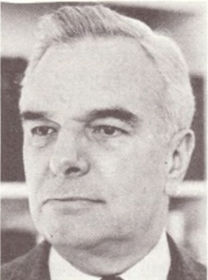

Douglas Wallace Bryant (1913–1994) was an American librarian, administrator, and international library leader, best known for his long tenure at Harvard University Libraries, where he played a central role in their modernization and expansion

Born on June 20, 1913, in Visalia, California, Bryant graduated from Stanford with a B.A. in 1935. He then earned a master’s degree and a diploma in librarianship from the University of Michigan.

Not long after Pearl Harbor he received a commission in the U.S. Naval Reserve. By the time of his release to inactive duty in 1946, he had risen to the rank of Lieutenant Commander and was head of the Technical Information Branch, Engineering Division, Bureau of Aeronautics. He was involved in postwar recovery efforts, including retrieving V-1 rocket documents from an Austrian lake.

Early in his career Bryant worked as assistant curator at the William L. Clements Library in Ann Arbor and later as senior reference assistant and assistant librarian of the Burton Historical Collection at the Detroit Public Library.

After the war he joined the University of California, Berkeley, as assistant librarian. In 1949 he was appointed cultural attaché at the U.S. Embassy in London, where he oversaw United States Information Service libraries across Britain. He built strong transatlantic library networks and collaborated closely with British colleagues, notably F. C. Francis, Principal Keeper of Printed Books at the British Museum and later Director of the British Museum. Bryant was in at the start of Francis’s great plan to print the entire catalogue of the British Museum, by photographing the catalogue's index cards and arranging them on pages. This was completed in the 1960s and was one of the largest contributions to scholarship in the humanities of the century

In 1952 Keyes DeWitt Metcalf , director of the Harvard University Library and librarian of Harvard College, recruited Douglas Bryant as administrative assistant librarian in the college library. Bryant rose through the ranks: associate university librarian (1955–1964), university librarian (1964–1972), and director of the Harvard University Library (1972–1979).

During his leadership, Harvard’s collections grew from roughly 7.25 million to about 10 million volumes, ten new library buildings were constructed (including the Countway Library of Medicine), early library automation began (including machine-readable shelflists), and cooperative ventures advanced.

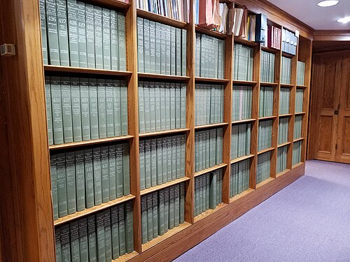

He was instrumental in the development of the National Union Catalog of pre-1956 imprints and was a founder and leader of the Research Libraries Group (serving as chairman of the board of the American Council of Research Libraries, 1969–70).

After retiring from Harvard in 1979, Bryant became the first director (and later trustee) of the American Trust for the British Library, raising substantial funds to acquire books and microfilm American materials for British collections.

“In April 1979, Douglas Bryant, Director of the University Library at Harvard, with support from Arthur Houghton, Jr. and Viscount Eccles, created the American Trust for the British Library as an independent U.S. charitable corporation. Under Mr. Bryant’s leadership, the ATBL was extremely effective raising over $4.7 million in the years up to 1992. Most of the funds replaced parts of the British Library’s North American collections, which had suffered damage during World War II. In the process of rebuilding the collections, he also provided microfilm copies of important works—an inspired idea that benefited many U.S. collections, as well as the British Library.” (See Grolier Club in sources).

Douglas Wallace Bryant died on June 12, 1994.

Selected Publications

Bryant, Douglas W., and Boynton S. Kaiser. “A University Library Position Classification and Compensation Plan.” The Library Quarterly 36, no. 1 (January 1966): 35–52.

Bryant, Douglas W. “The Publication of the British Museum Catalogue, 1881–1900.” College & Research Libraries 43, no. 3 (May 1982): 254–60.

Sources

American Antiquarian Society. “Obituaries.” Proceedings (1994).

Barker, Nicolas. “Obituary: Douglas Bryant.” The Independent, June 29, 1994.

“Douglas W. Bryant Harvard Library Director, 80.” New York Times, June 16, 1994.

Grolier Club. Guide to the Records of the American Trust for the British Library, 1979–2017. New York: Grolier.

Verba, Sidney. “Among Harvard’s Libraries: Douglas W. Bryant (1913–1994).” Harvard Library Bulletin 5, no. 3 (Fall 1994): 3–4.

Submitted by Kathleen de la Peña McCook

