Robert S. Bray (?-1976)

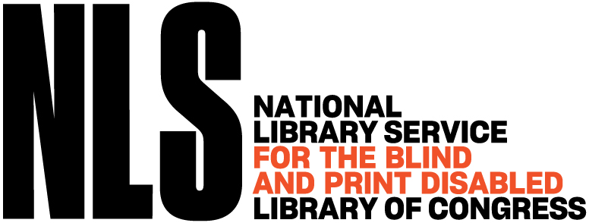

Robert S. Bray led the expansion of national library services for blind and physically handicapped readers at the Library of Congress. Bray joined the Library of Congress staff in 1940, initially working in reference and bibliographic roles (including as a bibliographer and reference assistant).
In 1957 he was appointed Chief of the Division for the Blind and Physically Handicapped—the direct predecessor to today’s National Library Service for the Blind and Print Disabled (NLS). He held this position for 15 years until his retirement in December 1972.

During his leadership, Bray oversaw transformative growth in the program:
- The network of cooperating regional libraries expanded from 28 to more than 100.
- Readership grew from roughly 58,000 to over 300,000 individuals.
- Annual appropriations increased dramatically, from slightly more than $1 million when he began to more than $8 million by fiscal year 1972–73.
Robert S. Bray
played a central role in advancing the Talking Book program and improving access to library materials for blind and physically handicapped Americans nationwide.
In 1969, the Library of Congress recognized his “far-reaching vision and his brilliant and creative leadership of a continually evolving national program” with its Distinguished Service Award. He also received other honors, including the Migel Award in 1963 (shared with another recipient).
Bray retired at the end of 1972.
In 1975, the American Council of the Blind (ACB) established the Robert S. Bray Award in his honor. This annual award recognizes outstanding contributions to library technology, communication devices, or expanding access and opportunities for blind and visually impaired people—directly reflecting Bray’s lifelong commitment to accessible library services. He died around 1976.

Bray’s work helped professionalize and scale library services for people with disabilities, laying foundational groundwork still evident in today’s NLS programs, including digital audiobooks, braille, and accessible formats. His legacy endures through the ACB award named after him and the continued growth of inclusive library initiatives.

Sources

American Council of the Blind. “Who Are the People for Whom the ACB Awards Are Named?—Robert S. Bray” Accessed June 12, 2026
American Foundation for the Blind. “The Beloved Voices.” Chapter 11 in historical online collection. Accessed June 12, 2026.
Grannis, Florence. “Robert S. Bray Retires.” The Braille Monitor, January 1973.
National Library Service for the Blind and Print Disabled, Library of Congress. “News July–September 2020.” Accessed June 12, 2026. (provides history of Robert S. Bray Award).

Submitted by ALA Member

