Louise C. Bedford – 1917-1981

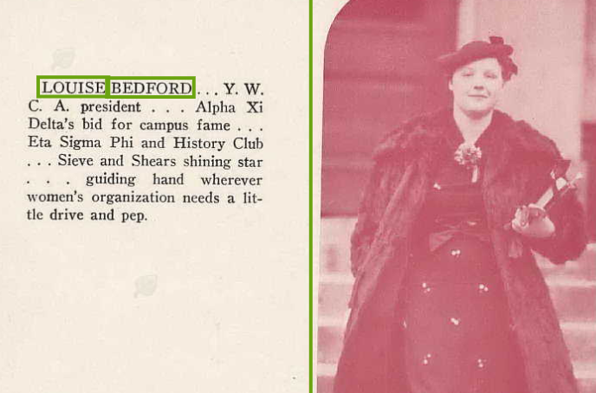
Caption: Louise Bedford…Y.W.C.A president…Alpha Xi Delta’s bid for campus fame…Eta Signma Phi and History Club…Sieve and Shears shining star…guiding hand wherever women’s organization needs a little drive and pep.” Image from Drake University Yearbook—1938. U.S., School Yearbooks, 1900-2016, Ancestry.com.

“We need the materials that allow a child freedom of choice in the media center—freedom to choose books that make reading fun, freedom to select a filmstrip to satisfy the curiosity aroused in the classroom. Freedom of choice is a great learning motivator.” –Louise C. Bedford, House of Representatives, Ninety-fifth Congress, p. 95

Louise C. Bedford (d. 1982) was a Kentucky school librarian and media specialist who advanced library services in public schools and held leadership roles in state and national library organizations. She was born in Iowa to a farming family. She attended Drake University in Des Moines, where she served as President of the Y.W.C.A, President of the Women’s League, and a member of the History Club and Eta Sigma Phi.

She is remembered for her work as a high school librarian, her coordination of instructional media programs at the county level, and her advocacy for library funding and cooperation.

Louise C. Bedford served as Librarian at Mt. Sterling High School in Montgomery County, Kentucky. Former students recalled her role in the school library, including during study hall periods in their senior year. She later advanced to the position of Instructional Media Coordinator for Montgomery County Schools, where she oversaw media and library programs across the district.

In 1974, Bedford received the Outstanding School Media Librarian award from the Kentucky Association of School Librarians (KASL) in recognition of her work as Instructional Media Coordinator for Montgomery County Schools.

She served as President of the Kentucky Library Association (KLA) during the 1979–1980 term, providing leadership for the state’s library community during a period of growing emphasis on school and public library collaboration.

In March 1981, Louise Bedford was identified by the American Library Association (ALA) Washington Office as a key contact and potential witness for a congressional oversight hearing on library programs. Scheduled for April 7, 1981 (during Legislative Day of National Library Week), the hearing—cosponsored by House subcommittees on education—focused on the impact of proposed federal budget cuts. She was listed alongside ALA President Peggy Sullivan and other library leaders as someone who could provide testimony on how budget reductions would affect library services in Montgomery County, Kentucky, public schools.

Louise C. Bedford passed away in 1981.

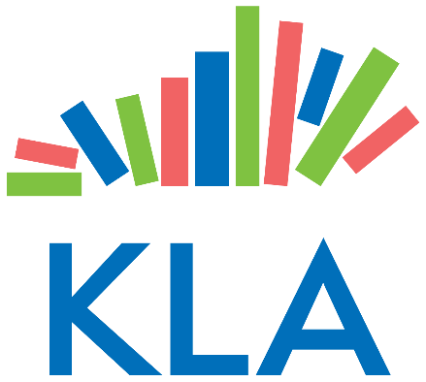

Sources

“ALA Report.” American Libraries 12, no. 11 (December 1981): 686–691. [This report includes the note on the recent death of Louise Bedford of Kentucky, describing her as “a veteran campaigner before the U.S. Congress and the general public on behalf of library development.”}

Ancestry.com. U.S., Find a Grave® Index, 1600s-Current [database on-line]. Lehi, UT, USA: Ancestry.com Operations, Inc., 2012. Original data: Find a Grave. Find a Grave®. http://www.findagrave.com/cgi-bin/fg.cgi.

American Library Association. “Washington Newsletter.” Vol. 33, No. 3 (March 25, 1981). ALA Institutional Repository (ALAIR). Accessed June 13, 2026.

Drake University Yearbook—1938. U.S., School Yearbooks, 1900-2016, Ancestry.com.

Kentucky Library Association (KLA). “Past Presidents.” Accessed June 13, 2026.

