Barbara Rose Johns Powell
March 6, 1935–September 28, 1991

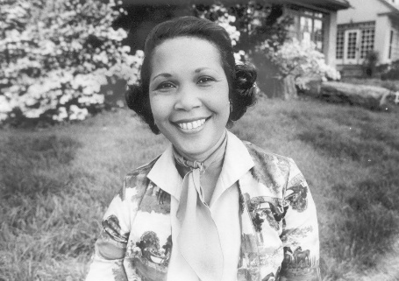

The most famous 20th Century American librarian earned her Masters degree from Drexel University in 1979. After graduating, she worked as a school librarian in the Philadelphia public school system. She died in 1991. She was 56.

There is no mention of her on Drexel’s website. Nor was she mentioned on the American Library Association website until this memorial was published.

On December 16, 2025, a statue of her was unveiled at the U.S. Capitol. It was first presented in Emancipation Hall and then moved to its permanent home in the Capitol Crypt, where it stands as Virginia’s contribution to the National Statuary Hall Collection.

Virginia’s Office of the Attorney General is named after her. Its website notes that it is fitting, because she “stood up for the American ideals of equality and opportunity.” Virginia dedicated a day in her honor, April 23, 2018, and has celebrated her on April 23 ever since.

In 2020, she was inducted into the National Women’s Hall of Fame, along with Aretha Franklin, Barbara Hillary, Henrietta Lacks, Toni Morrison, and Mary Church Terrell. She is the only librarian among the National Women’s Hall of Fame inductees.

The most widely held biographies of the most famous 20th Century American librarian are books for young readers: The Girl from the Tar Paper School by Teri Kanefield (Abrams, 2014) and The Untold Story of Barbara Rose Johns by Nicole A. Mansfield (Capstone, 2024).

Additional Resources

Brett Bonfield, “Perspective and Doing Good Work,” In the Library with the Lead Pipe, January 11, 2012

Lance Booth, “Overlooked No More: Barbara Johns, Who Defied Segregation in Schools,” New York Times, May 8, 2019

Barbara Rose Johns Powell, Encyclopedia Virginia. Note: this entry states that she earned a bachelor’s from Drexel University in 1979. In a personal email, dated January 3, 2012, Terri Breitenstine, Program Manager, Office of the University Registrar, Drexel University, wrote the following: “Thank you for your email. I can confirm the following in regards to Barbara Rose Powell: She was awarded her Master of Science on June 2, 1979. Her major was Library Science. She was admitted on September 27, 1976. If you need additional information, please do not hesitate to contact me.” Like most sources, including the Library of Congress, this entry lists her birth year as 1935. The National Archives uses 1934.

Robert Russa Moton Museum, The Moton School Story: Children of Courage

