Peggy Stillman (Margaret Peters Stalnaker) (1951-2026)
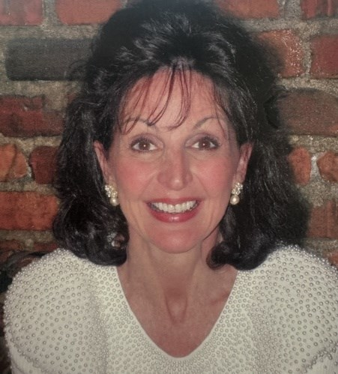

“Peggy put her heart and soul into the city.” --Chesapeake Vice Mayor Debbie Ritter, as quoted in Anderson, N. (2026, May 29). “Central library named to honor former director.” The Virginian-Pilot (Norfolk, VA), A3.

Peggy Stillman was the Director of Libraries and Research services at the Chesapeake Public Library System, Virginia, from 1985-2008. Peggy spent her entire professional career working for the Chesapeake Public Library system. She was Director of Libraries and Research services from 1985-2008 (she also served as an assistant city manager for other departments for several years). A new main library and several branches were constructed under her oversight, and her leadership catapulted the library into one of the top 20 public library systems in the United States. She received innumerable awards, including First Citizen of Chesapeake and the Semper Virginia Award in 2005.
Stillman was born in Macon, Georgia and grew up in Virginia. She earned a BA degree from Westhampton College of the University of Richmond in 1973; an MA from Virginia Commonwealth University in 1974, and an MLS in 1977 from the University of Maryland in 1977.
Stillman had incredible leadership skills that were widely recognized. Virginia’s governor appointed her to the Library of Virginia Board where she rose to chair. Over the course of her career, she also held leadership positions in various community organizations, including:
- American Cancer Society
- Foundation Board of the local Public Broadcasting System station
- Colonial Coast Girl Scout Council
- Tidewater Red Cross
- United Way of South Hampton Roads Board
- And more!
In 2026 the city council renamed the central library after he.
To say that she was heavily involved in the civic life of her community would be a huge understatement. A shining star of a civic engagement, Stillman shows us today just how much of an impact a librarian can have on every corner of a community. She left this world on January 29, 2026.

Sources
Altogether. (2026). Margaret Peters Stalnaker Obituary, https://www.altogetherfuneral.com/obituaries/rapp-funeral-cremation-service/silver-spring-maryland/margaret-stalnaker/january-2026
Anderson, N. (2026, May 29). “Central library named to honor former director.” The Virginian-Pilot (Norfolk, VA), A3.

--Submitted by Carolyn Caywood

