C. Sumner Spalding -1912-1997

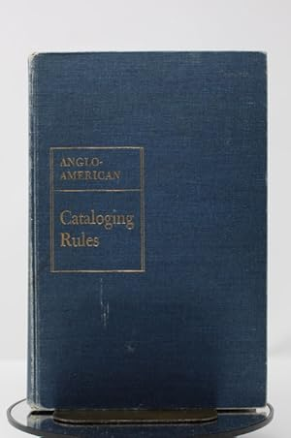

C. Sumner Spalding, 85, general editor of the first edition of the Anglo-American Cataloging Rules AACR), died on March 8 in Baltimore.” After his death Robert M. Hiatt, senior cataloging policy specialist, cataloging policy and support office, Library of Congress, noted:
C. Sumner Spalding will long be remembered not only as a giant in the cataIoging and classification-community but also as a true Renaissance man.”

Born in 1912, Mr. Spalding held bachelor's and master's degrees from Harvard University and a library science degree from Columbia University.
He joined the Library as a music cataloger in 1940 and subsequently served as assistant chief and chief of the Catalog Maintenance Division and chief of the Serial Record and Descriptive Cataloging Divisions.
With the outbreak of World War II, Spalding took a leave of absence from the Library of Congress and joined the U.S. Army where he served as bandmaster of the 362nd Army Band.

Spalding was assistant director of the Processing Department in Cataloging at the Library of Congress from 1968 until his retirement in January 1975.
He took a leave of absence from 1964 to 1966 to edit AACR.
During his professional life, Spalding represented the Library of Congress at many national and international conferences and served on many boards and committees.
The International Conference on Cataloguing Principles, Paris, 1961, at which he represented the Library of Congress, adopted an internationally accepted set of principles of choice and form of entry. These principles led to the first edition of the Anglo-American Cataloging Rules, for which Spalding served as general editor and for which he received the Margaret Mann Citation, the highest award in cataloging and classification offered by the American Library Association.

He also represented the Library at the International Meeting of Cataloguing Experts, Copenhagen, 1969, at which the machinery was set in motion for a series of International Standard Bibliographic Descriptions.
At the national level, Spalding served as the Library's representative to the United States Board on Geographic Names (BGN), an interagency organization responsible for providing uniformity in geographic nomenclature and orthography throughout the federal government. At the time of his retirement he was serving as chairman of BGN.
He was an accomplished church organist, choir director and composer. At 8l he was granted a patent for a specialized electronic device to enhance the sound of an organ.

Selected Publications

Spalding, C. Sumner. “Peter Cooper: A Critical Bibliography of His Life and Works.” Bulletin of the New York Public Library 45 (September 1941): 723–45.
Spalding, C. Sumner. “Library of Congress Book Catalogs: Proposed Expansion into Current Author and Subject Catalogs of American Library Resources.” College & Research Libraries 15, no. 1 (January 1954): 15–20.
Spalding, C. Sumner. The Cataloging of Serials at the Library of Congress. Washington, DC: Library of Congress, 1956.
Anglo-American Cataloguing Rules. North American text. Prepared under the direction of the American Library Association, the Library of Congress, the Library Association, and the Canadian Library Association. General editor: C. Sumner Spalding. Chicago: American Library Association, 1967.
Spalding, C. Sumner. “Main Entry: Principles and Counter-Principles.” Library Resources & Technical Services 11, no. 4 (Fall 1967): 389–96.
Spalding, C. Sumner. “The Library of Congress and the New Rules.” In The Code and the Cataloguer: Proceedings of the Colloquium on the Anglo-American Cataloging Rules Held at the School of Library Science, University of Toronto, on March 31 and April 1, 1967, edited by Katharine L. Ball, Katherine H. Packer, and Delores Phillips, 32–41. Toronto: University of Toronto Press, 1969.
Spalding, C. Sumner. “Romanization Reexamined.” Library Resources & Technical Services 21, no. 1 (Winter 1977): 3–12.

Sources

Hiatt, Robert M. “Celebrating C. Sumner Spalding.” Library Resources & Technical Services 41, no. 3 (1997): 274–75. https://doi.org/10.5860/lrts.41n3.274.
LC Cataloging Newsline, Volume 05, No. 04
Maxwell, M. N. F. (1977). Genesis of the Anglo-American cataloging rules. Libri: International Journal of Libraries & Information Services, 27, 238–262.
Pioneer in Cataloging Dies (March 24, 1997) - Library of Congress Information Bulletin

Submitted by Kathleen de la Peña McCook

