Louise F. Rees 1908-1985

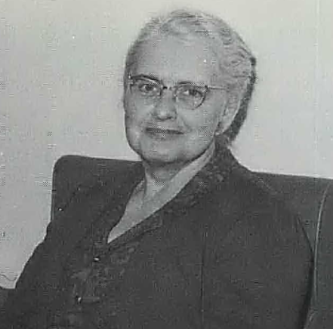

Louise F. Rees (d. 1985) was a library administrator, and educator who held leadership roles in the American Library Association (ALA) and helped establish library science education in Ohio.

Rees earned a Ph.B. from Shurtleff College, a B.S. in Library Science from the University of Illinois in 1938, and an M.L.S. from the University of Chicago.
After working as a high school librarian in Chicago she served from1943–1964 as School Library Consultant at the Michigan State Library (Lansing). This role explicitly involved statewide support for public and school libraries, including consulting on school library. Her work included elements of library extension services typical of state library consultants at the time—advising libraries across Michigan, working with architects, school boards, and superintendents.

In 1964 she joined the faculty of Bowling Green State University (BGSU) in Ohio as associate professor of library science and chairman of the newly established Department of Library Science. She remained in that leadership role into the mid-1960s, helping shape library education programs at the university. After retirement she was named University professor emeritus of library and education media at Bowling Green State University.
(The BGSU Department was merged into the Department of Curriculum and Instruction within the College of Education around May 1983. It had operated as an undergraduate teacher-preparation track focused on school librarianship and educational media).

Professional activities

Louise Rees was treasurer, Division of Libraries for Children and Young People (reported at the 1948 ALA conference;
- Chair, Planning Committee of the American Association of State Libraries (mid-1950s to early 1960s;
- Chair, Governmental Relations Section (or Section on Governmental Relations) of the American Association of State Libraries (circa 1959–1960; documented in 1959 ALA proceedings). She was also noted for leadership in the State School Library Supervisors group, which met at ALA Midwinter and Annual conferences where she was regularly listed in ALA handbooks as Michigan’s state school library consultant.
Louise Rees was elected president of the Library Administration Division (LAD) of the American Library Association in 1962 (LAD later evolved into the Library Administration and Management Association, or LAMA). She wrote the article, Rees, Louise F. “Public Librarians Must Face the Challenge.” ALA Bulletin 55, no. 2 (1961): 143–47.

Sources
“The Access to Public Libraries Study.” ALA Bulletin 57, no. 8 (1963): 742–45. http://www.jstor.org/stable/25696754.
Bowling Green State University. 1964-1965 Catalog. Bowling Green, OH: Bowling Green State University, 1964.
“Currents.” American Libraries 16, no. 11 (1985): 828–828.
Find a Grave. “Louise F. Rees.” Memorial ID 188534424. Accessed May 27, 2026.
“Library School News.” University of Illinois Library School Newsletter, 1943. (Mentions her October 1943 talk as Tilden Technical High School and her November 1, 1943, start as Michigan consultant.)

Library Administration and Management Association. “Fiftieth Anniversary Special: A Brief History and Timeline of the Library Administration and Management Association.”

Submitted by ALA Member

