Joseph Henry Reason - 1905-1997

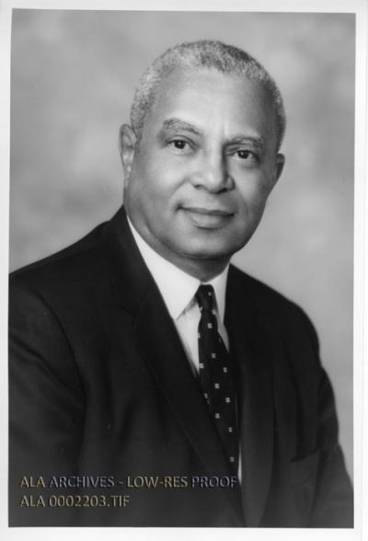

Dr. Joseph Henry Reason (1905–1997), a linguist and scholar, directed the Howard University Libraries for twenty-five years and became the first Black President of the Association of College and Research Libraries (ACRL).
In 1999, American Libraries named him one of the "100 Most Important Leaders We Had in the 20th Century."
He was born
on March 23, 1905, in Franklin, Louisiana.
He earned a B.A. in history summa cum laude from New Orleans University (now Dillard University) in 1928.
He initially taught at Gilbert Academy in New Orleans before moving into librarianship, encouraged by J.R.E. Lee Sr. at Florida Agricultural and Mechanical University (FAMU). He briefly directed the FAMU libraries around 1936–1938, then joined Howard University as a reference librarian in 1938.
He also pursued advanced studies in languages, receiving a B.A. in French from Howard University in 1932, an M.A. in French from the University of Pennsylvania in 1936 and a Ph.D. in Romance languages from the Catholic University of America in 1956, with a dissertation on Chrétien de Troyes’s Yvain.

In 1931, Reason married Bernice Chism. The couple had two children, Barbara Reason Butler and J. Paul Reason (who later became the first African American four-star admiral in the U.S. Navy).

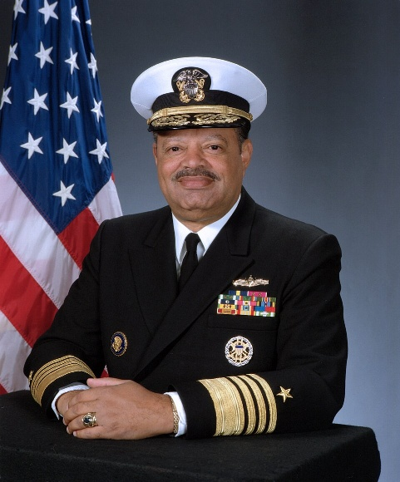
J. Paul Reason

From 1946 to 1971, Dr. Joseph Henry Reason served as director of the Howard University Libraries During his tenure, he oversaw significant expansion of the collections and facilities, transforming the system into a major research resource and helping Howard become the only predominantly Black institution admitted to the Association of Research Libraries (ARL).

Professional Activities.
Dr. Joseph Henry
Reason was elected to the American Library Association Council in 1956, nominated for ALA president in 1965 (the first Black American nominated), and served on the ALA Executive Board as second vice-president (1966–1967).
Within the Association of College and Research Libraries (ACRL), Dr. Reason held multiple committee roles. He served as executive secretary/acting director (1962–1963), and was elected president for 1971–1972.
In 1961–1962, he took a leave from Howard to represent ALA as an advisor on the Social Science Library Project at the University of Rangoon (Yangon) in Burma (Myanmar), helping establish a new social science library there.
A linguist and scholar, he also published articles on library topics and taught as a professor of Romance languages.

After retiring from Howard in 1971, Reason moved to Tallahassee, Florida. He continued contributing as a visiting professor in library science at Florida State University, vice chairman of the Legislative Task Force for the State Library of Florida, and a trustee of Eckerd College in St. Petersburg, Florida.
In recognition of his leadership, American Libraries named him one of the “100 Most Important Leaders We Had in the 20th Century” in 1999.

Joseph Henry Reason died July 26, 1997.

Selected Publications

He served as contributing editor of The Negro College Quarterly (1941–1947.
Reason, Joseph H. “Tacna-Arica.” Quarterly World, 1934.
Reason, Joseph H. An Inquiry into the Structural Style and Originality of Chrestien’s Yvain. Studies in Romance Languages and Literatures 57. Washington, DC: Catholic University of America Press, 1958.
Reason, Joseph H. “Library and Segregation.” In Encyclopedia of Library and Information Science, edited by Allen Kent, Harold Lancour, and Jay E. Daily, vol. 16, 22–26. New York: Marcel Dekker, 1975.
Reason, Joseph H. “Black Librarians in Florida.” In The Black Librarian in the Southeast: Reminiscences, Activities, and Challenges, edited by Annette L. Phinazee, 114–120. Durham, NC: North Carolina Central University School of Library Science, 1980.

Sources
American Library Association Archives, University of Illinois at Urbana-Champaign. Joseph H. Reason.
Joseph Henry Reason. Wikipedia
Kniffel, Leonard, Peggy Sullivan, and Edith McCormick. “100 of the Most Important Leaders We Had in the 20th Century 30, no. 11 (December 1999): 38–46, 48.
“Obituaries.” American Libraries 28, no. 10 (November 1997): 69.
Reason, Joseph Henry, memorial page. Memorial ID 33891563. Tallahassee Memory Gardens, Tallahassee, Leon County, Florida.
Joseph H. Reason. 1967. Black-and-white photograph. Library Photographic Vertical File, 1892–1985, RS 18/1/57, Box 23, Folder RE-RI. American Library Association Archives, University of Illinois at Urbana-Champaign.
Young, Ann-Christe. “People in the News.” College & Research Libraries News (1997).

Submitted by Kathleen de la Peña McCook

