Madison Mosley- 1950-2005

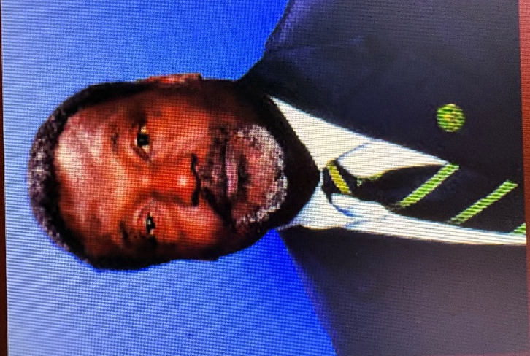

Dr. Madison Mosley was Stetson University College of Law Director of the Dolly & Homer Hand Law Library and Associate Professor of Law.
He was President of the Florida Library Association in 1999-2000.
Dr. Mosley earned the bachelor’s degree in library science and English from Florida State University in 1971, his master’s degree in library science from the University of North Carolina at Greensboro in 1974, and his doctorate in library science from Florida State University in 1980. Dr. Mosley worked for a year at Florida State University's Center for Studies and Vocational Education after earning the PhD.
He was director of the library at South Florida State College in Avon Park, Florida from 1982 to 1989. During this time he was on the Avon Park City Council before attending law school.
Dr. Mosley joined the Dolly & Homer Hand Law Library staff at Stetson University College of Law in 1993 after earning his law degree from the College of Law. He served as reference librarian and associate director before being appointed library director in February 2001.

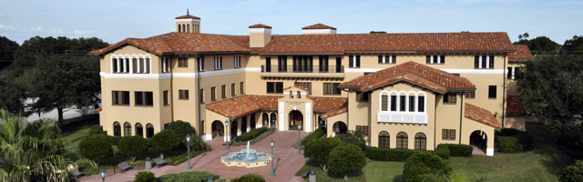

Dr. Mosley was an active member of the American Library Association and the ALA’s Black Caucus; American Association of Law Libraries and the AALL’s Southeastern Chapter; Florida Library Association; Association of College and Research Libraries; Florida Bar and National Bar Association.
He was also an active member of the community, serving as a member of the Avon Park city council, the co-chair of St. Petersburg’s Citizens Review Committee for the Police Department and the parliamentarian of the city’s African-American Voter Education Committee. He served as a board member of the Pinellas Public Library Cooperative and was very supportive of its work to foster library development.
He served as president of the Florida Library Association in 1999-2000.
He was a member of the Nominations Committee of the American Association of Law Libraries (AALL). He was also very involved with AALL's Diversity Committee and served as chair of AALL's Recruitment Committee in 1996-97. He mentored many students and other librarians throughout his service to our community and the profession.
Dr. Mosley died in 2005. At that time the Dean of the Stetson Law School stated:
“Dr. Mosley was an extraordinary individual. He was kind, intelligent, and very dedicated to Stetson and the library,” said Dean Darby Dickerson. “He was a talented and highly-trained library professional. His loss is a tremendous loss to the Stetson community. Our thoughts and prayers are with his family.”

Dr. Mosley was inducted into the Stetson Law School Hall of Fame posthumously in 2020.

Selected Publications
Mosley, Madison. “A Profile of the Library Learning Resources Center in Small Community/Junior Colleges. College & Research Libraries 45, no. 5 (September 1984): 392–398.
Mosley, M. M. (1993). What should be “free” at the library? Florida Libraries, 36, 171–172.
Mosley, Madison, Jr. “The Authorized Practice of Legal Reference Service.” Law Library Journal 87, no. 1 (Winter 1995): 203–209 .
Mosley, M. M. (1996). Chasing the specter of librarian malpractice. Florida Libraries, 39, 84–85.
Mosley, Madison, Jr. “Perceptions of African-American Law School Students Toward Law Librarianship as a Career Choice.” The Journal of Academic Librarianship 25, no. 3 (May 1999): 232–234.

Sources
Basse, Craig. “Mosley, 55, Law Librarian at Stetson Law Library.” Tampa Bay Times, March 30, 2005.
Florida Library Association. Presidents.
“Madison Mosley Obituary - FL.” Orlando Sentinel.
"Remembering Dr. Mosley." Stetson Lawyer 45, no. 1 (Spring 2005): 16–17.
Waters, S., Kuester, E., & Burdett, P. (2005, July 1). Memorial: Madison M. Mosley, Jr. (1950-2005). Law Library Journal, 97(3), 613–615.

Submitted by Florida Library Association Member.

