John P. McDonald (1922–1993)

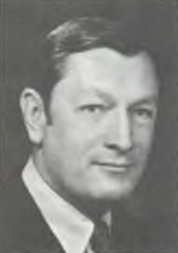

John P. McDonald (1922–1993) was University Librarian and Director of University Libraries at
the University of Connecticut (UConn) for more than two decades, transforming its libraries into
a dynamic center for research and scholarship.

McDonald served in the U.S. Navy during World War II. He attained the rank of lieutenant and
served in the U.S. Naval Reserve until 1951.

He graduated from the University of Virginia in 1946 before earning his Master of Library
Science from Drexel University in 1951. After early professional roles at the University of
Pennsylvania Library and as associate director at Washington University Library in St. Louis, he
was appointed University Librarian at UConn in 1963.

During his tenure, McDonald oversaw extraordinary growth: the library’s collections expanded
from roughly 450,000 volumes to more than 2.5 million. He played a central role in designing
and constructing UConn’s new central library facility, later named the Homer Babbidge Library.

A forward-thinking administrator, he guided the library’s early adoption of automation,
strengthened its archival and special collections, and advanced state, regional, national, and
international resource-sharing networks.

McDonald’s influence extended well beyond Storrs. He served as president of the Association of
Research Libraries (ARL) in 1971–1972 and, while on leave from UConn, as its executive
director from 1974 to 1976.

He consulted on library buildings and management for colleges and universities across the
United States, the U.S. Virgin Islands, and Santiago, Chile—his final project in 1990 was for the
American Museum of Natural History in New York.

Among many honors, he received the Outstanding Alumnus Award from Drexel’s Library School
Alumni Association (1975), the Distinguished Service Award from the Connecticut Library
Association (1986), and the Leadership Award from the UConn Alumni Association (1986). He
was also awarded an honorary Doctor of Laws degree by Wesleyan University.

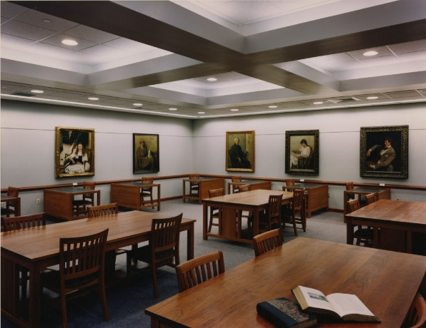

Beyond his professional accomplishments, McDonald was a dedicated conservationist, naturist,
and passionate bird-watcher. He served on the board of Joshua’s Tract Conservation and
Historic Trust, acted as secretary of the Friends of Trail Wood in Hampton, and belonged to the
National Audubon Society, Connecticut Audubon Society, Connecticut Ornithological
Association, and Natchaug Ornithological Society. His personal collection of more than 1,000
bird books was donated to UConn and is preserved in the John P. McDonald Reading Room in
the Thomas J. Dodd Research Center—an enduring monument to his love of nature and
learning.

Sources

“John P. McDonald; Was Head of UConn Libraries.” Hartford Courant, November 20, 1993.
https://www.courant.com/1993/11/20/john-p-mcdonald-was-head-of-uconn-libraries/.

University of Connecticut Archives &amp; Special Collections. “University Libraries Director’s
Records [John P. McDonald, 1963-1988].” Accessed May 1, 2026.
https://archivessearch.lib.uconn.edu/repositories/2/resources/715.

“John P. McDonald (1922-1993).” Find a Grave Memorial no. 127999059. Accessed May 1,
2026. https://www.findagrave.com/memorial/127999059/john_p-mcdonald.

Submitted by ALA Member.

