Guy R. Lyle – 1907-1994

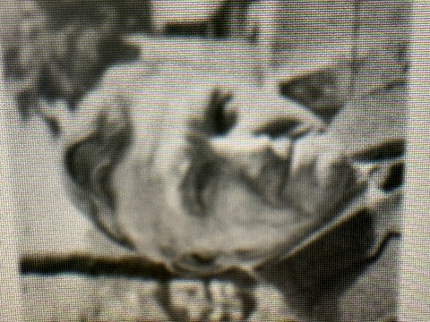

Guy Redvers Lyle (1907–1994) was a Canadian-born American librarian, administrator, author, and educator recognized for his leadership in academic librarianship and his influential writings on college and university library management. He received the Joseph W. Lippincott Award in 1972 for distinguished service to librarianship from the American Library Association.
Lyle was born in Lloydminster, Saskatchewan, Canada. He earned a B.S. in library science from Columbia University’s School of Library Service in 1929 and an M.S. in 1932.
He held successive directorships at Antioch College, the Woman’s College of the University of North Carolina (now the University of North Carolina at Greensboro), Louisiana State University, and Emory University, where he served until his retirement in 1972.

While at the Woman’s College, Lyle was elected president of the Association of College and Research Libraries (ACRL) for 1954–1955.

His publications shaped the profession for decades. The most notable was the textbook The Administration of the College Library, first issued in 1944 and reaching a fourth edition in 1974.
Other key works included The President, the Professor, and the College Library (1963), The Librarian Speaking: Interviews with University Librarians (1970), and his autobiographical memoir Beyond My Expectation: A Personal Chronicle (1981).

Lyle also consulted widely for colleges and universities and played a role in advancing interlibrary cooperation in the Southeast.

Selected Publications

Lyle, Guy R. Beyond My Expectation: A Personal Chronicle. Metuchen, NJ: Scarecrow Press, 1981.
Lyle, Guy R. (editor) Praise from Famous Men: An Anthology of Introductions. Metuchen, N. J.: Scarecrow Press, Inc. 1977.
Lyle, Guy R. The Administration of the College Library. 4th ed. New York: H. W. Wilson Company, 1974. (1st ed. 1944; 2nd ed. 1949; 3rd ed. 1961.)
Lyle, Guy R. The Librarian Speaking: Interviews with University Librarians. Athens: University of Georgia Press, 1970.
Lyle, Guy R. The President, the Professor, and the College Library. New York: H. W. Wilson Company, 1963.
Lyle, Guy R. The Librarian’s Role in Society—The Challenge. Sixth Annual Mary C. Richardson Lecture. Geneseo, NY: State University College, Division of Library Education, 1963.
Lyle, Guy R., and H. Tatnall Brown Jr. A Bibliography of Christopher Morley. Washington, DC: Scarecrow Press, 1952.
Lyle, Guy R. “College Libraries Encourage Reading.” Journal of Higher Education 12, no. 4 (April 1941): 191–197.
Lyle, Guy R., and Virginia M. Trumper. Classified List of Periodicals for the College Library. 3rd ed. Boston: F. W. Faxon Company, 1938. (Earlier editions appeared in 1934 and circa 1935–1936.)
Lyle, Guy R. College Library Publicity. Boston: F. W. Faxon Company, 1935.
Lyle, Guy R. “A Royal Book-Collector.” The Library Quarterly 3, no. 2 (April 1933): 180–191.

For the exhaustive bibliography of Guy R. Lyle’s publications (including journal articles, reviews, and shorter works compiled by Ruth Walling), see:
Farber, Evan Ira, and Ruth Walling, eds. The Academic Library: Essays in Honor of Guy R. Lyle. Metuchen, NJ: Scarecrow Press, 1974, 162–171.

Sources

American Library Association, “ACRL and Choice History,” https://www.ala.org/acrl/aboutacrl/history/history.
Evan Ira Farber and Ruth Walling, eds., The Academic Library: Essays in Honor of Guy R. Lyle (Metuchen, NJ: Scarecrow Press, 1974)
Guy Redvers Lyle, Beyond My Expectation: A Personal Chronicle (Metuchen, NJ: Scarecrow Press, 1981).
“People in the News,” College & Research Libraries News (1994), https://crln.acrl.org/index.php/crlnews/article/view/18826/21622.
Stuart A. Rose Manuscript, Archives, and Rare Book Library, Emory University, “Guy Redvers Lyle papers,” biographical note, https://archives.libraries.emory.edu/repositories/7/resources/3034.

