Augustus Frederick Kuhlman (1889 –1986)

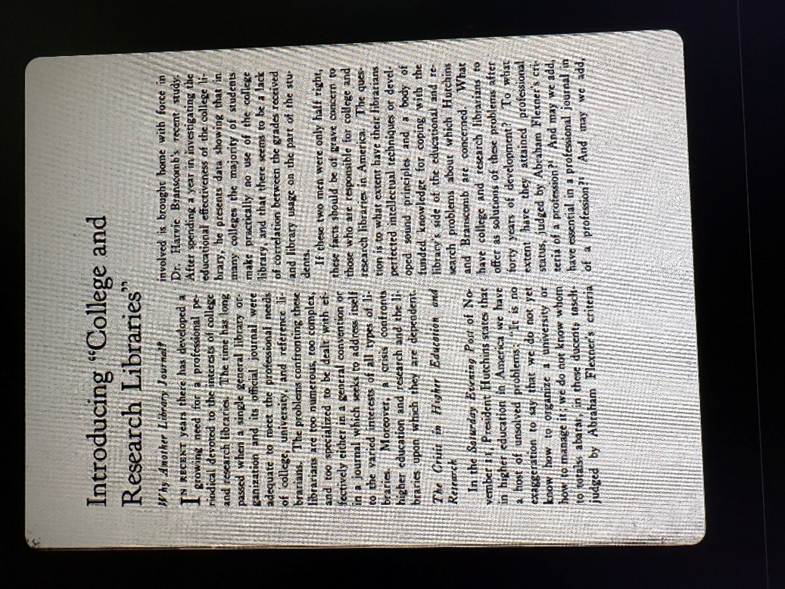

Augustus Frederick Kuhlman (September 3, 1889 – December 27, 1986) played a foundational role in the early history of the Association of College and Research Libraries (ACRL) as the driving force behind the creation and launch of its official scholarly journal.

He served as the founding and first editor of College & Research Libraries (C&RL) from its inaugural issue in December 1939 through 1941. In his introductory editorial (“Introducing ‘College and Research Libraries’: Why Another Library Journal”), Kuhlman outlined the journal’s eight core purposes, including serving as the official organ of communication within the association, publishing significant articles and reviews, stimulating research, and—most importantly—helping ACRL develop “into a strong and mature professional organization.”
Dr. Kuhlman was a librarian, bibliographer, and library administrator known for his work in social science bibliography (especially criminology) and for advancing cooperative library resources in the U.S. South.
Kuhlman earned his master’s and doctoral degrees from the University of Chicago. He began his career working in library and bibliographic roles there, including union lists and catalogs for Chicago-area institutions.
He contributed to numerous library surveys and union catalogs (e.g., for Chicago and Cook County libraries, including atlases and other specialized materials).
In 1936 Dr. Kuhlman was appointed director of the Nashville Joint University Libraries (a cooperative serving Vanderbilt University, George Peabody College, and Scarritt College), with the rank of full professor at Vanderbilt and Peabody. He played a key role in developing plans for shared library resources among these institutions and participated in regional conferences on graduate work and library development in the South

He was active in the American Library Association.
- He was Chairman, ALA Committee on Public Documents (prominently 1933 through the mid-to-late 1930s). He led the committee, organized sessions at ALA annual and midwinter conferences, and coordinated work on policies, distribution, and use of public documents (federal, state, municipal, and foreign).
- He was
- Chairman of the ALA Committee on Archives and Libraries (late 1930s including leadership or editorial oversight of proceedings titled Archives and Libraries.

- ACRL originated as the College Library Section of the American Library Association (ALA) in 1890 and reorganized as the Association of College and Reference Libraries in 1938 (becoming ALA’s first division in 1940). In this formative period, Kuhlman was appointed Chairman of the Publications Committee of the Association of College and Reference Libraries (by president-elect Phineas L. Windsor) in 1938–1939. In that capacity, he led the effort to establish a dedicated professional journal to address the long-recognized lack of specialized literature for college, university, and research libraries. He remained an active behind-the-scenes leader in the 1940s , serving on the committee studying ACRL’s relationship with ALA and advocating for a professional executive secretary and greater autonomy.
- Subcommittee for the South, ALA Board on Resources of American Libraries (late 1940s) This subcommittee (under the standing Board on Resources of American Libraries) focused on surveying and improving research resources in Southern academic libraries and promoting cooperative efforts.

Kuhlman remained based in Nashville in his later years and died there in 1986 at age 97.

He is remembered as a significant figure in early 20th-century American librarianship, particularly for bridging bibliography with practical library administration and regional cooperation.

Selected Publications

Kuhlman, Augustus Frederick. “Two ARL Approaches to Counting Holdings of Research Libraries.” College & Research Libraries 21, no. 3 (May 1960): 207–211.
Kuhlman, Augustus Frederick. The Joint University Libraries: A Survey of Resources Needed and Their Estimated Cost. Nashville, Tenn.: Joint University Libraries, 1948.
Kuhlman, Augustus Frederick. “Can the Association of College and Reference Librarians Achieve Professional Status?” College & Research Libraries 7, no. 2 (April 1946): 145–151.

Kuhlman, Augustus Frederick, Philip Davidson, and Joint University Libraries Conference of Graduate Deans and Librarians. The Development of Library Resources and Graduate Work in the Cooperative University Centers of the South. Nashville: Joint University Libraries, 1944.

Kuhlman, Augustus Frederick. The North Texas Regional Libraries: An Inquiry into the Feasibility and Desirability of Developing Them as a Cooperative Enterprise. Nashville: Peabody Press, 1943.
Kuhlman, Augustus Frederick. “The Program of the Joint University Libraries.” College & Research Libraries 3, no. 2 (March 1942): 108–116.

Wilson, Louis Round, Augustus Frederick Kuhlman, and Guy R. Lyle. Report of a Survey of the University of Florida Library for the University of Florida, February–May, 1940. Chicago: American Library Association, 1940.

Kuhlman, Augustus Frederick, and Icko Iben. Report of a Survey of the University of Mississippi Library for the University of Mississippi. University, Miss.: University of Mississippi, 1940.
Kuhlman, Augustus Frederick. “Introducing ‘College and Research Libraries’: Why Another Library Journal.” College & Research Libraries 1, no. 1 (December 1939): 7–10.
Kuhlman, A. F. “Association of College and Reference Libraries: A Section of the American Library Association.” ALA Bulletin 33, no. 11 (1939): P81–88. http://www.jstor.org/stable/25690267.

Thiele, Walter, prepared under the direction of Augustus Frederick Kuhlman. Official Map Publications: A Historical Sketch, and a Bibliographical Handbook of Current Maps and Mapping Services in the United States, Canada, Latin America, France, Great Britain, Germany, and Certain Other Countries. Chicago: American Library Association, 1938.

McMurtrie, Douglas C., with contribution by Augustus Frederick Kuhlman. A Nationwide Inventory of American Imprints under WPA Auspices: An Address at the 1938 Conference at Kansas City of the American Library Association, Section on Archives and Libraries. Chicago: Privately printed, 1938.

Kuhlman, Augustus Frederick. Atlases in Libraries of Chicago: A Bibliography and Union Check List. Chicago: University of Chicago Libraries, Document Section, 1936.

Kuhlman, Augustus Frederick. Private Civic and Social Service Agencies of Chicago: A Union List of Their Reports and Publications. Chicago: University of Chicago Bookstore, 1936.

Kuhlman, Augustus Frederick. “Neglected Categories of Research Materials Bearing Upon Social Aspects of Medicine.” Social Forces 14, no. 3 (March 1936): 373–381.
Kuhlman, Augustus Frederick. “Government Publications Significant for Medical Research.” Bulletin of the Medical Library Association 24, no. 2 (December 1935): 124–133.

Kuhlman, Augustus Frederick, and James Goodwin Hodgson. Chicago and Cook County: A Union List of Their Official Publications, Including the Semi-Official Institutions. Chicago: University of Chicago Library, 1934.

Kuhlman, Augustus Frederick. “A Movement to Preserve Social Science Source Materials.” American Journal of Sociology 38, no. 5 (March 1933): 777–785.

Kuhlman, Augustus Frederick, ed. Public Documents: State, Municipal, Federal, Foreign: Policies and Problems Concerning Issuance, Distribution and Use; Papers Presented at the 1933 Conference of the American Library Association. Chicago: American Library Association, 1934. (Kuhlman chaired the ALA Committee on Public Documents and edited or contributed to multiple volumes in this series through the 1930s, including those with Archives and Libraries sections in 1937 and later.)
Kuhlman, Augustus Frederick. A Guide to Material on Crime and Criminal Justice. Prepared by Augustus Frederick Kuhlman for the Committee on Survey of Research on Crime and Criminal Justice of the Social Science Research Council. New York: H. W. Wilson, 1929. This is his best-known work. It is a classified and annotated union catalog of books, monographs, pamphlets, and periodical articles. It was prepared for the Social Science Research Council’s Committee on Survey of Research on Crime and Criminal Justice and served as a foundational research tool in the field for decades.

Sources
Davis, Mary Ellen, and Mary Jane Petrowski. “ACRL and Choice History.” Association of College and Research Libraries. https://www.ala.org/acrl/aboutacrl/history/history.
Kaser, David. “Augustus Frederick Kuhlman (1889-1986).” In Supplement to the Dictionary of American Library Biography, edited by Wayne A. Wiegand, 46–50. Englewood, CO: Libraries Unlimited, 1990.
Kuhlman, A. F. “Association of College and Reference Libraries: A Section of the American Library Association.” ALA Bulletin 33, no. 11 (1939): P81–88. http://www.jstor.org/stable/25690267.
Martell, Charles. “Editorial.” College & Research Libraries 50, no. 1 (January 1989): 7–10.
https://doi.org/10.5860/crl_50_01_07. This is the 50th-anniversary editorial reflecting on the journal’s history and explicitly referencing Augustus Frederick Kuhlman’s foundational 1939 editorial.
“PEOPLE,” College & Research Libraries News 48, no. 3 (1987): 144, https://doi.org/10.5860/crln.48.3.144.
Vanderbilt University. Eskind Biomedical Library. “Augustus Frederick Kuhlman (1889-1986) Biographical File.” EBL-0638. VUMC Historical Images and Biographies Repository, Nashville, TN, 1962–1986.https://collections.library.vanderbilt.edu/repositories/4/resources/468.

Submitted by Kathleen de la Peña McCook

