Anne Rebecca Izard – 1916- 1990

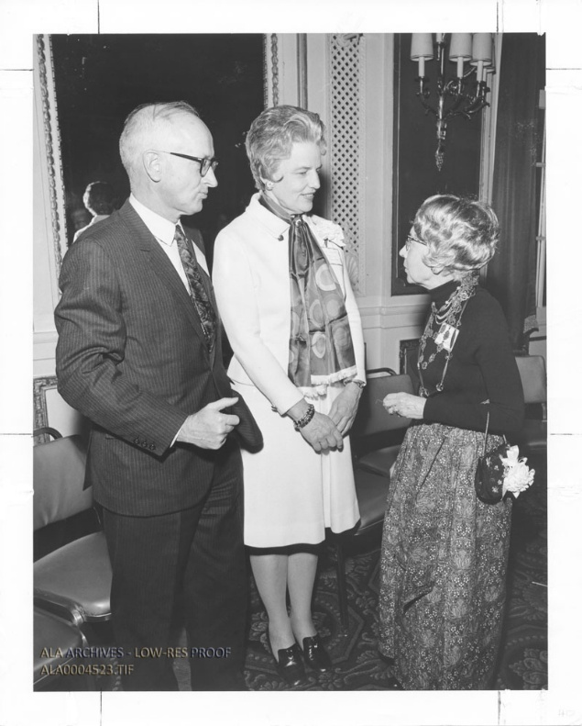
“Daniel Melcher, Anne Izard, and Sara Fenwick.” (L-R)
Photo above is of Anne Izard, then chair of the Newbery-Caldecott Selection Committee standing and talking with Daniel Melcher (donor of the awards) and Sara Fenwick (President of Children’s Library Services Division).

Anne Rebecca Izard (1916–1990) was a children's librarian, storyteller, educator, and leader in library services to children. She served as president of the Children's Services Division (CSD, now the Association for Library Service to Children or ALSC) of the American Library Association (ALA) from 1972 to 1973 and was widely recognized for her advocacy of high-quality literature, storytelling, and professional development for librarians.

Izard was born
in 1916 in North Carolina.
She earned a bachelor’s degree from Duke University in 1937 and a master’s degree from Simmons College in Boston in 1940, where she specialized in children’s services.

She began her library career at the New York Public Library, working under Anne Carroll Moore. There, she volunteered during vacations to tell stories at the Herald Tribune Fresh Air Camps, discovering the power of oral storytelling to connect with children.

Izard went on to serve as a children's librarian in Greenwich, Connecticut, and Mount Vernon, New York. In Mount Vernon, her storytelling programs were so popular that more than 200 children would line up around the block waiting for the library to open.

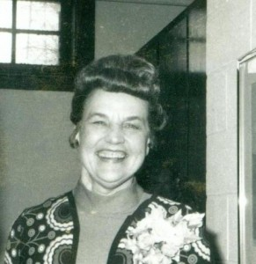

In 1959, she became the first Children's Services Consultant for the Westchester Library System in New York, a position she held for nearly two decades until her retirement in 1976. In this role, she conducted classes, workshops, and monthly meetings on book reviewing, storytelling techniques, and building quality children's book collections. She was known for her insistence on excellence in books, storytelling, and service to children, providing hands-on assistance to librarians across the system.

Professional Activity

As Children's Services Division president (1972–1973), Izard presided over major events, including the Newbery-Caldecott Awards Dinner, and chaired the Newbery-Caldecott Awards Committee.
She served on numerous ALA committees and received statewide and national recognition for her contributions to children's education and librarianship, including the James E. Allen Jr. Memorial Award from the New York Board of Regents for distinguished service to education.

An early member of the National Association for the Preservation and Perpetuation of Storytelling (now the National Storytelling Network), Izard founded the Westchester Storytellers Guild in the mid-1970s. She organized annual conferences that trained volunteer storytellers—many of whom later gained national prominence—and promoted the art form among librarians and the public.
Her influence extended internationally; in 1969, a Japanese librarian, Mrs. Mitsue Ishitake, studied with her and later established storytelling troupes (Ohanashi Caravans) across Japan and beyond.

After retiring in 1976 and moving to Gwynedd, Pennsylvania, Izard devoted herself almost entirely to storytelling. She was a featured teller at the 1984 National Storytelling Festival in Jonesborough, Tennessee, and continued sharing stories with both children and adults, preserving the oral tradition.

Anne R. Izard died January 1990.
Her legacy endures through the storytelling practices she established in Westchester County, the Anne Izard Storytellers’ Choice Award (named in her honor by the Westchester Library Association), and her impact on generations of librarians, storytellers, and children worldwide.

Selected Publications

Izard, Anne. Review of Kristy’s Courage, by Babbis Friis-Baastad. Library Journal, November 15, 1965.

Izard, Anne R. “Children’s Librarians in 1970.” American Libraries 2 (October 1971): 973–976.

Izard, Anne. “Disturbing Your Universe.” Elementary English 51, no. 3 (March 1974): 399–401.

Sources

Izard, Anne R." ALSC (and CSD) Presidents, 1969–Present. Association for Library Service to Children (ALSC), American Library Association.
"Anne Izard Biography." Westchester Library Association. Accessed May 22, 2026
"Anne Izard, 74, Dies; A Children's Librarian." New York Times, January 13, 1990.

Submitted by ALA Member

