Sharon Anne Hogan - 1945–2002

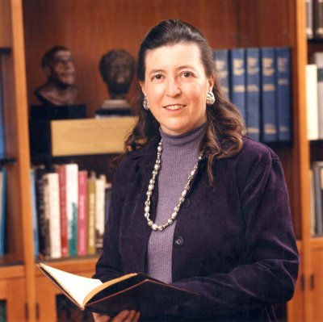

Sharon Anne Hogan (1945–2002) was an academic librarian, university administrator, and leader in library instruction during the transition of libraries to the digital/electronic era. She was widely recognized for helping shift academic libraries from traditional print-focused institutions into modern information retrieval and digital systems.

Sharon Hogan served as University Librarian (and vice provost for information management) at the University of Illinois at Chicago (UIC) from 1990 until her death in 2002. In this role, she was a national advocate for issues including copyright, free speech, privacy, and open access to information. She testified before Congress on library-related legislation and opposed Internet filters and state laws that would have restricted interlibrary lending by applying local obscenity standards.
She began her professional career at the University of Michigan in Ann Arbor, serving as a librarian and faculty member from 1968 to 1982 with appointments in both the School of Information and Library Studies and the Program in American Culture; during this period she taught one of the first bibliographic instruction credit courses offered for graduate students anywhere in the country.
From 1983 to mid-1985 she served as Acting Director of Libraries at Temple University in Philadelphia.
In July 1985 she was appointed Director of Libraries at Louisiana State University (LSU), Troy Middleton Library in Baton Rouge, a position she held until 1990.
In 1990 Hogan joined the University of Illinois at Chicago (UIC) as University Librarian and Vice Provost for Information Management, where she oversaw both the library system and campus-wide computing, telecommunications, and information services.
She was active in the American Library Association (ALA). She was President of the Association of College and Research Libraries (ACRL) for the 1985–86 term. She was a founding member and chair of the ACRL Bibliographic Instruction Section (In 1995 the membership voted to rename it the Instruction Section (IS) to reflect the broader evolution of the field from “bibliographic instruction” toward information literacy and teaching practices).
Sharon Hogan also served on the ALA Executive board and as the chair of the ALA's Task Force on Core Competencies for Librarians.

Honors
2002 — Robert R. McClarren Legislative Development Award, Illinois Library Association.
2001 — Intellectual Freedom Award, Illinois Library Association (for her opposition to Internet filters and restrictive state legislation on obscenity standards that would have hindered interlibrary lending).
2000-Academic/Research Librarian of the Year, Association of College and Research Libraries (ACRL)
1995— Chinese American Librarians Association Presidential Recognition Award.
1988- Miriam Dudley Bibliographic Instruction Librarian of the Year Award, ACRL.
1987 — Distinguished Alumni Award, University of Michigan School of Information and Library Studies.

Hogan died April 27, 2002, at age 57 while convalescing in Paradise Valley, Arizona. Tributes appeared in Library Journal, The New York Times, and academic publications, which dedicated issues or sections to her memory.

Selected Publications

Hogan was the founding co-editor of the journal Research Strategies (beginning with volume 1 in 1983).
Hogan, Sharon A., and Mary W. George. “Cropping Up: Librarians’ Desire to Conduct Serious Research.” Research Strategies 4 (Spring 1986): 58
George, Mary, and Sharon Hogan. “What’s 3x5 and Full of Holes?” Research Strategies 1 (Summer 1983): 136–138.
George, Mary, and Sharon Hogan. “The Concept of Bibliography.” Research Strategies 1 (Spring 1983): 89–92.
Hogan, Sharon, and Mary George. “Start-Up Thoughts.” Research Strategies 1 (Winter 1983): 2–3.

Beaubien, Anne K., Sharon A. Hogan, and Mary W. George. Learning the Library: Concepts and Methods for Effective Bibliographic Instruction. New York: R. R. Bowker, 1982.
Hogan, Sharon Anne. “Training and Education of Library Instruction Librarians.” Library Trends 29, no. 1 (Summer 1980): 105–126.
Hogan also provided formal congressional testimony that was published in hearing records (e.g., statements on e-government and distance education in 1999 and 2001.

Sources
Beaubien, Anne K., Sharon A. Hogan, and Mary W. George. Learning the Library: Concepts and Methods for Effective Bibliographic Instruction. New York: R. R. Bowker, 1982.
“Hogan, Sharon A. (1991-2002).” The American Library Association Archives. University of Illinois at Urbana-Champaign. Accessed May 11, 2026. https://archon.library.illinois.edu/ala/?p=creators/creator&id=4097.
“In Dedication: Sharon Hogan, 1945–2002.” First Monday 7, no. 5 (May 2002).
“Sharon Anne Hogan, 57, a Leading Librarian of the Electronic Age.” The New York Times, May 4, 2002. https://www.nytimes.com/2002/05/04/us/sharon-anne-hogan-57-a-leading-librarian-of-the-electronic-age.html.
“Sharon Hogan, 57.” Chicago Tribune, May 1, 2002. https://www.chicagotribune.com/2002/05/01/sharon-hogan-57/.
“UIC Librarian Hogan Dies at 57.” Library Journal, May 2002.
“ACRL Honors the 2000 Award Winners.” College & Research Libraries News 61, no. 3 (March 2000): 188–91.

Submitted by Kathleen de la Peña McCook

