Carolyn Hixson Harris -1947 -1994



Carolyn Hixson Harris (full name Carolyn Lynnet Hixson Harris was a preservation librarian and educator. She was president of the Resources and Technical Services Division (RTSD) of the American Library Association. She is remembered as one of the key figures who professionalized and institutionalized preservation education and practice within American librarianship.
Harris earned a B.A. in Art History (1969) and a Master of Library Science (1970), both from the University of Texas at Austin. Her career began as a manuscript cataloger at the Harry Ransom Humanities Research Center at UT Austin (1973–1980).
In 1981 she moved to Columbia University Libraries, where she served as Head of Preservation (1981–1987), Assistant Director for Preservation (1987–1989), and later Director of the university’s Preservation and Conservation Programs (appointed 1990; she began teaching in the program in 1989).

In 1992, under her leadership, Columbia’s preservation and conservation education programs relocated to the Graduate School of Library and Information Science at UT Austin. She continued as director and senior lecturer there until her death; new dedicated facilities (classrooms, offices, and laboratories) were opened in December 1993.

Harris was professionally active in the American Library Association. She served as president of the Resources and Technical Services Division (RTSD, then ALCTS, now part of Core) from 1988 to 1989, contributing to national policies on bibliographic control and preservation advocacy.

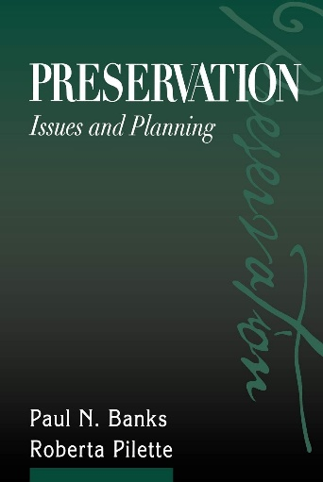

She published extensively on conservation and preservation topics. Notable works include articles on mass deacidification, scholar involvement in preservation decisions, preservation of library materials, education for preservation administration, electronic security systems, and selection for preservation. Her essay, “Selection for Preservation.” In Preservation: Issues and Planning, was published posthumously.
Her writings earned her the John Brubaker Award from the Catholic Library Association (1983) and the Rex Dillow Award (1990) for distinguished writing.

Following her death in Austin, Texas, at age 46, an endowment was established in her name to support scholarships for students in preservation and conservation studies or to fund laboratory equipment.
In recognition of her (and Paul Banks’s) foundational contributions to the field, the Association for Library Collections & Technical Services (formerly RTSD) created the Paul Banks and Carolyn Harris Preservation Award in 2001 to honor professionals who have made significant advancements in library and archival preservation and conservation.

Selected Publications

Harris, Carolyn L. “Mass Deacidification: Science to the Rescue?” Library Journal 104, no. 13 (1979): 1423–27.
Harris, Carolyn. “Brittle Books: A Way of Life.” Catholic Library World 53 (March 1982): 332–35. (Winner of the Catholic Library Association John Brubaker Award, 1983.)
Harris, Carolyn L. “Preservation of Library Materials.” In The ALA Yearbook of Library and Information Services, vol. 11. Chicago: American Library Association, 1986.
Bagnall, Roger S., and Carolyn L. Harris. “Involving Scholars in Preservation Decisions: The Case of the Classicists.” Journal of Academic Librarianship 13, no. 3 (1987): 140–46.
Pilette, Roberta, and Carolyn Harris. “It Takes Two to Tango: A Conservator’s View of Curator/Conservator Relations.” Rare Books & Manuscripts Librarianship 4, no. 2 (1989): 103–11.
Harris, Carolyn L. “Education for Preservation Administration: Part 1—The Role of the Conservation Education Program of Columbia University’s School of Library Service.” Conservation Administration News, no. 42 (July 1990): 8–9, 24.
Harris, Carolyn L. “Education for Preservation Administration: Part 2—The Role of the Conservation Education Program of Columbia University’s School of Library Service.” Conservation Administration News, no. 43 (October 1990): 4–5, 29.
Harris, Carolyn L. “Library Binder’s Role in Preservation Education.” New Library Scene 9 (1990): 8–11.
Harris, Carolyn L., and Paul N. Banks. “The Library Environment and the Preservation of Library Materials.” Facilities Manager 6, no. 3 (Fall 1990): 21–24. (Winner of the Rex Dillow Award, 1990.)
Harris, Carolyn, Carol Mandel, and Robert Wolven. “A Cost Model for Preservation: The Columbia University Libraries’ Approach.” Library Resources & Technical Services 35, no. 1 (1991): 33–54.
Harris, Carolyn L. “The Preservation Consideration in Electronic Security Systems.” Library & Archival Security 11, no. 1 (1991): 35–42.
Harris, Carolyn L., et al. “The Columbia University Libraries Staff Development Seminar.” Journal of Academic Librarianship 17 (1991): 71–73.
Harris, Carolyn L. “Selection for Preservation.” In Preservation: Issues and Planning, edited by Paul N. Banks and Roberta Pilette, 206–24. Chicago: American Library Association, 2000. (Posthumous chapter; the volume was planned by Harris prior to her death.)

Sources

American Library Association. “Paul Banks and Carolyn Harris Preservation Award.”

“Obituary: Carolyn Hixson Harris.” Abbey Newsletter 17, no. 7 (December 1993).
“Obituaries: Carolyn Harris, 46.” Columbia University Record 19, no. 18 (February 25, 1994): 7.
Rare Books and Manuscripts Section, Association of College and Research Libraries, American Library Association. “Memorial Resolution for Carolyn Harris.” RBMS Newsletter no. 20 (April 1994): 4.

Spiegel, Pam. “People in the News.” College & Research Libraries News, 1994.

Submitted by ALA Member

