Hoyt R. Galvin – 1911-1995

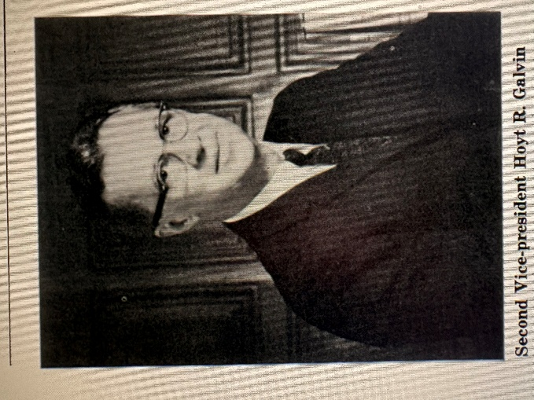

Hoyt Rees Galvin (1911–1995) was a library administrator, long-time director of the Charlotte Mecklenburg Library, North Carolina, and consultant.
He was b
orn February 26, 1911, on a farm in Pleasantville, Marion County,Iowa and had no early exposure to libraries until he took a job in the library at nearby Simpson College to help fund his education.
He graduated from Simpson College in 1932 and pursued library science at the University of Illinois, earning a second bachelor’s degree.

Galvin’s first professional position was as librarian for the Tennessee Valley Authority (TVA) in Knoxville, Tennessee (1935–1937).
In 1937 he became director of a three-county regional library system based in Huntsville, Alabama, serving until 1940. There he helped establish one of the nation’s first regional library programs (in cooperation with the TVA, county governments, and school boards) and introduced the first bookmobile in the Huntsville Public Library system.

In November 1940 Galvin was appointed director of the Charlotte Public Library (later the Public Library of Charlotte and Mecklenburg County and now Charlotte Mecklenburg Library), a position he held until his retirement on February 28, 1971. During his thirty-year tenure he oversaw racial integration of library staff and major expansion of facilities. He played a key role in securing voter approval for a bond issue that funded the 1956 main library building and several branches and successfully advocated for dedicating 5 percent of North Carolina Alcoholic Beverage Control profits to library support.
In 1967 his library board encouraged him to assume for a six-month period the additional duties of acting university librarian (half time) of the University of North Carolina, Charlotte.
Galvin was nationally recognized as an authority on public library buildings and planning. After retirement he maintained a consulting practice, completing approximately 190 consulting projects involving 116 building programs or surveys in thirty-three states into the 1980s.
He also co-authored a UNESCO publication on small public library buildings and taught seminars and library-school classes at the University of Pittsburgh.

Professional Activity

Hoyt R. Galvin was president of the Alabama Library Association (1940-1941) and chairman of the Alabama State Library Board.
He was president of the North Carolina Library Association and president of the North Carolina Adult Education Association in 1943.
He was president of the Southeastern Library Association (1962-64).
For the American Library Association Galvin was a member of the Special Council Committee on Freedom of Access to Libraries (1965-1968) and the ALA/American Institute of Architects/ National Book Committee Library Buildings Jury (1966-1967). He was a member of the ALA/Canadian Library Association Joint Committee (1961-1967) and chairman of the Physical Facilities Subcommittee of the Public Library Association Standards Committee (1965-1966).
He was elected president of the Library Administration Division for the 1965-1966 term. (LAD, was later renamed the Library Administration and Management Association or LAMA)
He was a member of the U.S. Office of Education Advisory Committee on Library Research and Training (1966-1970).

Hoyt R. Galvin died December 22, 1995, in Charlotte, North Carolina.
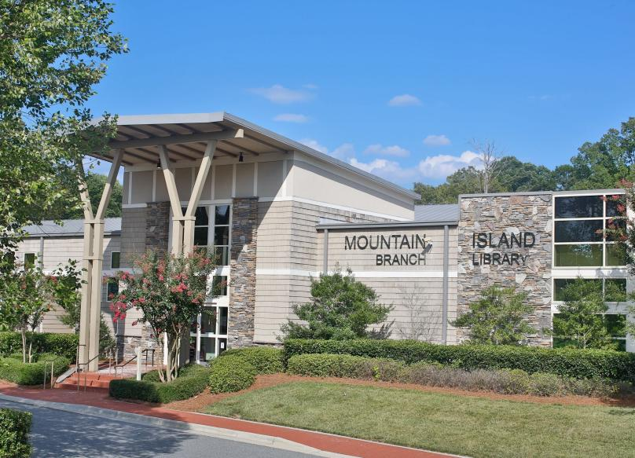
The Charlotte Mecklenburg Library Mountain Island branch address honors him as “Hoyt Galvin Way.” Mountain Island Library - Now Open | Charlotte Mecklenburg Library [4420 Hoyt Galvin Way
Charlotte, NC 28214].

Consulting

Hoyt R. Galvin’s was a nationally recognized expert on public library facilities planning. He transitioned into a private consulting practice immediately after retirement

By 1984, Galvin documented 190 different consulting jobs, encompassing 116 distinct building programs or surveys across 33 states. These figures appear in his professional advertisements in library journals (such as Library Journal “Career Leads” sections), where he highlighted “30+ yrs. of experience on 190+ jobs in 33 states.” The work was primarily for public libraries and systems, though it occasionally extended to related regional or county projects.
Galvin’s consulting focused on producing detailed written building programs—comprehensive planning documents that outlined a library’s functional needs, space requirements, site considerations, furniture/equipment specifications, and operational flow before architects were fully engaged. He also conducted broader facility surveys (assessing existing buildings and recommending expansions, renovations, or new construction) and provided guidance on site selection, parking, and integration of modern library services. Many projects resulted in formal reports that libraries used to secure bond funding or guide architects.
The Charlotte Mecklenburg Library Special Collections preserves these in the Hoyt R. Galvin Papers.
He collaborated frequently with architects and emphasized the consultant’s role as a bridge between librarians’ service goals and architectural realities
The archives and contemporary references document projects such as:
- Huntsville Public Library, Alabama (1959)
- Moultrie and Colquitt County Public Library, Georgia (1960)
- Anniston Public Library, Alabama (ca. 1961)
- Savannah and Chatham County, Georgia (1961)
- Decatur and DeKalb County, Georgia (1961)
- Waco Public Library, Texas (1959)
- Smithfield and Johnston County, North Carolina (1964)
- Raleigh and Wake County, North Carolina (1965)
- Multiple other North Carolina county/system projects (Statesville/Iredell, Cumberland/Fayetteville, etc.)
- Chemung Southern Tier Library System and Chemung County, New York (1968)
- Anderson County Main Library, South Carolina (1968)
- Morristown and Hamblen County, Tennessee (1966)
- Delaware County District Library, Ohio (1979—recommended new construction)
- Beaumont, Texas central library
- Sarasota County, Florida projects

These spanned small-town libraries to larger urban and regional systems, reflecting Galvin’s versatility and reputation. He co-authored the influential UNESCO manual The Small Public Library Building (1958, with Martin Van Buren) and edited ALA’s Planning a Library Building proceedings (1955).
From 1967 to 1978 he co-compiled (with Barbara N. Asbury) the annual “Public Library Buildings” statistical series in Library Journal, plus a 1978 article on “Public Library Parking Needs.”
In 1968 he co-wrote (with Dorothy D. Corrigan) “Library Building Consulting: Problems and Ethics” in the ALA Bulletin, which addressed consultant selection, role definitions, potential conflicts of interest, and best practices for collaborative planning with librarians and architects. He was regularly listed in ALA consultant directories and spoke or taught at library-building institutes and library schools.
Galvin’s work helped standardize library-building programs nationwide during a boom period of public library construction in the 1960s–1980s. His emphasis on functional, user-centered design (rooted in his own Charlotte experience and UNESCO guidelines) influenced countless facilities still in use today.
Galvin’s consulting practice transformed decades of hands-on library administration into a national service that shaped the physical infrastructure of American public libraries.

Selected Publications

Galvin, Hoyt R. “National Institute on War and Post-War Issues.” Social Forces 21, no. 4 (1943): 496–496.
Galvin, Hoyt R., comp. Audio-Visual Manual for Public Libraries. Charlotte, NC: Public Library of Charlotte and Mecklenburg County, 1946.

Galvin, Hoyt R., comp. Films in Public Libraries: A Project of the Audio-Visual Committee of the American Library Association. New York: R. R. Bowker Company, 1947.

Galvin, Hoyt R., and Rex M. Wiest. “Bookmobiles or Branches?” North Carolina Libraries 12 (1954): 70–72.

Galvin, Hoyt R. “Salute to Public Library Section Leaders.” North Carolina Libraries 11, no. 1 (January 1952).

Galvin, Hoyt R., ed. Planning a Library Building: Proceedings of the Library Buildings Institute, St. Paul, Minnesota, June 19–20, 1954. Chicago: American Library Association, 1955.

Galvin, Hoyt R., and Martin Van Buren. The Small Public Library Building. UNESCO Public Library Manuals 10. Paris: UNESCO, 1958.

Galvin, Hoyt R. Proposed Outline for Public Library Buildings Institutes and Workshops. Washington, DC: U.S. Department of Health, Education, and Welfare, Library Services Branch, 1964.

Galvin, Hoyt R., and Barbara N. Asbury. “Public Library Buildings.” Library Journal, December 1 issues, 1967–1978 (annual statistical series on public library construction).

Galvin, Hoyt R., and Barbara N. Asbury. “Public Library Parking Needs.” Library Journal 103 (November 15, 1978): 2310–13.

In addition to the works above, Galvin prepared approximately 190 library building program reports, surveys, and consulting studies (1958–1990s) for public libraries across more than thirty states.

Sources
Alabama Library Association. Alabama Library Association Handbook. Rev. December 6, 2022. Accessed May 28, 2026.
Charlotte Mecklenburg Library “Library History.”
Charlotte Mecklenburg Library. Special Collections. Hoyt R. Galvin Papers, 1916-1993. Finding aid. Charlotte, NC: Charlotte Mecklenburg Library. Series: Library Consulting (Boxes 12–14) of the Hoyt R. Galvin Papers, 1916–1993.
The Charlotte Observer. “Hoyt Galvin Dies.” December 24, 1995. Cited in Charlotte Mecklenburg Library Special Collections, Hoyt R. Galvin Papers.
Hays, Paul A. 2005. From Carnegie to Fort Book: The History of the Huntsville-Madison County Library. West Conshohocken, PA: Infinity Pub. Co.
“Hoyt R. Galvin, recently retired director of the Charlotte and Mecklenburg County Public Library in North Carolina, will serve as visiting lecturer at the University of Pittsburgh's Graduate School of Library and Information Sciences.” American Libraries. Dec. 1971, Vol. 2, No. 11.
Huntsville History Collection. (n.d.). Hoyt Rees Galvin
North Carolina Library Association. “Past Presidents.”
Southeastern Library Association. Biennial Meetings and Officers of the Southeastern Library Association.
Whitten, Sam G., and Frank B. Sessa. “New ALA Officers.” ALA Bulletin 63, no. 8 (1969): 1166–68.

Submitted by Kathleen de la Peña McCook

